Welcome to Class! Do Now Please!
Questions/Concerns:
**1. What AP Region is Al-Andalus in?

**2. How did Islam spread to Spain?

**3. What other factors led to the spread of Islam in the Post-Classical Era?

Directions: Please read the questions below. Then, after watching the video, answer them silently.
- How was Spain positively affected by Islam?

Document Analysis
Prompt: Analyze the long-term effects of the Al-Andalus Caliphate in Spain.

Scope:
Topic:
HTS:
Re-Written Question:

Document 1

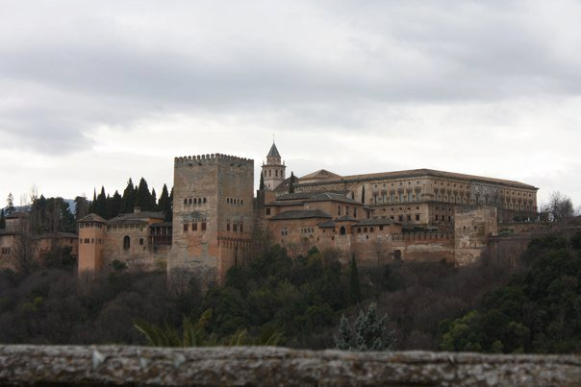
Source: The Alhambra Palace, Granada, Spain.
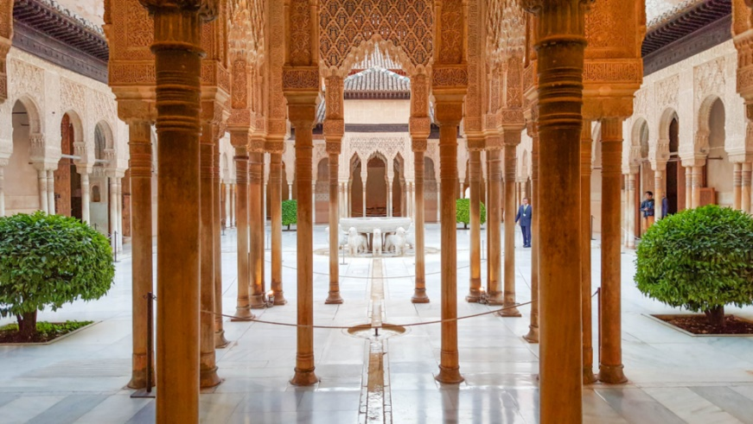
The history of the Alhambra is linked with the geographical place where it is located: Granada, Spain.. Originally designed as a military area, the Alhambra became the residence of royalty and of the court of Granada in the middle of the thirteenth century, after the establishment of the Islamic kingdom of Nasrid and the construction of the first palace, by the founder king Mohammed ibn Yusuf ben Nasr, better known as Alhamar. Throughout the thirteenth, fourteenth and fifteenth centuries, the fortress became a citadel with high ramparts and defensive towers, which house two main areas: the military area, or Alcazaba, the barracks of the royal guard, and the medina or court city, the location of the famous Nasrid Palaces and the remains of the houses of noblemen and plebeians who lived there. The complex of monuments also has an independent palace opposite the Alhambra, surrounded by orchards and gardens, which was where the Granadine kings relaxed: the Generalife. This fortress, and the gardens surrounding it, still stand today, and represent the influence of Islamic culture and religion on the city of Granada.
Significance:

Document 2
Source: This document records a peace treaty between Abd al-Aziz and Tudmir, the local ruler of Murcia. Treaties such as this were used to enlist the cooperation of local administrators and inhabitants. This treaty establishes the local Christian population as a protected group under Muslim rule. As with any dhimmi group, they were guaranteed personal safety and allowed to retain their religion in return for their loyalty to the Muslim regime and payment of an annual tax.
In the name of god the merciful and compassionate, this is a document granted by Abd al-Aziz to Tudmir, establishing a treaty of peace and protection. We will not set special conditions for him or any among his men, nor harass him, nor remove him from power. They will not be coerced into matters of religion, their churches will not be burned, as long as he remains sincere and fulfills the following conditions we have set for him. He will not give shelter to our fugitives or enemies, and he and each of his men should also pay one dinar every year, along with wheat, barley, and fruit juice.

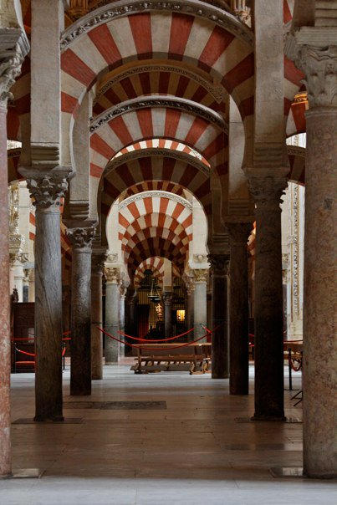
Document 3
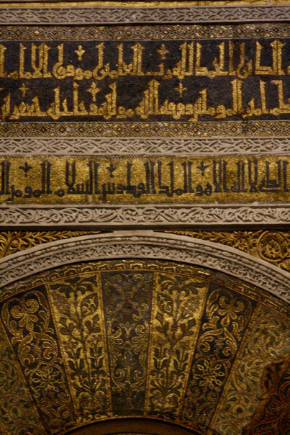
Source: La Mezquita, Spain

One of the largest mosques in the world, La Mezquita, or the Great Mosque is even by today's standards an impressive building, measuring about 250,000 sq. ft. Located in Cordoba, Spain, it was built in the 8th century CE by Islamic Architects, and is recognized today as one of UNICEF’s World Heritage Centers.

Significance:

Document 4
Source: Of the Moorish poetry which survived the fall of Granada, much was preserved by the Spaniards themselves and in the Spanish language. The victors knew how to value the spirit of the vanquished; and ballads of Moorish origin, telling of Moorish loves, long remained popular in Spain. The authors of most of these have been forgotten. The text of some of the best known of them is given here.
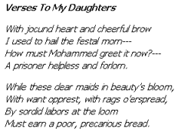
Significance:

Exit Ticket

Directions: Using the documents from our lesson, please write a body paragraph responding to our Main Inquiry Question for today: Analyze the long-term effects of the Al-Andalus Caliphate in Spain.

_______________________________________________________________________________________

_______________________________________________________________________________________

_______________________________________________________________________________________

_______________________________________________________________________________________

_______________________________________________________________________________________

_______________________________________________________________________________________

_______________________________________________________________________________________

_______________________________________________________________________________________

_______________________________________________________________________________________

_______________________________________________________________________________________

_______________________________________________________________________________________

_______________________________________________________________________________________

_______________________________________________________________________________________

_______________________________________________________________________________________

_______________________________________________________________________________________

_______________________________________________________________________________________

_______________________________________________________________________________________

_______________________________________________________________________________________

_______________________________________________________________________________________

_______________________________________________________________________________________

_______________________________________________________________________________________

_______________________________________________________________________________________

Homework
Directions: Please complete the questions below in detailed bullet points in preparation for our Extended Oral Drill on Monday.

QUESTION | ANSWER
- **Define a caliphate.
- **Name two Islamic Caliphates from the Post-Classical Era.
- **What is one factor that led to the spread of Islam?
- Describe the political rule of the Abbasid.
- **What was the capital of the Abbasid Caliphate?
- **What are two accomplishments of the city of Baghdad?
- What defines a “Golden Age?”
- How was the Al-Andalus Caliphate created?
- Name two long-term effects of the Al-Andalus Caliphate.
- **What led to the Sunni/Shi’a Split?
- What are the similarities between Christians and Muslims?
- How is the spread of Islam in the Post-Classical Era similar to the spread of Christianity in the Classical Era?
- **Define cultural diffusion.
- **What are the three trade routes used in the Classical Era?

