Welcome to Class! Do Now Please!
Questions/Concerns:
**1. What factors led to the spread of Islam in the Post-Classical Era?

**2. What are the Five Pillars? List them below.

**3. Define an Islamic Caliphate.

Directions: Using the images below, please answer the questions.

- What type of resources would be necessary to create and organize a city such as the one seen in the map? For example, in order to create the advanced urban planning of Mohenjo-Daro in the Ancient Era, there needed to be a strong leader, access to natural resources, and specialized labor

- The image on the right was taken on July 15th, 2019, in a shopping district in Western Baghdad. What do you know about Baghdad in our current times?

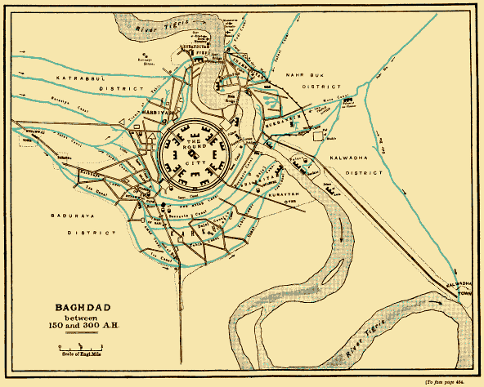

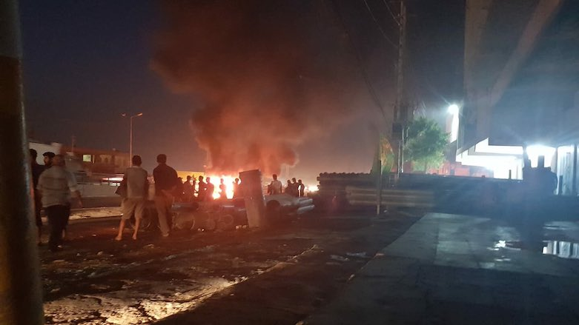

Document Analysis
Prompt: How did the city of Baghdad usher in the Islamic Golden Age?

Scope:
Topic:
HTS:
Re-Written Question:

Document 1

Source: The Abbasids’ House of Wisdom in Baghdad by Subhi Al-Azzawi

The Caliph Haroun Al-Rasheed (who reigned for 23 years from 786-809 CE) built a magnificent Scientific Academy in which was housed a huge bookstore containing manuscripts and books about various subjects in the arts and the sciences and in different languages. In this Academy, translators, scientists, scribes, authors, men of letters, writers, authors, copyists and others used to meet every day for translation, reading, writing, scribing, discourse, dialogue and discussion. Many manuscripts and books in various scientific subjects and philosophical concepts and ideas, and in different languages were translated there. The languages which were spoken, read and written there were Arabic, Farsi, Hebrew, Aramaic, Syriac, Greek and Latin; also occasionally Sanskrit, which was used to translate the old Indian manuscripts in astronomy and mathematics. In addition to the Library of the House of Wisdom, there were many other Baghdadi Libraries attached to the many Faith Schools, each containing thousands of books and manuscripts. There were also private individual libraries, which were not open to the general public, but were available to scientists, philosophers, researchers and writers.
Significance: How did the city of Baghdad usher in the “Islamic Golden Age”?

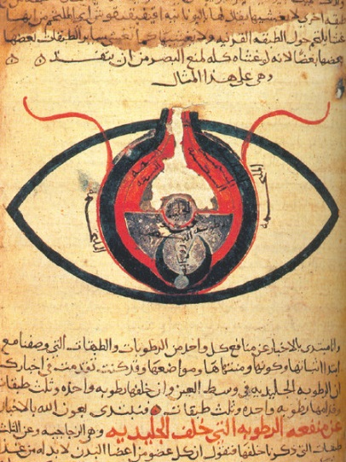
Document 2
Source: The eye, according to Hunain ibn Ishaq, a scholar, physician, and scientist of the Abbasid Empire. This depiction of the eye is the first to note that the human eye has multiple layers, with notes including where light enters and exits the eye. From a medical journal dated circa 1200.

Significance: How did the city of Baghdad usher in the “Islamic Golden Age”?

Document 3
Source: Baghdad “the city of the Arabian Nights” was in its prime about 800 CE., during the reign of the famous caliph Harun-al-Rashid. What this city - which represented the crown of Medieval Muslim civilization - resembled, is told by an author and historian named Yakut, who saw Baghdad in its glory.
The city of Baghdad formed two vast semi-circles on the right and left banks of the Tigris, twelve miles in diameter. The numerous suburbs, covered with parks, gardens, villas and beautiful promenades, and plentifully supplied with rich bazaars, and finely built mosques and baths, stretched for a considerable distance on both sides of the river. In the days of its prosperity the population of Baghdad and its suburbs amounted to over two millions! Immense streets, none less than forty cubits wide, traversed the city from one end to the other, dividing it into blocks or quarters, each under the control of an overseer or supervisor, who looked after the cleanliness, sanitation and the comfort of the inhabitants. The water exits both on the north and the south were like the city gates, guarded night and day by relays of soldiers stationed on the watch towers on both sides of the river. Every household was plentifully supplied with water at all seasons by the numerous aqueducts which intersected the town; and the streets, gardens and parks were regularly swept and watered, and no refuse was allowed to remain within the walls. An immense square in front of the imperial palace was used for reviews, military inspections, tournaments and races; at night the square and the streets were lighted by lamps.
Baghdad was a veritable City of Palaces, not made of stucco and mortar, but of marble. The buildings were usually of several stories. The palaces and mansions were lavishly gilded and decorated, and hung with beautiful tapestry and hangings of brocade or silk. The rooms were lightly and tastefully furnished with luxurious divans, costly tables, unique Chinese vases and gold and silver ornaments. The mosques of the city were at once vast in size and remarkably beautiful. There were also in Baghdad numerous colleges of learning, hospitals, infirmaries for both sexes, and lunatic asylums.

Document 4
Source: Source: One Thousand and One Nights (also known as Arabian Nights), a collection of folk-tales from the Middle East and Northern Africa, arranged and published in the Abbasid Empire

IT IS RELATED, O auspicious King, that there was a merchant of the merchants who had much wealth, and business in various cities. Now on a day he mounted horse and went forth to recover monies in certain towns, and the heat sore oppressed him; so he sat beneath a tree and, putting his hand into his saddle bags, took thence some broken bread and dry dates and began to break his fast. When he had ended eating the dates he threw away the stones with force and lo! an Ifrit [1] appeared, huge of stature and brandishing a drawn sword, wherewith he approached the merchant and said, “Stand up that I may slay thee, even as thou slewest my son!” Asked the merchant, “How have I slain thy son?” and he answered, “When thou atest dates and threwest away the stones they struck my son full in the breast as he was walking by, so that he died forthwith. Quoth the merchant, “Verily from Allah we proceeded and unto Allah are we returning. There is no Majesty, and there is no Might save in Allah, the Glorious, the Great! If I slew thy son, I slew him by chance medley. I pray thee now pardon me.” Rejoined the Jinni, “There is no help but I must slay thee.” Then he seized him and dragged him along and, casting him to the earth, raised the sword to strike him; whereupon the merchant wept, and said, “I commit my case to Allah.”

[1] Ifrit: An Arabian mystical creature made of fire

Document 5

Source: The mihrab [2] of a mosque in Baghdad, Abbasid Empire

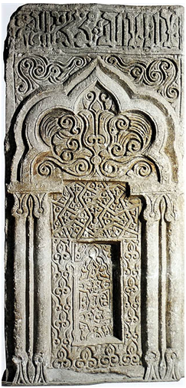
During this golden age [under the Abbasid], a distinctive style emerged and new techniques were developed that spread throughout the Muslim realm and greatly influenced Islamic art and architecture. A new way of carving surfaces, the so-called beveled style, as well as a repetition of abstract geometric forms, later to be known to the West as “arabesque,” was widely used as wall decoration and other media.

[2] Mihrab- a semicircular niche in the wall of a mosque that indicates the direction of Mecca and hence the direction that Muslims should face when praying

Significance: How did the city of Baghdad usher in the “Islamic Golden Age”?

Exit Ticket

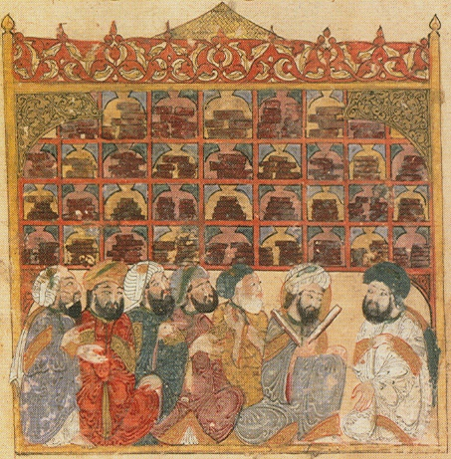
Directions: Answer parts A and B.

Source: Depiction of the House of Wisdom- Baghdad circa 800 CE

- Identify and explain two historical claims about the Abbasid Caliphate that are supported by this image.
- Explain one limitation of the image as a source of information about the Abbasid Caliphate.

________________________________________________

________________________________________________

________________________________________________

___________________________________________________________________________________________

___________________________________________________________________________________________

___________________________________________________________________________________________

___________________________________________________________________________________________

___________________________________________________________________________________________

___________________________________________________________________________________________

___________________________________________________________________________________________

___________________________________________________________________________________________

___________________________________________________________________________________________

___________________________________________________________________________________________

___________________________________________________________________________________________

___________________________________________________________________________________________

___________________________________________________________________________________________

___________________________________________________________________________________________

___________________________________________________________________________________________

___________________________________________________________________________________________

___________________________________________________________________________________________

___________________________________________________________________________________________

___________________________________________________________________________________________

___________________________________________________________________________________________

___________________________________________________________________________________________

___________________________________________________________________________________________

___________________________________________________________________________________________

___________________________________________________________________________________________

___________________________________________________________________________________________

___________________________________________________________________________________________

___________________________________________________________________________________________

___________________________________________________________________________________________

___________________________________________________________________________________________

___________________________________________________________________________________________

___________________________________________________________________________________________

___________________________________________________________________________________________

___________________________________________________________________________________________

___________________________________________________________________________________________

___________________________________________________________________________________________

___________________________________________________________________________________________

___________________________________________________________________________________________

___________________________________________________________________________________________

___________________________________________________________________________________________
Homework
Directions: Please read and annotate the reading below by Robert Strayer. Then, answer the questions that follow in complete sentences.
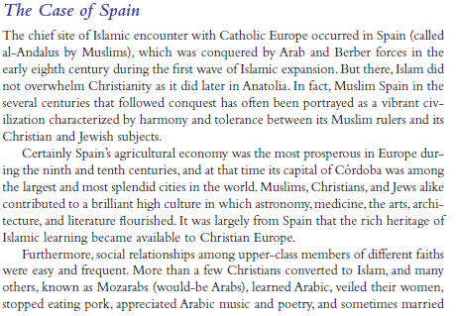
**
**
**
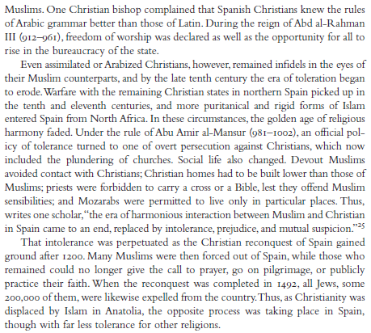
*

**1. What AP Region is Al-Andalus in?

**2. What contributions did Muslims make in Al-Andalus?

**3. Describe the relationships between Christians, Muslims, and Christians in Al-Andalus. What explains the nature of this relationship?

*4. How were Christians and Jews treated in Al-Andalus?

5. What was the end result of this treatment of Christians and Jews?

