Welcome to Class! Do Now Please!
Questions/Concerns

**1. Define Feudalism.

**2. What caused the development of Feudalism in the Post-Classical era?

3. The serfs in Feudalism can BEST be described as

a) Relatively wealthy compared to the classical era
b) Bound to the land and forced to work agriculture
c) Have freedom to try different jobs
d) Christian Monks that gave up wealth

4. What role did the Church play in Feudalism?

- What changes existed between Rome and Constantinople?

- What continuities existed?

Document Analysis
Prompt: Analyze the continuities and changes between the Roman and Byzantine Empires in the Classical and Post-Classical Eras.

Scope:
Topic:
HTS:
Re-Written Question:

Source: Stayer Ways of the World second edition, 2011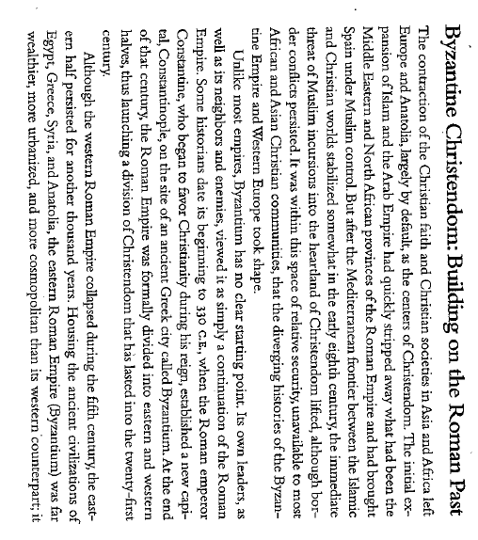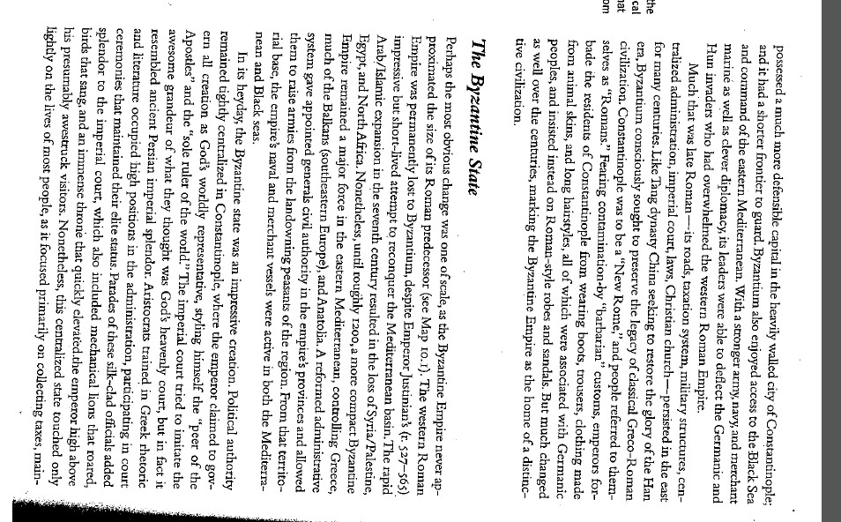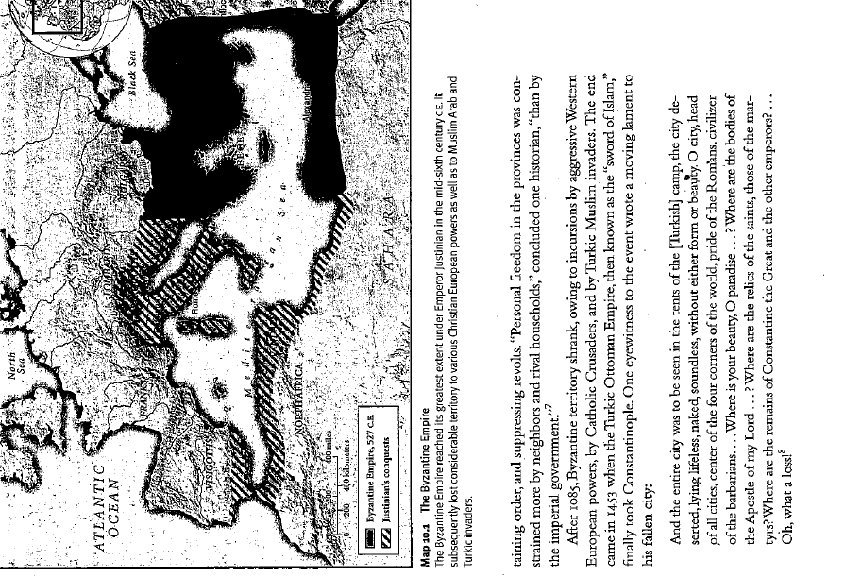
**
**
**
**
**
**

Exit Ticket
- Identify and explain TWO continutities between Rome and the Byzantine Empire.
- Identify and explain ONE change between Rome and the Byzantine Empire
___________________________________________________________________________________________

___________________________________________________________________________________________

___________________________________________________________________________________________

___________________________________________________________________________________________

___________________________________________________________________________________________

___________________________________________________________________________________________

___________________________________________________________________________________________

___________________________________________________________________________________________

___________________________________________________________________________________________

___________________________________________________________________________________________

___________________________________________________________________________________________

___________________________________________________________________________________________

___________________________________________________________________________________________

___________________________________________________________________________________________

___________________________________________________________________________________________

___________________________________________________________________________________________

___________________________________________________________________________________________

___________________________________________________________________________________________

___________________________________________________________________________________________

___________________________________________________________________________________________

___________________________________________________________________________________________

___________________________________________________________________________________________

___________________________________________________________________________________________

___________________________________________________________________________________________

___________________________________________________________________________________________

___________________________________________________________________________________________

___________________________________________________________________________________________

___________________________________________________________________________________________

___________________________________________________________________________________________

___________________________________________________________________________________________

___________________________________________________________________________________________

___________________________________________________________________________________________

___________________________________________________________________________________________

___________________________________________________________________________________________

___________________________________________________________________________________________

___________________________________________________________________________________________

___________________________________________________________________________________________

___________________________________________________________________________________________

___________________________________________________________________________________________

___________________________________________________________________________________________

___________________________________________________________________________________________

___________________________________________________________________________________________

___________________________________________________________________________________________

___________________________________________________________________________________________

___________________________________________________________________________________________

___________________________________________________________________________________________

___________________________________________________________________________________________

