Welcome to Class! Do Now Please!
Questions/Concerns

**1. What led to the split of the Christian church?

**2. Who is the leader of the Roman Catholic church?

**3. Who is the leader of the Eastern Orthodox church?

**4. What role did the Roman Catholic church play in Western Europe during the Post-Classical Era?

What events in Western Europe led to the start of the Crusades?

How many Crusades were there total?

What were the effects of the Crusades?

Teacher Model: POV
Key Ideas and Questions:

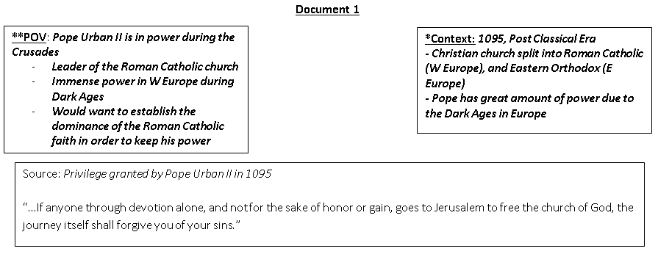

Document 2
Source: Alexius Comnenus, the Byzantine Emperor, was concerned about the Muslim Turks who had conquered the land of Israel. He wrote a letter to several leaders in Western Europe in 1091 CE requesting their assistance.

I am writing to inform Your majesty that the very saintly empire of the Greek Christians is daily being persecuted by Muslims... The blood of Christians flows in unheard-of scenes of carnage amidst the most shameful insults ... I shall merely describe a few of them – The Arabs committing crimes towards all ages and rank, defacing of holy places, for example.

Therefore in the name of God and because of the true holiness of the Greek Christians, we ask you to bring to this city all the faithful soldiers of Christ...Bring me aid and bring aid to the Greek Christians. Come then with all your people and give battle with all your strength so that all this treasure shall not fall into the hands of the Turks. Therefore, act while there is still time, otherwise the kingdom of Christians shall vanish from your sight and the Holy Sepulchre [Jesus’ tomb] shall vanish.
By coming, you will find your reward in heaven and, if you do not come, God will condemn you. Remember that you will find all those treasures and also the most beautiful women of the East. The incomparable beauty of the Greek women would seem to be a sufficient reason to attract the armies of the Franks to our land”

Teacher Model: Purpose
Key Ideas and Questions:

Document 1

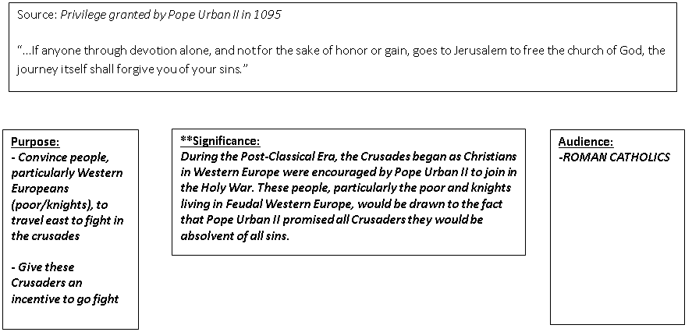

Exit Ticket

Document 3
Source: The Pope was moved by the letter and made a speech to his followers at the Council of Clermont on November 27, 1095 CE asking them to help the Byzantines.

“For you must hasten to carry aid to your brethren dwelling in the East, who need your help, which they have often asked. For the Turks, a Persian people, have attacked them...I insist with prayer--not I, but God--that, as believers of Christ, you urge men by frequent rallying, men of all ranks, knights as well as foot soldiers, rich as well as poor, to hasten to exterminate this vile race from the lands of your brethren...Christ commands it. And if those who set out should lose their lives on the way by land, or in crossing the sea, or in fighting the pagans, their sins shall be taken away...Oh what a disgrace, if a race so despised, using the instrument of demons, should so overcome a people endowed with faith in the all-powerful God, and magnificent with the name of Christ... Let those who for a long time have been robbers now become soldiers of Christ. Let those who once fought against brothers and relatives now fight against these barbarians...let them passionately undertake the journey under the guidance of the Lord.”

Homework
Directions: Please read and annotate the reading below. Then, complete the SPICE chart with 3-5 detailed bullet points per SPICE theme.
The Crusades, Even Now By KAREN ARMSTRONG
**When Pope Urban II summoned the knights of Europe to take part in the First Crusade in November 1095, he could not have imagined the enduring effects of his enterprise. The Pope hoped that a crusade would bring peace to war-torn Europe and enhance the power of the Western Church. Instead of fighting one another in pointless feudal wars, the Pope believed, the knights should join forces, go to the aid of the Greek Orthodox Christians of Byzantium, liberate territory in Anatolia recently conquered by the Islamic Turks and, finally, march to Jerusalem to rescue Christ's tomb from the infidels.
The Pope envisioned a conventional military campaign but found to his astonishment that he had launched a mass movement. This Crusade was the first cooperative act of the new Europe as it struggled back onto the international scene. For the next 200 years, crusading became the major political passion of the West. Long before the rise of nationalism, thousands of men and women from different countries and all classes of society marched 3,000 miles to defend the Holy Land, which they considered to be their shared patria. These soldiers of Christ established European colonies in the Middle East and began to dream of world domination.
But Crusading was expensive and dangerous. In the early campaigns, most Crusaders died, victims of starvation and disease on the journey. Many survivors returned penniless, for knights often mortgaged their lands at home in order to equip their armies. Crusading's rewards were always more spiritual than financial; it was a genuine religious passion. Crusaders sewed crosses to their clothes and believed that they were literally following in Jesus' footsteps in the land where he had lived and carried his cross to his death. They regarded their Crusade as an act of the love of God.
**That's not to say that Crusading did not have its dark side as well. One of the first armies to leave Germany for Jerusalem attacked all of the Jewish communities along the Rhine Valley in 1096, the first of many pogroms inspired by the Crusades. To these Christian soldiers it seemed absurd to march 3,000 miles to fight Muslims when the people who had actually killed Christ (or so the Crusaders believed) were alive and well on their very doorstep. As Western Christians invented a new identity for themselves, Jews became the demonic "other." The "blood libel" -- the belief that Jews used the blood of Christian children to make matzoh at Passover -- first surfaced in England in 1191, when Richard Lion-Heart took the cross and prepared to lead the Third Crusade. The image of the Jew as the child-slayer revealed an almost Oedipal Christian fear of the parent faith. When Hitler started his modern crusade against European Jewry, the ground had been prepared by a millennium of Christian anti-Semitism.
**Crusading also made Islam the ideological enemy of the West. When the first Crusaders captured Jerusalem in July 1099, they slaughtered some 30,000 of the city's Jewish and Muslim inhabitants in two days. At the Haram al-Sharif, the third holiest place in the Islamic world, an exultant witness reported that the blood reached the horses' knees. The massacre shocked many Europeans, but within a few years scholarly monks began describing Muslims as a "savage race 1/2. 1/2. 1/2. 1/2 fit only for extermination." Like Jews, Muslims became the shadow self of the new Europe, a projection of the buried fears and worries that the Christians had regarding their own identity and behavior.
**The Crusades also permanently damaged relations with the Greek Orthodox Church. Western Christians had long resented what they perceived as a superior attitude on the part of the Eastern Christians. That many Crusaders hated their Orthodox brethren more than the Muslims was made disgracefully evident in 1204, when the Fourth Crusade abandoned its assault on the Islamic world and turned its venom instead on the Christian city of Constantinople -- an attack the Eastern Christians have never forgiven.
Despite their violence and destructiveness, the Crusades helped to shape some of the more positive enthusiasms of the Age of Faith. Many of the stories and legends of the courtly-love tradition -- along with the peculiar Western conception of romantic love as a hopelessly unhappy happiness -- grew out of the Crusades. Both were inspired by the love of distant objects: a remote lady and a far-off land.
**While the Crusaders failed to permanently recapture the Holy Land, they gained much from their encounter with the Islamic world. In the lands the Crusaders had taken, the local Arabs civilized the European settlers: they taught them to take baths and to accord greater rights to women. The Arabs also taught the Crusaders how to process sugar from the cane, and provided European merchants with a vast array of luxury goods to ship home: silk, linen, flax, samite (a heavy silk fabric), balm and the dye Tyrian purple. The number of Arabic words introduced into English at this time attests to the extent of this cross-cultural pollination: "orange," "lemon," "alfalfa," "cube," "alchemy," "alkali," "algebra," "alembic," "amalgam," "tariff," "soda," "admiral," "checkmate."

**Social
**Political
Interactions with the Environment
**Cultural
*Economic

