Welcome to Class! Do Now Please!
Questions/Concerns:
Directions: Using your HW from last night, please answer the questions below.

**1. Where were the first 3 civilizations located?
____________________________________________________________________________________
2. Identify the date of emergence for each of the following civilizations:

Middle East: ________ BCE
Nile River valley: ________ BCE
Coastal Peru: ________ BCE
Indus river/Saraswati River valleys: ________ BCE
China: ________ BCE
Olmec: ________ BCE

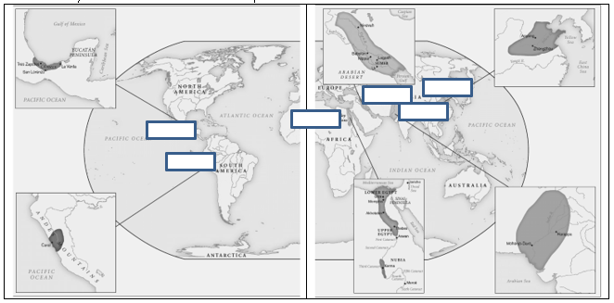
**3. Identify the first civilizations on the map below:

Classical China: The Essentials

2.1.A: Transition from a feudal to a centralized state under the Qin Dynasty

Under emperor Shihuangdi, the Qin established the first centralized imperial state in China (221–210 BCE). The Qin unified warring and fragmented feudal states into a single centralized empire through both conquest and forceful diplomacy. During the Warring States period, the use of bronze weapons declined in favor of relatively cheap iron weapons. There was also a transition in warfare from skilled aristocratic chariots to large infantries; this weakened the power of aristocrats who could afford expensive chariots. As articulated in Sun Tzu’s The Art of War (c. 500 BCE), battlefield strategies and management of military resources was what increasingly decided battles, not the skills of elite warriors. The Qin armies also deftly utilized iron weapons. The Qin state maintained unified political authority by creating and implementing harsh, authoritarian law codes informed by Legalism. The peasantry under the Qin were mostly free and paid taxes in the form of a military levy. The Qin also supported imperial unity through standardizing and simplifying the writing of Chinese as well as weights and measures. The Qin Dynasty was highly centralized and organized into 40 provinces, each with numerous local administrative districts overseen by a governor directly appointed by the emperor.

2.1.B: Political and philosophical expansion of the Han Dynasty

The Han Dynasty established a centralized empire that built upon Qin bureaucratic structures and traditions and at its height employed close to 20 times more people than the Roman Empire. Han emperors abandoned the authoritarian principles of Legalism and instead associated themselves with Confucianism. Confucianism became closely associated with the Chinese state and its governing class of imperial appointees, which established the model of rule by scholar-bureaucrats. This system rewarded merit as opposed to aristocratic lineage. Large armies expanded the Han Dynasty’s territorial borders significantly beyond those of the Qin. At its height, the Han Dynasty stretched to Vietnam in the south, Korea in the north, and Central Asia to the west. Chinese merchants and peasants followed state expansion: between five and 10 million Chinese peasants settled in the Yangtze Valley during the Han Dynasty. Han imperial expansion and migration promoted sinicization (bringing people who are not of Chinese descent under the influence of Chinese culture) and a more uniform style of cultural practices throughout East Asia.

2.1.C: Economic and religious foundations of the Han Dynasty

China commanded the largest and most innovative economy in the world during the Classical Period. Free peasants in many cases owned land and produced agricultural goods for local markets. Wheat and rice farmers used iron tools and new inventions including the wheelbarrow, seed drill, and cast-iron plow. Silk, porcelain, paper, cast-iron commodities, and other sophisticated handicraft were produced mostly by free laborers. The quality and portability of these goods made them ideal for long-distance trade. During the Han Dynasty, significant urbanization took place in response to local expansions of commerce and consumer demand and the long-distance trade along the Silk Roads. The principle religion of the Han was Daoism, which emanated from complex ideas and practices. Daoist traditions relating to detachment and meditation would eventually ease the transition to Buddhism in China. There was often a commingling by practitioners of Confucianism, the predominant social philosophy in Han China, with Daoism.

You Do: Improving Sentences
Reminders/Steps:
- Examine the sentence
- Note the Gaps- write in question form
- Re-read the essentials (note the paragraph #!) and take detailed notes
- Revise sentence, including details from notes
- Create follow up questions- these spark additional research

Steps | Notes
- Examine the Sentence | They made one government out of many through fights and laws based on ideas.
- Note the Gaps
- Read the Essentials (2.1.A- Transition) and Record Notes
- Revise the Sentence
- Create Follow Up Questions

Steps | Notes
- Examine the Sentence | They made an even bigger one that used the same system but different ideas.
- Note the Gaps
- Read the Essentials (2.1.B- Pol/Phil. Expansion) and Record Notes
- Revise the Sentence
- Create Follow Up Questions

Steps | Notes
- Examine the Sentence | Two key beliefs, new ideas, free folks, and money made over a long distance made the Han what it was.
- Note the Gaps
- Read the Essentials (2.1.C- Econ/Rel Foundation) and Record Notes
- Revise the Sentence
- Create Follow Up Questions

Exit Ticket – The Story of Classical China

Warring States Period  - Following the collapse of the Zhou dynasty, various states competed for control of China  - Instability led to the rise of 3 philosophies to bring order to China: Daoism, Legalism, Confucianism. |  | **Unification Under the Qin |  | Rise of the Han
**Han Political Philosophy |  | **Han Economy and Religion |  | Collapse of the Han  - Large landowners established private armies and refused to pay taxes  - Peasants rebelled against the government  - Nomadic invasions from Central Asia took territory from the Han government  - China fragmented into multiple competing states for 400 years.

Homework
Directions: Take Cornell Notes on the reading below. Your Cornell Notebook should be brought to class on Wednesday to be graded.

China in the Ancient Era

As one of the First Civilizations, a Chinese state had emerged as early as 2200 B.C.E. and under the Xia, Shang, and Zhou dynasties had grown progressively larger, but by 500 B.C.E. this Chinese state was in shambles. Any earlier unity vanished in an age of warring states, featuring the endless rivalries of seven competing kingdoms.

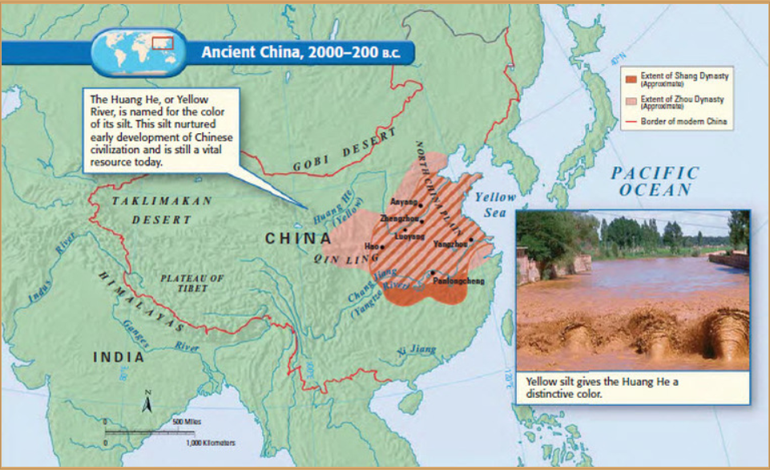

In China, a much older tradition had long linked events on earth with affairs in heaven. In this conception, heaven was neither a place nor a supreme being, but rather an impersonal moral force that regulated the universe. Emperors were called the Son of Heaven and were said to govern by the Mandate of Heaven so long as they ruled morally and with benevolence. Peasant rebellions, “barbarian” invasions, or disastrous floods were viewed as signs that the emperor had ruled badly and thus had lost the Mandate of Heaven. Among the chief duties of the emperor was the performance of various rituals thought to maintain the appropriate relationship between heaven and earth. What moral government meant in practice was spelled out in the writings of Confucius and his followers, which became the official ideology of the empire.

Unification by the Qin

To many Chinese, this was a wholly unnatural and unacceptable condition, and rulers in various states vied to reunify China. One of them, known to history as Qin Shihuangdi (i.e., Shihuangdi from the state of Qin), succeeded brilliantly. The state of Qin had already developed an effective bureaucracy, had subordinated its aristocracy, had equipped its army with iron weapons, and enjoyed rapidly rising agricultural output and a growing population. It also had adopted a political philosophy called Legalism, which advocated clear rules and harsh punishments as a means of enforcing the authority of the state. With these resources, Shihuangdi (ruled 221–210 B.C.E.) launched a military campaign to reunify China and in just ten years soundly defeated the other warring states. Believing that he had created a universal and eternal empire, he grandly named himself Shihuangdi, which means the “first emperor.” Unlike Augustus, he showed little ambivalence about empire. Subsequent conquests extended China’s boundaries far to the south into the northern part of Vietnam, to the northeast into Korea, and to the northwest, where the Chinese pushed back the nomadic pastoral people of the steppes. Although the boundaries fluctuated over time, Shihuangdi laid the foundations for a unified Chinese state, which has endured, with periodic interruptions, to the present.

China’s Classical Era Investments

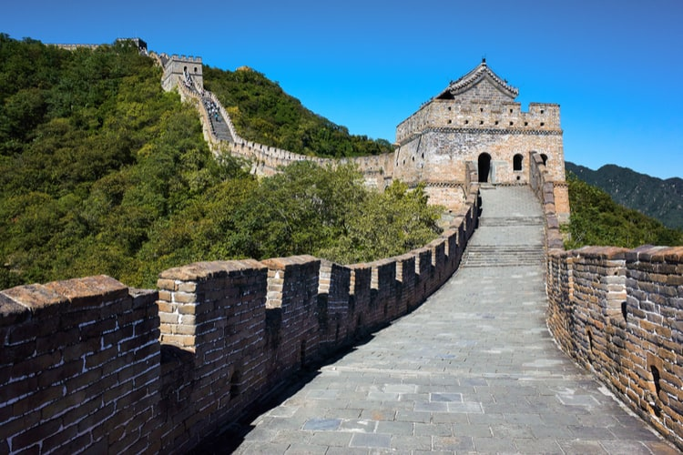
Building on earlier precedents, the Chinese process of empire formation was far more compressed than the centuries-long Roman effort, but it was no less dependent on military force and no less brutal. Scholars who opposed Shihuangdi’s policies were executed and their books burned. Aristocrats who might oppose his centralizing policies were moved physically to the capital. Hundreds of thousands of laborers were recruited to construct the Great Wall of China, designed to keep out northern “barbarians,” and to erect a monumental mausoleum as the emperor’s final resting place. More positively, Shihuangdi imposed a uniform system of weights, measures, and currency and standardized the length of axles for carts and the written form of the Chinese language.

Chinese authorities invested heavily in public works—roads, bridges, aqueducts, canals, protective walls—all designed to integrate their respective domains militarily and commercially. Furthermore, they invoked supernatural sanctions to support their rule.

Qin Collapse

The speed and brutality of Shihuangdi’s policies ensured that his own Qin dynasty did not last long, and it collapsed unmourned in 206 B.C.E.The Han dynasty that followed (206 B.C.E.–220 C.E.) retained the centralized features of Shihuangdi’s creation, although it moderated the harshness of his policies, adopting a milder and moralistic Confucianism in place of Legalism as the governing philosophy of the states. It was Han dynasty rulers who consolidated China’s imperial state and established the political patterns that lasted into the twentieth century.

