Welcome to Class! Do Now Please!
Questions/Concerns

**1) What is the Capital of the Byzantine Empire?

**2) Why did Constantine move the Capital?

**3) Analyze the similarities and difference between Islam and Christianity.

QUESTION | ANSWER
- What factors lead to the split of the Christian Church? | 7. How did Islam influence the Chola Kingdom?
- What Factors lead to the Sunni Shia split? | 8. how did Islam influence the Delhi Sultanate?
3. What is one factor that led to the spread of Islam? | 9. What is the Justinian Code?
- What is Feudalism? | 10. Who are the Dhimmi?
5. What led to the creation of Feudalism? | 11. Why does the influence of Islam differ between East and West Africa?
6. What is a continuation between Rome and the Byzantine Empire?

Document Analysis
Prompt: Analyze the similarities and differences between Constantinople and Baghdad.
Scope:
Topic:
HTS:
Re-Written Question:

HARUN AL-RASHID’S BAGHDAD
PART 1:
P1
**Following the decline of the Umayyad Caliphate in 750, the center of the Islamic world gravitated to Iraq with the rise of Abu al-Abbas, the founder of the new Abbasid caliphate, and soon the Abbasid dynasty established a new capital in Baghdad. The zenith of the Abbasid caliphate and the Arab "Golden Age" came with the ascendancy of Mansur's grandson, Harun Al Rashid, the famous caliph of the 1001 Arabian Nights. Baghdad was the largest city in the world in the 9th century.
P2
**Al-Rashid's Baghdad is perhaps best known for the wealth and luxurious lifestyles of its inhabitants. As a commercial center, it was unsurpassed for its time. Ships from all over the world brought their rich cargoes to the Persian Gulf and up the Tigris River to Baghdad. Silks and porcelain from China, spices and precious metals from India, and ivory, gold dust, and black slaves from Africa were shipped to Baghdad by sea. Caravans brought jewels overland from Turkey, pearls from Arabia, and furs and white slaves from Scandinavia and Russia. Taxes in the form of money or goods flowed into the capital from all the provinces of the empire, and wealthy merchants developed trade networks on land and sea linking the commercial centers of Europe, Asia, and Africa. The Middle East, because of its geographical position, became the center of world trade.
P3
As a result, the ruling classes were able to live on a scale that the world had rarely seen before. Al-Rashid’s wife, Zubeidah, who set the fashions of the city, wore jewel-studded shoes and had workmen design and construct a tree of mechanical chirping birds made of pure gold. Moreover, luxurious living was not confined to the ruling classes. With Baghdad and the Middle East as the center of world trade, a new and wealthy middle class of artisans, merchants, and professionals arose, whose services commanded high salaries. Indeed, the economic boom affected all classes, and few lives were left untouched.

Significance:

BAGHDAD AS AN INTELLECTUAL CAPITAL
P4
**Although wealth was perhaps the most spectacular aspect of al-Rashid’s Baghdad, its cultural and scientific achievements were more significant. Al-Rashid wanted Baghdad to be the center of learning, and to this end he invited famous poets and scholars from all over the Middle East, including Turks and Persians as well as Arabs, to come to Baghdad to work and live at the Bayt al-Hikma, or House of Wisdom, a research center supported by the caliph.
**The intellectual ferment began with the translation of books from all over the world into Arabic. One of these books was an Indian text on astronomy and the Indian system of numbers. Borrowed by the Arabs, this system has in turn been adopted by the Western world and is used in the West today. What we know as Arabic numerals, the decimal system, and the use of the number zero have come to us by way of al-Rashid’s Baghdad. A large number of Greek texts were also translated, including the works of Aristotle and Plato as well as works on medicine, mathematics, and astronomy, the medical works of Hippocrates, and Euclid's Elements of Geometry were among the books translated with the help of Syrian Christians who could read both Greek and Arabic. Much of Greek learning that otherwise might well have disappeared was thus saved for the world.
P5
Original research in the field of medicine included the dissection of apes by the Christian physician, Yuhanna, and the production of a ten-volume treatise on the eye by his student, Hunayn. There were many famous practicing physicians as well, such as al-Razi, who wrote books on smallpox and measles as well as his most famous work, an encyclopedia that catalogued all Greek, Hindu, and Persian medical knowledge as well as the results of his own medical research. An equally famous physician, lbn Sina (Avicenna), codified all Greek and Arabic medical knowledge into a volume that became the standard medical textbook in the Arab world and in Europe for the next eight hundred years. The first pharmacies date from this period, during which there were more than nine hundred registered pharmacists in Baghdad.
P6
**Original scientific research was also conducted in the field of astronomy. Because of their desert tradition and Bedouin tribal roots in Arabia, the Arabs had always been interested in the stars. With the translation of Ptolemy's astronomical works, interest in astronomy increased, leading to the construction of an observatory in Baghdad that was to calculate accurately the length of the solar year. Other astronomers studied the moon's influence on the tides, and corrected errors in Ptolemy's observations of the orbit of the moon and planets. A mathematician, al-Khwarizmi, designed the first set of astronomical tables in Arabic and wrote a book on algebra that was widely used in Europe and thus introduced the word algebra into English. Other original research was done in the fields of chemistry, zoology, music, and philosophy.
P8
P7
**The Muslims of Harun al-Rashid’s Baghdad almost single-handedly created the science of chemistry. They were able to distinguish between acids and alkalis, produce many drugs, and were convinced that all metals were made of the same basic substance, and could, therefore, be transformed into other metals or alloys. They also invented many of the laboratory equipment used in the chemistry and biology labs today: the pipette, beakers, and glass test tubes.

Significance:

PART 3: Muslims and the Arts
**The Arabs made important contributions to literature as well. Arabs have always had the special gift of storytelling and poetry. The Arabic language itself is suited to colorful tales about life in the desert or palace. Hundreds of poets created poems of great beauty. The one most known in the West was the 1001 Arabian Nights, based on the glory and splendor of Baghdad, and include such famous characters as Aladdin, Sinbad, and Ali Baba. Poets were held in high regard; music developed and combined with poetry to provide the Muslim with tales of love, war, and heroism.
P9
P10
In art, the two fields in which the Arabs excelled were architecture and the decorative arts. Beautiful mosques were built with spacious interiors, large domes, great pillars and arches to provide Muslims with a dignified place in which to pray. Besides the mosques, the Muslims built large palaces. Beautiful patterns from flowers and geometric figures were used to decorate the interior of mosques and palaces. Skilled craftsmen produced rugs, pottery, tiles, and metalwork of original and delicate designs.
**Learning in Baghdad was not confined to the scholarly work of the elite. There were elementary schools for both boys and girls. Theological colleges were established for the advanced study of Islam and became the models for the modern university. There were public as well as private libraries, and many bookstalls were to be found on the streets of Baghdad.
P11

Significance:

Exit Ticket

**1. Analyze the similarities and differences between Constantinople and Baghdad. Ensure that your response includes:

- Specific Similarity
- Specific Difference
- Argument-Why similarity or difference occurs

___________________________________________________________________________________________
___________________________________________________________________________________________
___________________________________________________________________________________________
___________________________________________________________________________________________
___________________________________________________________________________________________
___________________________________________________________________________________________
___________________________________________________________________________________________
___________________________________________________________________________________________
___________________________________________________________________________________________
___________________________________________________________________________________________
___________________________________________________________________________________________
___________________________________________________________________________________________
___________________________________________________________________________________________
___________________________________________________________________________________________
___________________________________________________________________________________________
___________________________________________________________________________________________
___________________________________________________________________________________________
___________________________________________________________________________________________
___________________________________________________________________________________________
___________________________________________________________________________________________

Homework
Directions: Please read and annotate the text below. Then, answer the questions that follow in complete sentences.
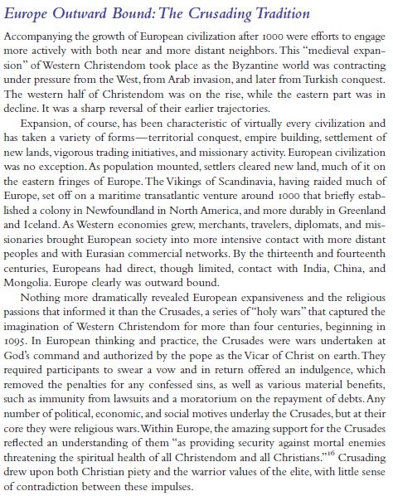
**
**
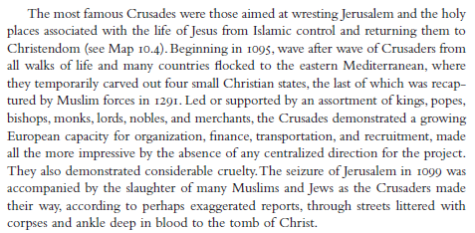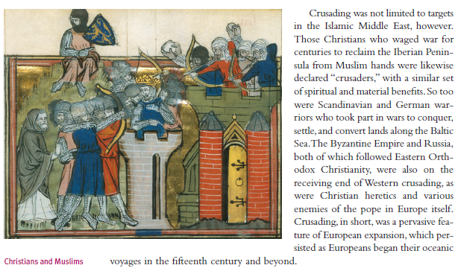
**
**1. Why were the Crusades started? Which city were the majority of these wars fought in?

**2. How were Christians convinced to fight in the crusades?

3. Where else did Crusades take place in this era?

