Welcome to Class! Do Now Please!
Questions/Concerns:
**1. What are the similarities between Islam and Christianity?

**2. What are the differences between Islam and Christianity?

LEQ Essay Structure
On the APWH and APUSH exams, there are two essay types- the DBQ, which you’ve already written this school year, and the LEQ, or long-essay question. On an LEQ essay, you are required to use your prior knowledge as evidence. The structure below is for a comparative LEQ Essay.
**1. What should your comparative thesis statement sound like?

**2. How many pieces of evidence do you need in each body paragraph?

**3. Where do you get your evidence in an LEQ Essay?

**4. How many pieces of analysis do you need in each body paragraph?

Teacher Model – Comparative Thesis Statements

Key Ideas/Questions

Analyze the similarities and differences between Islam and Judaism.

Scope: Ancient and Post-Classical Era, Middle East
Topic: Sim/diff between Islam and Judaism
HTS: Comparison
Re-Write: How are Islam and Judaism similar and different?

Similarities  - Monotheistic  - Believe Abraham was the first prophet  - Religious significance in the city of Jerusalem  - Believe in fasting  - Do not eat shellfish or pork | Differences  - Islam = Jesus is a prophet, Judaism = Jesus is a false prophet  - Islam = Give 2.5% for alms, Judaism = no specific amount, only obligation to help  - Islam = fast during month of Ramadan, Judaism = fast one day during Yom Kippur

Both (similarities). However, (differences).

Both Islam and Judaism are monotheistic faiths and do not believe in eating shellfish or pork. However, while Islam believes Jesus was a prophet, Judaism does not. In addition, while Islam believes in giving 2.5% of income for alms, Judaism only believes in an obligation to help the poor without a specific monetary amount.

√ Thesis is clear (gives the reader an idea of what the body paragraphs will be about)
√ Thesis uses the sentence stem provided
√ Thesis includes two accurate similarities
√ Thesis includes two accurate differences

Independent Practice
Directions: Using the teacher model, please break down the prompt below, brainstorm your evidence, and write a thesis statement.
Analyze the similarities and differences between Islam and Christianity.

Scope:
Topic:
HTS:
Re-Write:

Similarities | Differences

Thesis: _____________________________________________________________________________________

___________________________________________________________________________________________

___________________________________________________________________________________________

___________________________________________________________________________________________

___________________________________________________________________________________________

___________________________________________________________________________________________

____Thesis is clear (gives the reader an idea of what the body paragraphs will be about)
____Thesis uses the sentence stem provided
____Thesis includes two accurate similarities
____Thesis includes two accurate differences

Exit Ticket
Directions: Write your revised thesis in the space provided. Then, write your two topic sentences for each body paragraph.

Revised Thesis: _______________________________________________________________________________

___________________________________________________________________________________________

___________________________________________________________________________________________

___________________________________________________________________________________________

___________________________________________________________________________________________

___________________________________________________________________________________________

Topic Sentence #1 (Similarities): _________________________________________________________________

___________________________________________________________________________________________

___________________________________________________________________________________________

___________________________________________________________________________________________

Topic Sentence #2 (Differences): _________________________________________________________________

___________________________________________________________________________________________

___________________________________________________________________________________________

___________________________________________________________________________________________

Homework
Directions: Please read and annotate the text below. Then, answer the questions that follow.
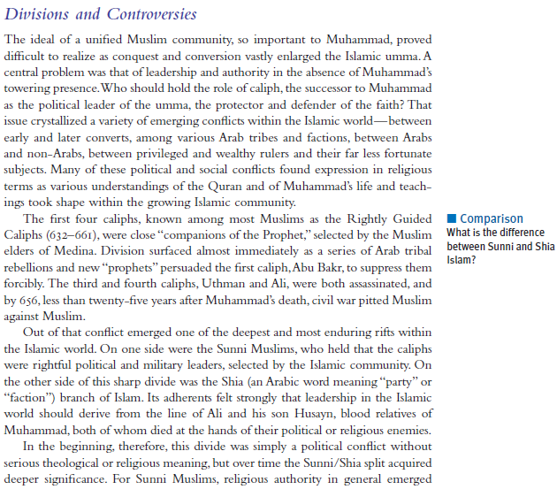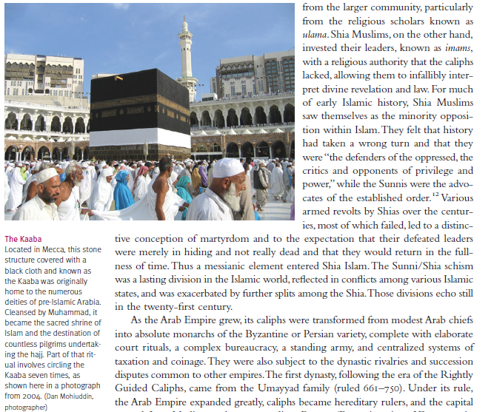
**
**
**
**

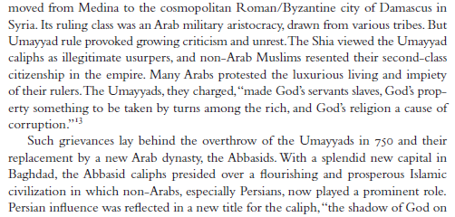
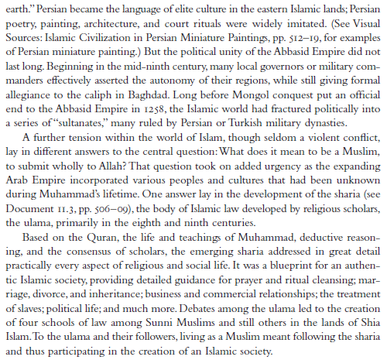
**
**1. What initially caused disagreement within the Islamic community?

**2. Who do Sunnis believe should be the caliph?

**3. Who do Shi’a believe should be the caliph?

4. Where did the Abbasid move their capital?

5. What is the sharia?

