Welcome to Class! Do Now Please!
Questions/Concerns:
**1. How did the Han Dynasty use written language and their government to bring non-Chinese people into their empire effectively?

2. Which Han ruler established the beginnings of the civil service system?
a. Emperor Wen
b. Emperor Wudi
c. Emperor Zhao
d. Emperor Xuan

**3. What was the civil service system?

Document Analysis
Prompt: To what extent were the Qin and Han dynasties similar in Classical China?
Scope :
Topic:
HTS:
Re-Written Question:

OEV

Context

ERA:

PLACE:

TRENDS:

Source 6.7: Excerpts from the Confucian Analects, compiled by followers in the fifth century BCE and widely spread in the Han Empire during the second and third centuries CE, translated by James Legge, 1893.

[1] The Master [Confucius] said, “to rule a country of a thousand chariots, there must be reverent attention to business, and sincerity; economy in expenditure, and love for men; and the employment of the people at the proper seasons.”

[2] Tsze-kung asked about government. The Master said, “The requisites of government are that there be sufficiency of food, sufficiency of military equipment, and the confidence of people in their ruler.” Tsze-kung said, “If it cannot be helped, and one of these must be dispensed with, which of the three should be foregone first?” “The military equipment,” said the Master. Tsze-kung again asked, “If it cannot be helped, and one of the remaining two must be dispensed with, which of them should be foregone?” The Master answered, “Part with the food. From of old, death has been the lot of all men; but if the people have no faith in their rulers, there is no standing for the state.”

[3] Chi K’ang asked Confucius about government, saying, “What do you say to killing the unprincipled for the good of the principled?” Confucius replied, “Sir, in carrying on your government, why should you use killing at all? Let your evinced desires be for what is good, and the people will be good.”

Significance Statement (Complete sentences, answers MIQ):

Source 6.8: Excerpt from Tao Te Ching/Dao de Jing (sacred text of Taoism/Daoism), by Laozi, written in the fourth century BCE, translated by Dwight Goddard in 1919.

[1] Therefore the wise ruler does not suggest unnecessary things, but seeks to satisfy the minds of his people. He seeks to allay appetites but strengthen bones.... If he, himself, practices restraint then everything is in quietness.... In ruling his country, if the wise magistrate loves his people, he can avoid compulsion. In measuring out rewards, the wise magistrate will act like a mother bird. While sharply penetrating into every corner, he may appear to be unsuspecting. He will persuade, but not compel by force.
[2] When great men rule, subjects know little of their existence. Rulers who are less great win the affection and praise of their subjects. A common ruler is feared by his subjects, and an unworthy ruler is despised.... How carefully a wise ruler chooses his words. He performs deeds, and accumulates merit! Under such a ruler the people think they are ruling themselves.

Significance Statement (Complete sentences, answers MIQ):

Observe and Analyze

**1. What do good political leaders try to do according to Confucius and Laozi?

2. Examine how the two passages illustrate the relationship between leaders and their people. To what degree is this a contrast to Legalist ideals?

3. Emperors during the Qin Period were known to ban texts that did not conform to Legalism. Han rulers supported the creation of both Confucian and Taoist schools. How are these actions consistent with the philosophies each dynasty supported?

**4. Use the sources to complete the following sentence stems:

While Legalism ______________________________________________________________________________,

Confucianism ________________________________________________________________________________.

While both Taoism and Confucianism ____________________________________________________________,

only Taoism _________________________________________________________________________________.

Exit Ticket
Directions: Directions: Answer the question below by writing an introductory paragraph that includes:

• Contextual and background information directly related to the topic of the prompt (ERA, PLACE, TRENDS)
• Thesis that fully answers the prompt with specific reasons/sub-claims (Use the sentence stem Both (similarities). However, while __________, ________ (difference)).

Guiding Prompt: To what extent were the Qin and Han dynasties similar in Classical China?

___________________________________________________________________________________________
___________________________________________________________________________________________
___________________________________________________________________________________________
___________________________________________________________________________________________
___________________________________________________________________________________________
___________________________________________________________________________________________
___________________________________________________________________________________________
___________________________________________________________________________________________
___________________________________________________________________________________________
___________________________________________________________________________________________
___________________________________________________________________________________________
___________________________________________________________________________________________
___________________________________________________________________________________________
___________________________________________________________________________________________
___________________________________________________________________________________________
___________________________________________________________________________________________
___________________________________________________________________________________________
___________________________________________________________________________________________
___________________________________________________________________________________________
___________________________________________________________________________________________
___________________________________________________________________________________________

Homework
Directions: Please read and annotate the text and images below, making quality marginal notes as you read. Then, answer the questions that follow.
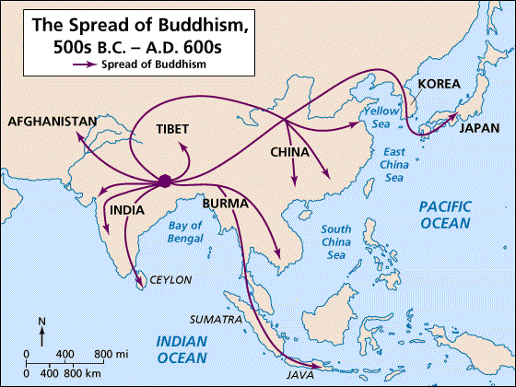
**Buddhism came from India, far beyond the Chinese world. It was introduced to China by Central Asian traders and received little support from Han dynasty rulers. In fact, the religion spread only modestly among Chinese until after the Han dynasty collapsed (220 C.E.), when it appealed to people who felt bewildered by the loss of a predictable and stable society. Not until the Sui dynasty emperor Wendi (581–604 C.E.) reunified China did the new religion gain state support, and then only temporarily. Buddhism thus became one of several alternative cultural traditions in a complex Chinese mix.

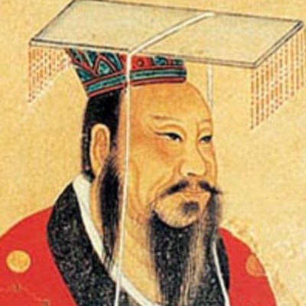
The Chinese empire grew out of a large cultural heartland, already ethnically Chinese. Furthermore, as the Chinese state expanded, especially to the south, it actively assimilated the non-Chinese or “barbarian” people. In short, they became Chinese, culturally, linguistically, through intermarriage, and in physical appearance as well. Many Chinese in modern times are in fact descended from people who at one point or another were not Chinese at all. Chinese characters, which represented words or ideas more than sounds, were not easily transferable to other languages, but written Chinese could be understood by all literate people, no matter which spoken dialect of the language they used. Thus Chinese served as an instrument of elite assimilation.

**Politically, China established effective centralized control over vast regions and huge populations, through an elaborate bureaucracy to hold the empire together. The Han emperor Wudi (right, reigned 141–87 B.C.E.) established an imperial academy for training officials for an emerging bureaucracy with a curriculum based on the writings of Confucius. This was the beginning of a civil service system, complete with examinations and selection by merit, which did much to integrate the Chinese empire and lasted into the early twentieth century.

**1. How did Buddhism spread to China?

2. What happened to non-Chinese people conquered by the empire?

**3. Who was Emperor Wudi? What were his accomplishments?

