Welcome to Class! Do Now Please!
Questions/Concerns:
QUESTION | ANSWER
- **Who is the founder of Islam?
- **Which AP region was Islam founded in?
- What is one factor that led to the creation of Islam?
- **What are the Five Pillars?
- What is one similarity between Islam and Christianity?
- What is one difference between Islam and Christianity?
- What is one similarity between Islam and Judaism?
- What is one difference between Islam and Judaism?
- **Name one factor that led to the spread of Islam in the Post-Classical Era.
- **What led to the Sunni/Shi’a Split?
- **What is one Islamic Caliphate from the Post-Classical Era?
- *What city do all Muslims have to make a pilgrimage to?
- What language do all Muslims speak?
- What is a caliph?

1. What does “Caliph” translate to in English?

2. Who is claiming to have created a caliphate in our society today?

3. What other civilizations in World History have rulers who serve both political and religious functions?

Document Analysis
Prompt: How does the creation of the Islamic Caliphate represent changes and continuities in political rule from the Classical to the Post-Classical Era?

Scope:
Topic:
HTS:
Re-Written Question:

Document 1
Source: Rules for Governing by Abu al-Hasan al-Mawardi (circa 1030 CE). This is the earliest comprehensive work on the governing of the Islamic state- it includes the structure of the state, the qualifications of a caliph, and guidance on creating laws within a caliphate.

The Caliph, or supreme leadership, is intended to uphold the faith and manage the affairs of the world. According to the revealed law, however, men must submit to the leader of the faith. Allah has made it obligatory for us to obey those in power. Muhammad himself said “You will be ruled after me by some who are benign, and some who are depraved. Listen to them and obey them in all that is right. The good that they do will be for your benefit and theirs; the bad they do will be for you and against them.”
There are seven conditions of eligibility for supreme leadership: first, justice, second knowledge conducive to the exercise of independent judgement in crises or decision-making; third, sound hearing, vision and speech so that perception could serve as a correct basis for action; fourth physical fitness and freedom from handicaps’ fifth, wise handling of subjects; sixth, dauntless courage in defense of the homeland and repulsion of its enemies, and seventh, notable Qurayshite [1] descent.
Supreme leadership is established in two ways: selection by electors, or appointment by a predecessor.

[1] Qurayshite- the tribe that the prophet Muhammad was born into.

Document 2

Source: The Book of Government on Rules for Kings by Nizam al-Mulk . Nizam al-Mulk was a Persian bureaucrat who served sultans of the Turks for thirty years (written between 1086-1091 CE).

In every age God (be He exalted) chooses one member of the human race and, having adorned and endowed him with kingly virtues, entrusts him with the interests of the world and the well-being of His servants; He charges that person to close the doors of corruption, confusion, and discord, and He imparts to him such dignity and majesty in the eyes and hearts of me, that under his just rule they may live their lives in constant security and ever wish for his reign to continue.
He selects ministers and their functionaries from among the people, and giving a rank and post to each, he relies upon them for the efficient conduct of affairs spiritual and temporal. If his subjects tread the path of obedience and busy themselves with their tasks he will keep them untroubled by hardships, so that they may pass their time at ease in the shadow of his justice. Further he will bring to pass that which concerns the advance of a civilization, such as constructing underground channels, digging main canals, building bridges across great waters, rehabilitating villages and farms, raising fortifications, building new towns, and erecting lofty buildings; for which things he will be renowned for ever; he will gather the fruit of his good works in the next world and blessing will be showered upon him. It is incumbent upon the king to enquire into religious matter, to be acquainted with divine precepts and prohibitions and put them into practice, and to obey the commands of God (be He exalted); it is his duty to respect doctors of religion and pay their salaries out of the treasury, and he should honor pious men. Once or twice a week he should invite religious elders to his presence and hear from them the commands of the Truth.

Document 3

Source: Expansion of the Islamic Caliphate, 622-750 CE.

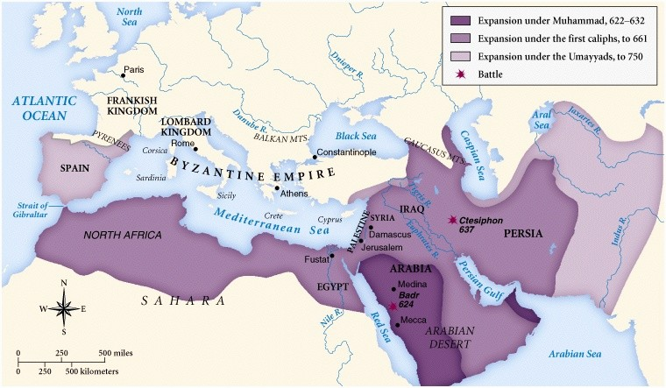

Significance: How does the creation of the Islamic Caliphate represent changes and continuities in political rule?

Exit Ticket
Directions: Please write a thesis statement and topic sentences in response to today’s MIQ: How does the creation of the Islamic Caliphate represent changes and continuities in political rule? As a reminder, your thesis should be structured with the following sentence stem: There were clear continuities between ____ and ____ such as _____. However, there were also clear changes such as ______ and ______.

**Thesis:____________________________________________________________________________________

___________________________________________________________________________________________

___________________________________________________________________________________________

___________________________________________________________________________________________

___________________________________________________________________________________________

___________________________________________________________________________________________

___________________________________________________________________________________________

**Topic Sentence 1 (Continuities): _______________________________________________________________

___________________________________________________________________________________________

___________________________________________________________________________________________

___________________________________________________________________________________________

**Topic Sentence 1 (Changes):___ _______________________________________________________________

___________________________________________________________________________________________

___________________________________________________________________________________________

___________________________________________________________________________________________

Homework
Directions: Please read and annotate the text below. Then, answer the questions that follow.
**A love of knowledge was evident in Baghdad, established in 762 CE as the capital city of the Abbasid Caliphate in modern-day Iraq. Scholars, philosophers, doctors, and other thinkers all gathered in this center of trade and cultural development.. Academics—many of them fluent in Greek and Arabic—exchanged ideas and translated Greek texts into Arabic. Chief Muslim leaders after Muhammad’s death were referred to as Caliphs.The era of the Abbasid Caliphs’ construction and rule of Baghdad is known as the Golden Age of Islam. It was an era when scholarship thrived.

After the death of Muhammad, the Umayyad Dynasty gained the reins of power. Based in Damascus, Syria, the Umayyad Caliphate faced internal pressures and resistance, partly because they displayed an obvious preference for Arab Muslims, excluding non-Arab Muslims like Persians. Taking advantage of this weakness, Sunni Arab Abu al-Abbas mounted a revolution in 750 CE. With support from his followers, he destroyed the Umayyad troops in a massive battle and formed the Abbasid Dynasty in its place.

The leaders of the Abbasid Dynasty built Baghdad, the capital of modern-day Iraq. Baghdad would come to replace and overshadow Damascus as the capital city of the empire. It was located near both the Tigris and Euphrates rivers, making it an ideal spot for food production that could sustain a large population.

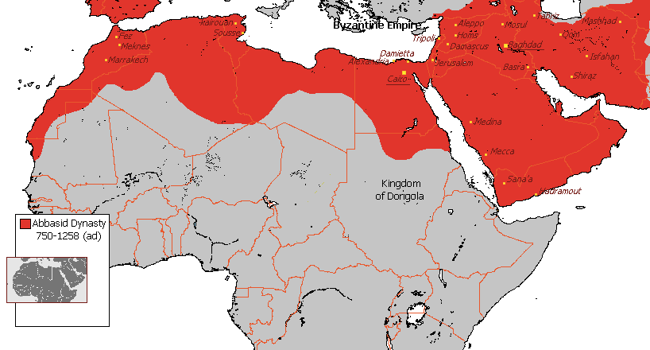
**The Abbasids built Baghdad from scratch while maintaining the network of roads and trade routes the Persians had established before the Umayyad Dynasty took over. Baghdad was strategically located between Asia and Europe, which made it a prime spot on overland trade routes between the two continents. Some of the goods being traded through Baghdad were ivory, soap, honey, and diamonds. People in Baghdad made and exported silk, glass, tiles, and paper. The central location and lively trade culture of the city made a lively exchange of ideas possible as well. Baghdad attracted many people, including scholars, to live within its borders.

**Abbasid Caliphs Harun al-Rashid and his son, al-Ma’mun, who followed him, established a House of Wisdom in Baghdad—a dedicated space for scholarship. The House of Wisdom increased in use and prestige under al-Ma’mun’s rule, from 813 to 833. He made a special effort to recruit famous scholars to come to the House of Wisdom. Muslims, Christians, and Jews all collaborated and worked peacefully there.

**Caliphs like al-Rashid and al-Ma’mun directly encouraged a translation movement, a formal translation of scholarly works from Greek into Arabic. The Abbasid rulers wanted to make Greek texts, such as Aristotle’s works, available to the Arab world. Their goal was to translate as many of these famous works as possible in order to have a comprehensive library of knowledge and to preserve the philosophies and scholarship of Greece. The Abbasids aimed to have philosophy, science, and medicine texts translated. In addition to Arab Muslim scholars, Syrian Christians translated Syriac texts into Arabic as well.

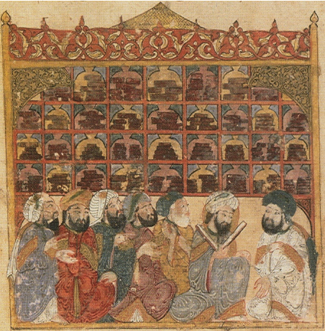
Why were the Abbasids so interested in a massive translation undertaking? In addition to their desire to have a comprehensive library of knowledge and the Qur’an’s emphasis on learning as a holy activity, they also had a practical thirst for medical knowledge. The dynasty was facing a demand for skilled doctors—so having as much knowledge as possible for them to access was a must.

One way the Abbasid dynasty was able to spread written knowledge so quickly was their improvements on printing technology they had obtained from the Chinese; some historians believe this technology was taken after the Battle of Talas between the Abbasid Caliphate and the Tang Dynasty in 751. The Chinese had guarded paper making as a secret, but when the Tang lost the battle, the Abbasids captured knowledgeable paper makers as prisoners of war, forcing them to reproduce their craft.
In China, papermaking was a practice reserved for elites, but the Arabs learned how to produce texts on a larger scale, establishing paper mills which made books more accessible. In turn, Europeans eventually learned these papermaking and producing skills from Arabs.

**During the Golden Age of Islam, Arab and Persian scholars—as well as scholars from other countries—were able to build on the information they translated from the Greeks and others during the Abbasid Dynasty and forge new advances in their fields. Ibn al-Haythm invented the first camera and was able to form an explanation of how the eye sees. Doctor and philosopher Avicenna wrote the Canon of Medicine, which helped physicians diagnose dangerous diseases such as cancer. And Al-Khwarizmi, a Persian mathematician, invented algebra, a word which itself has Arabic roots.

**1. What were the benefits of establishing a capital at Baghdad?

**2. What were the accomplishments of the Abbasid?

