Welcome to Class! Do Now Please!
Questions/Concerns:
**1. What trade routes did East Africa have access to in the Classical and Post-Classical Eras?

**2. Why was this the case?

**3. How does this compare to the trade networks West Africa had access to?

Directions: Using the Do Now, your prior knowledge, and the video, please answer the question below.

- Who dominated the Indian Ocean Trade Network? Why?

- Who regulated trade and prices in this trade network? How is this different from other trade networks?

Document Analysis
Prompt: Compare the impact of Islam on the cultural and political structures of East and West Africa.
Scope:
Topic:
HTS:
Re-Written Question:

Document 1
Source: Al-Mas’udi (c. 915), Arab merchant who travelled to Persia, India, China, and East Africa. From Muruj al-Dhahab wa Ma’adin al-Jawhar.

The pilots of Oman pass by the channel to reach the island of Kanbalu, which is in the Zanj sea. It has a mixed population of Muslims and Zanj idolaters…

The land of Zanj produced wild leopard skins. The people wear them as clothes, or export them to Muslim countries. They also export tortoise shell for making combs. It has a warm climate and is fertile. The Zanj capital is there and they have a king called the Mfalme. This is the ancient name of their kings; he has 300,000 horsemen.

There are many wild elephants but no tame ones. The Zanj do not use them for war or anything else, but only hunt and kill them. The Zanj rush upon them with very long spears, and kill them for their ivory. It is from this country that come tusks weighing fifty pounds and more. They usually go to Oman, and from there are sent to China and India. This is the chief trade route, and if it were not so, ivory would be common in Muslim lands.

The Zanj have an elegant language and men who preach in it. One of their holy men will often gather a crowd and exhort his hearers to please God in their lives and to be obedient to him. He explains the punishments that follow upon disobedience, and reminds them of their ancestors and kings of old. These people have no religious law: their kings rule by custom and by political expediency.
The Zanj eat bananas, which are as common among them as they are in India. They also eat honey and meat. Every man worships what he pleases, be it a plant, an animal, or a mineral. They have many islands where the coconut grows: its nuts are used as fruit by all the Zanj peoples.

Document 2
Source: Al-Idrisi (1100-1166), Arab geographer who worked in the court of Roger II of Sicily. From Nuzhat al-Mushtaq fi Ikhtiraq al-Afaq (The book of travels of one who cannot travel himself).

The Zanj of the East African coast have no ships to voyage in, but use vessels from Oman and other countries which sail to the islands of Zanj which depend on the Indies. These foreigners sell their goods there, and buy the produce of the country. Opposite the Zanj coasts are the Djawaga islands; they are numerous and vast; their inhabitants are very dark in color.

Among the islands of Djawaga included in the present section is Andjuba, whose principal town is called Unguja in the language of Zanzibar, and whose people, although mixed, are actually mostly Muslims. The island is 400 miles round; bananas are the chief food. It is a healthy, sweet, and pleasant food. The island is very populous; there are many villages and cattle. They grow rice. There is a great trade in it.

From Medouna to Malindi, a town of the Zanj, one follows the coast for three days and three nights by sea. Malindi lies on the shore, at the mouth of a river of sweet water. It is a large town, whose people engage in hunting and fishing. On land they hunt the lion and other wild beasts.

They own and exploit iron mines; for them iron is an article of trade and the source of their largest profits.

Document 3
Source: Chao Ju-Kua, (1226) commissioner of foreign trade at Ch’uan-chou in Fukien Province, China. From the Chu-fan-chih (Description of Barbarous Peoples).

Zanzibar (Ts’ong-pa)
The Ts’ong-pa country is an island of the sea south of Hu-ch’a-la. To the west it reaches a great mountain. The inhabitants are of Arab stock and follow the Arab religion. They wrap themselves in blue foreign cotton textiles and wear red leather shoes. The climate is warm, and there is no cold season. The products of the country consists of elephants’ tusks, native gold, etc.

Every year Hu-ch’a-l and the Arab localities along the sea coast send ships to this country with white cotton cloth, porcelain, copper, and red cotton to trade.

Exit Ticket
Directions: Please write a thesis statement and topic sentences in response to today’s MIQ: Compare the impact of Islam on the cultural and political structures of East and West Africa. Ensure that your thesis follows our comparative sentence stem: Both (sim). However, (diff).

**Thesis:____________________________________________________________________________________

___________________________________________________________________________________________

___________________________________________________________________________________________

___________________________________________________________________________________________

___________________________________________________________________________________________

___________________________________________________________________________________________

___________________________________________________________________________________________

**Topic Sentence 1 (Similarities): _______________________________________________________________

___________________________________________________________________________________________

___________________________________________________________________________________________

___________________________________________________________________________________________

**Topic Sentence 1 (Differences):___ _____________________________________________________________

___________________________________________________________________________________________

___________________________________________________________________________________________

___________________________________________________________________________________________

Homework
Directions: Please read and annotate the text below. Then, answer the questions that follow.
The Mughal Empire: A Muslim Minority Rules in India
**East of Persia, Muslims struggled to extend their dominion over India and its Hindu population. In the northern part of the subcontinent, the main Islamic rulers were the Delhi sultans, who had established their regime in 1206 CE. For the next few centuries, while the Mongols overran most of the rest of Asia, these sultans tried to spread their control across India. Although they ultimately failed, the third of the great Islamic empires was eventually constructed on the foundations they laid.

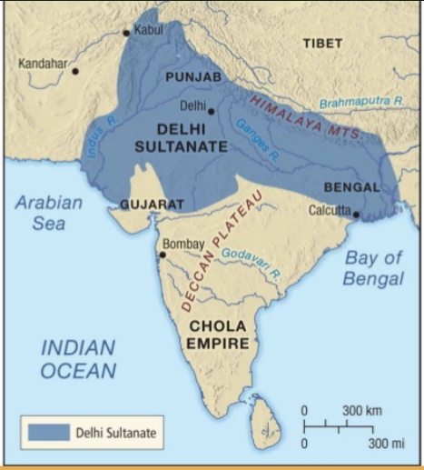
The Delhi Sultanate in India
**In the 1220s, Genghis Khan complicated the Delhi sultan’s situation by chasing Central Asian tribes out of their homelands and into northern India. The reigning sultan, Iletmish, prudently refused the refugees’ offers of alliance and encouraged them to run westward to Persia. He thus prevented a Mongol invasion of India. By the time of his death in 1236, Iletmish had consolidated all of northern India under the Delhi sultanate (see map).
A sensible and enlightened ruler, Iletmish did what he could to reconcile India’s Hindu majority to Islamic rule. He left the Hindu local princes in power as long as they paid tribute and supported him against the Mongols. He also appointed his daughter, Radiya as his successor, as she was clearly more capable than his sons. But when Iletmish died in 1236 CE, her succession was opposed by her brothers and a group of military officers. Radiya died fleeing Delhi in 1240 CE.

**Radiya’s defeat plunged the Delhi Sultanate into a series of coups that ended in 1266 CE with the assumption of power by a powerful general who served under the sultan. Afterwards, Sultan Ala al-Din ruled- he was imaginative, skillful and ruthless, and was able to expand the sultanate southward both to extend its empire but also to gain money and soldiers for defense against the Mongols. In 128 he captured the West Indian state of Gujarat and its vast treasury from Indian Ocean trade. Then he crossed the Deccan plateau and was able to occupy the tip of the subcontinent. India, it seemed, had at last been united under Muslim control.

But Ala al-Din’s rule did not last. His successors were victorious in battle against the Mongols, but could not hold India together. The subcontinent was simply too large and too diverse (linguistically, culturally, and geographically) to be consolidated by groups who struggled with administration.

**The Delhi Sultanate’s authority crumbled rapidly. In 1338, a Sufi sect contributed to the defection of the northeastern state of Bengal from mainstream Muslim rule. In 1347 Muslim nobles formed an independent kingdom on the Deccan plateau. In South India, Hindu states that Ala al-Din had conquered broke away to form aa new empire, and, in 1390, the West Indian Island of Gujarat left as well. These losses made the Sultanate susceptible to invasion. Delhi was reduced to the status of a Northern Indian city-state.

Cultural Diffusion in the Indian Subcontinent

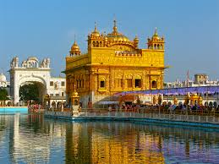
**Further fragmenting the Indian sub-continent was the emergence of a new Sikh religion in the late 15th century. In Northern India, conflict between the Sikhs and Muslims had scarred the population. There a Hindu mystic named Nanak, inspired by a spiritual experience, worked to develop a synthesis of the two faiths. Impressed by Islamic monotheism, he accepted the idea of united of God, and blended it with Hindu beliefs such as dharma and karma, and rejected the Hindu caste system in favor of the Islamic belief of the equality of all believers. Nanak’s teachings, known as Sikhism, are still centered in Northern India today. The holiest site, known as the Golden Temple at Amritsar, is pictured here.

**1. What AP region was the Mughal Empire in?

**2. How were Hindus treated in the Delhi Sultanate?

3. Compare the treatment of Hindus to the treatment of Christians and Jews in the Abbasid Caliphate.

**4. Define Sikhism.

