Welcome to Class! Do Now Please!
Questions/Concerns

**1. Who is the head of the Greek Orthodox Church?

**2. Who is the head of the Roman Catholic Church?

3. What similarities existed between these two sects?

**4. What differences existed between these two sects?

Document Analysis
Prompt: Analyze the factors that led to the split of the Christian Church in the Post-Classical Era.

Scope:
Topic:
HTS:
Re-Written Question:

Document 1
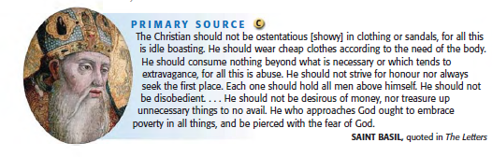

Document 2
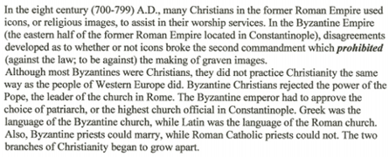
Source: Ellis, Textbook, World History : Survey Edition - 09 edition

Significance:

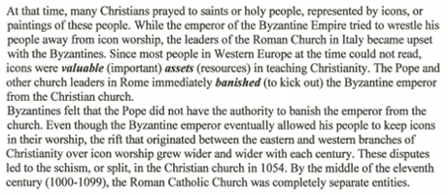

Exit Ticket
Directions: Using the sentence stem below, please write a quality thesis statement and topic sentences answering our Main Inquiry Question: What factors led to the split of the Christian Church? STEM: Scope + Topic was caused by ______ and ______.
Thesis: ____________________________________________________________________________________

___________________________________________________________________________________________

___________________________________________________________________________________________

___________________________________________________________________________________________

___________________________________________________________________________________________

Topic Sentence (Cause #1): ___________________________________________________________________

___________________________________________________________________________________________

___________________________________________________________________________________________

Topic Sentence (Cause #2): ___________________________________________________________________

___________________________________________________________________________________________

___________________________________________________________________________________________

Homework
Directions: Please complete the questions below in preparation for our Extended Oral Drill on Monday.
QUESTION | ANSWER
- **Who is the founder of Islam?
- What led to the spread of Islam?
- **Where did Islam spread in Post-Classical Era?
- **What are the Five Pillars?
- What is one similarity between Islam and Christianity?
- **What is feudalism?
- **What caused the “Dark Ages” in Western Europe?
- **What are the two major sects of the Christian religion?
- **What led to the Great Schism?
- What is a caliph?
- **Who is the Pope?
- **Who is the Patriarch?
- **What is the holy book of Islam?

