Welcome to Class! Do Now Please!
Question/Concerns:

**1. Where did the Mongol Empire begin?
A)The Grassy-Steppes of Central Asia
B) East Asia
C)The Middle East
D)Europe

**2. All the factors led to rise of the Mongols EXCEPT
A) The leadership of Ghengis Khan
B) Their superior Military Tactics
C) Their appealing message
D) Their use of religious tolerance

3. All the factors were used by the Mongols to maintain their empire EXCEPT
A) The use of religious tolerance
B) Protecting trade routes
C) Relying on local bureaucrats
D) Allowing citizens to vote on policies

**4. Identify and explain ONE effect of the Mongols.

Document Analysis
Prompt: Analyze the impacts of the Mongols on the Post-Classical Era
Scope:
Topic:
HTS:
Re-Written Question:

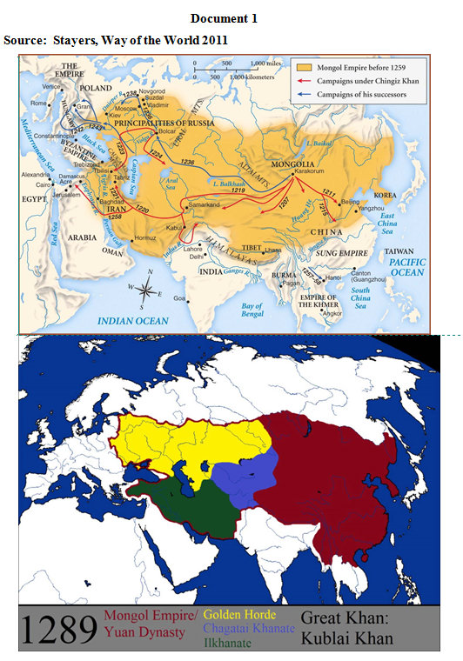
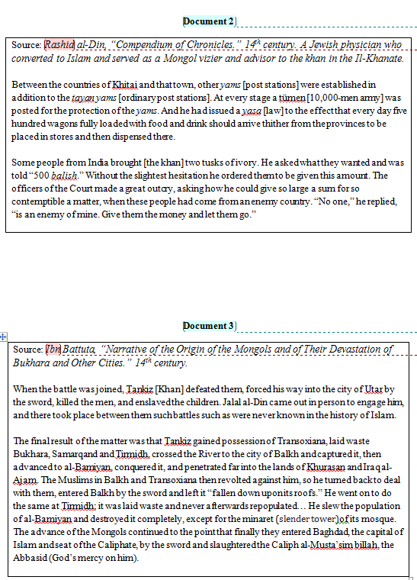
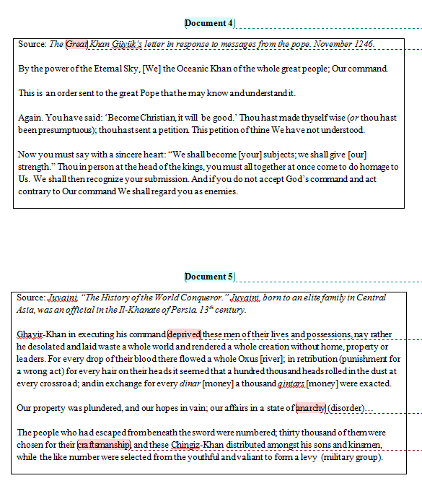

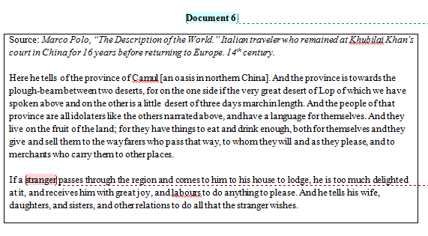

5
Exit Ticket
Directions: Write an introduction paragraph responding to the prompt below. As a reminder, this paragraph should include your context (era + place + 3-4 trends defined) and your thesis (The Mongol empire resulted in multiple effects, including ________________).

Analyze the effects of the Mongols on the Post-Classical Era.

_______________________________________________________________________________________________
_______________________________________________________________________________________________
_______________________________________________________________________________________________
_______________________________________________________________________________________________
_______________________________________________________________________________________________
_______________________________________________________________________________________________
_______________________________________________________________________________________________
_______________________________________________________________________________________________
_______________________________________________________________________________________________
_______________________________________________________________________________________________
_______________________________________________________________________________________________
_______________________________________________________________________________________________
_______________________________________________________________________________________________
_______________________________________________________________________________________________
_______________________________________________________________________________________________
_______________________________________________________________________________________________
_______________________________________________________________________________________________
_______________________________________________________________________________________________
_______________________________________________________________________________________________
_______________________________________________________________________________________________
_______________________________________________________________________________________________

Homework
Directions: Please complete the graphic organizer below using detailed bullet points. As a reminder, any missing, incomplete, or poor homework will result in an automatic zero, and your inability to participate in seminar.

What allowed for the rise of the Mongols?
(3-4 Detailed Bullet Points)
What are the effects of the Mongol Empire?
(5-6 Detailed Bullet Points)

