Welcome to Class! Do Now Please!
Questions/Concerns

** 1) What is Bryan Ward-Perkins argument (Doc 7)?

**2) Should Medieval Western Europe be referred to as the Dark Age? Explain.

**3) (Review Rubric on back) How will you show professionalism in today’s seminar?

4) (Review Rubric on back) What is one grow that you will focus on from our last seminar?

CONTRIBUTING
CORE HABIT | WHAT TO DO
Project | - Speak audibly in a professional tone.  - Shift body to make eye contact with classmates.
Share in turn | - Speak in turn.
Speak as a professional | - Use classmates’ names.
 | - Use complete sentences.
 | - Address question succinctly.
Listen as a professional | - Track speaker with hands down.  - Nod or snap professionally.
  - Turn to page if speaker references
  - Pause to give time to turn to page and scan to confirm class is ready.
Take notes as a professional | Observer (during discussion):  - Copy down key information.  - Annotate diagrams.
Participant (after discussion):
  - Write down/summarize key information.
BUILDING
CORE HABIT | WHAT TO DO
Argue from Evidence | - Utilize textual or numerical evidence to justify claim.
 | - Connect textual evidence to the argument.
 | - Show your work/explain your thinking.
Acknowledge | - “That’s an interesting point about--”  - “I like Destiny’s thinking about--”
Go Deeper | - Support peer’s ideas with evidence.  - “If we look at p. 141… this supports what Destiny is saying--”  - “I agree with Destiny’s thinking about…as on p. 12 Poe writes--”
  - “I want to zoom in on Destiny‘s evidence; I think it’s interesting that Poe uses ‘slaughtered’ instead of ‘killed’ because--”
  - “I’d like to zoom in on ‘red’ because I think it connotes violence--”

Guided Discussion Notes

Round 1 Review

1. Historians argue that the Roman Empire never truly fell and that it was a gradual transition.

Identify and explain ONE piece of evidence that undermines this argument
___________________________________________________________________________________________
___________________________________________________________________________________________
___________________________________________________________________________________________
___________________________________________________________________________________________
___________________________________________________________________________________________
___________________________________________________________________________________________

2. Refer to your Habits of Academic Discourse handout. What is one habit that we did successfully in this round of discussion?

___________________________________________________________________________________________
___________________________________________________________________________________________
___________________________________________________________________________________________

3. What is one habit that we can improve in? How can we improve?

___________________________________________________________________________________________
___________________________________________________________________________________________
___________________________________________________________________________________________

Exit Ticket

Directions: Using the evidence from our Guided Seminar, please write a SEXAEXA paragraph responding to our Guided Seminar Question: Did the Roman Empire truly fall? Did the following period in Western Europe deserve the name the “Dark Ages”?
___________________________________________________________________________________________
___________________________________________________________________________________________
___________________________________________________________________________________________
___________________________________________________________________________________________
___________________________________________________________________________________________
___________________________________________________________________________________________
___________________________________________________________________________________________
___________________________________________________________________________________________
___________________________________________________________________________________________
___________________________________________________________________________________________
___________________________________________________________________________________________
___________________________________________________________________________________________
___________________________________________________________________________________________
___________________________________________________________________________________________
___________________________________________________________________________________________
___________________________________________________________________________________________
___________________________________________________________________________________________
___________________________________________________________________________________________
___________________________________________________________________________________________
___________________________________________________________________________________________
___________________________________________________________________________________________
___________________________________________________________________________________________
___________________________________________________________________________________________
___________________________________________________________________________________________
___________________________________________________________________________________________
___________________________________________________________________________________________
___________________________________________________________________________________________
___________________________________________________________________________________________
___________________________________________________________________________________________
___________________________________________________________________________________________
___________________________________________________________________________________________
___________________________________________________________________________________________
___________________________________________________________________________________________
___________________________________________________________________________________________
___________________________________________________________________________________________
___________________________________________________________________________________________
___________________________________________________________________________________________
___________________________________________________________________________________________
___________________________________________________________________________________________
___________________________________________________________________________________________
___________________________________________________________________________________________
___________________________________________________________________________________________
___________________________________________________________________________________________
___________________________________________________________________________________________
___________________________________________________________________________________________
___________________________________________________________________________________________
___________________________________________________________________________________________
___________________________________________________________________________________________
Homework
Directions: Read and annotate the text below, making quality marginal notes as you read. Then, answer the questions that follow.

The Great Schism

**The Great Schism (schism- a split or division between strongly opposed sections or parties, caused by differences in opinion or belief) split the main faction of Christianity into two divisions, Roman Catholic and Eastern Orthodox. Today, they remain the two largest denominations of Christianity.

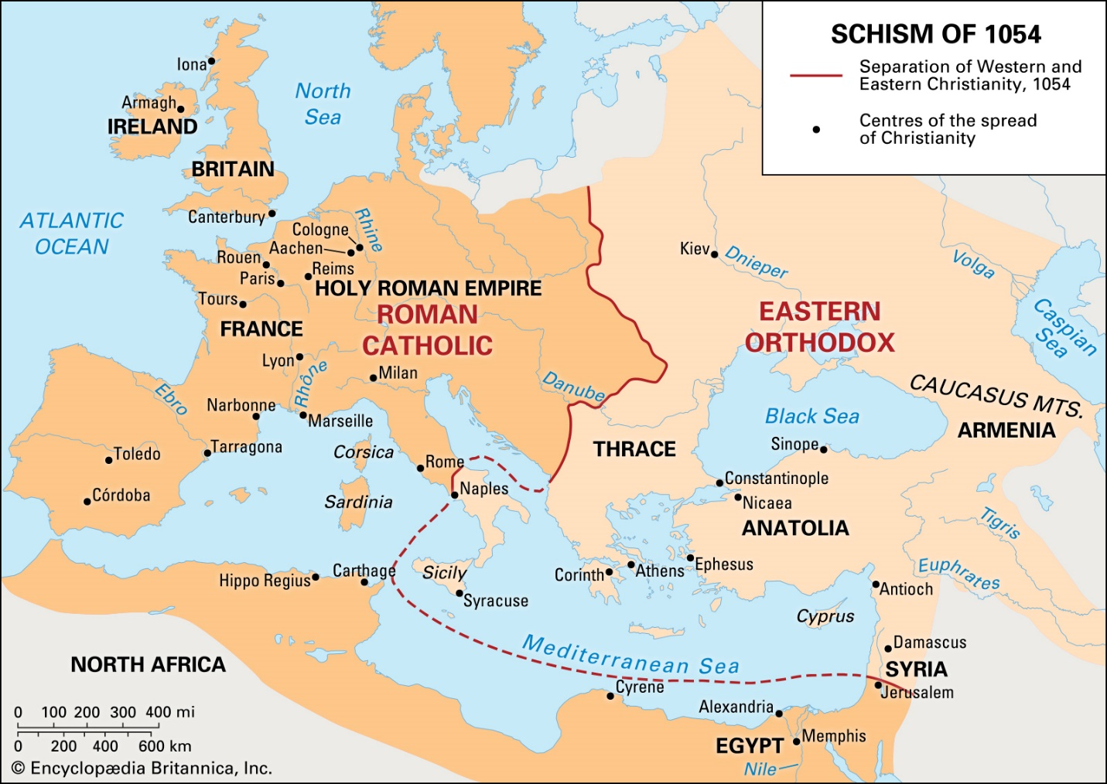

When the Roman capital was moved to Constantinople, the Christian religion also began to change. While the Pope remained in Western Europe, and enjoyed a large amount of power as Western Rome fell, disease spread, and the feudal system began, in Eastern Europe a new head of the Christian church, called the Patriarch, was created.

**While the Pope had ultimate religious and political power in the West, the Patriarch was subservient to the Emperor in the East. As the Byzantine Empire continued to grow, the tension between these two leaders continued to grow as well. This tension erupted on July 16, 1054, when Patriarch Cerularius was excommunicated (excluded from the Christian church) by Pope Gregory XI. In return, Patriarch Cerularius excommunicated Pope Gregory. This excommunication led to the formal creation of two sects (branches) of Christianity- the Greek Orthodox Church in the East, and the Roman Catholic Church in the West. This split is known as the Great Schism.
**The Great Schism was both a spiritual and practical conflict. For instance, while the Roman Catholic Church was led by the Pope, the Greek Orthodox Church was led by the Patriarch, who answered to the Byzantine Emperor. In addition, while the Roman Catholic Church allowed for the use of icons (religious images), the Greek Orthodox Church did not. And, while the Roman Catholic Church conducted services in Latin, the Greek Orthodox Church did so in Greek. A more practical conflict that led to the Great Schism was whether the pope, the spiritual leader in Rome, had authority over the patriarchs, religious leaders in the east.

The Great Schism was long-lasting; the two branches of Christianity are still split. Catholicism is the single largest Christian denomination, with more than a billion followers around the world. Eastern Orthodoxy is the second-largest Christian denomination, with more than 200 million followers. Eastern Orthodoxy includes national churches such as Greek Orthodox and Russian Orthodox.

**1. What does schism mean?

**2. What does excommunicated mean?

3. What led to an increase in power of the Pope?

**4. What are the differences between the Roman Catholic and Greek Orthodox Church? (Name at least two)

