Welcome to Class! Do Now Please!
Questions/Concerns

**1. What are internal factors that lead to the collapse of an Empire?

**2. What are external factors that lead to the collapse of an Empire?

3. What factors lead to the collapse of the Roman Empire?

4. What do you think is America’s greatest threat to collapse?

- What is feudalism?

- How did the “status quo” remain the same as a result of this system?

Document Analysis
Prompt: Analyze the factors that lead to creation of the Feudal system in Western Europe during the Post-Classical Era.
Scope:
Topic:
HTS:
Re-Written Question:

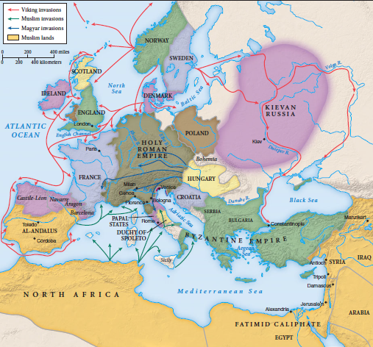
Document 1
Source: Ways of the World- Europe in the Middle Ages.
Significance:

Document 2
Source: Below are a few passages taken from the Annals of St. Bertin, the poem of Abbo on the siege of Paris, and the Chronicle of St. Denis, which show something of the character of the Northmen's part in early French history, first as mere invaders and afterwards as permanent settlers.
843 A.D. Pirates of the Northmen's race came to Nantes, killed the bishop and many of the clergy and laymen, both men and women, and pillaged the city. Thence they set out to plunder the lands of lower Aquitaine. At length they arrived at a certain island [the isle of Rhé, near La Rochelle, north of the mouth of the Garonne], and carried materials thither from the mainland to build themselves houses; and they settled there for the winter, as if that were to be their permanent dwelling-place.
844. The Northmen ascended the Garonne as far as Toulouse and pillaged the lands along both banks with impunity. Some, after leaving this region went into Galicia [in Northern Spain] and perished, part of them by the attacks of the crossbowmen who had come to resist them, part by being overwhelmed by a storm at sea. But others of them went farther into Spain and engaged in long and desperate combats with the Saracens; defeated in the end, they withdrew.
845. then the other, came without meeting any resistance to Paris. Charles [the Bald] resolved to hold out against them; but seeing the impossibility of gaining a victory, he made with them a certain agreement and by a gift of 7,000 livres he bought them off from advancing farther and persuaded them to return. Euric, king of the Northmen, advanced, with six hundred vessels, along the course of the River Elbe to attack Louis of Germany. The Saxons prepared to meet him, gave battle, and with the aid of our Lord Jesus Christ won the victory. The Northmen returned down the Seine and coming to the ocean pillaged, destroyed, and burned all the regions along the coast.

Document 3

Source: Bishop Fulbert of Normandy (c.1150)
He who swears fealty to his lord must not injure his lord by giving up secrets of his castles... he must do nothing to injure the rights of justice of his lord... he must do no wrong to his lord's possessions.

Exit Ticket
1. “Feudalism was caused by the fall of the Roman Empire.”
A. Identify and explain one piece of evidence that corroborates this claim.
B. Identify and explain two pieces of evidence that refute this claim.
_______________________________________________________________________________________________
_______________________________________________________________________________________________
_______________________________________________________________________________________________
_______________________________________________________________________________________________
_______________________________________________________________________________________________
_______________________________________________________________________________________________
_______________________________________________________________________________________________
_______________________________________________________________________________________________
_______________________________________________________________________________________________
_______________________________________________________________________________________________
_______________________________________________________________________________________________
_______________________________________________________________________________________________
_______________________________________________________________________________________________
_______________________________________________________________________________________________
_______________________________________________________________________________________________
_______________________________________________________________________________________________
_______________________________________________________________________________________________
_______________________________________________________________________________________________
_______________________________________________________________________________________________
_______________________________________________________________________________________________
_______________________________________________________________________________________________
_______________________________________________________________________________________________
_______________________________________________________________________________________________
_______________________________________________________________________________________________
_______________________________________________________________________________________________
_______________________________________________________________________________________________
_______________________________________________________________________________________________
_______________________________________________________________________________________________
_______________________________________________________________________________________________
_______________________________________________________________________________________________
_______________________________________________________________________________________________
_______________________________________________________________________________________________
_______________________________________________________________________________________________
_______________________________________________________________________________________________
_______________________________________________________________________________________________
_______________________________________________________________________________________________
_______________________________________________________________________________________________
_______________________________________________________________________________________________
_______________________________________________________________________________________________
_______________________________________________________________________________________________
_______________________________________________________________________________________________
_______________________________________________________________________________________________
_______________________________________________________________________________________________
_______________________________________________________________________________________________
_______________________________________________________________________________________________
_______________________________________________________________________________________________
_______________________________________________________________________________________________
_______________________________________________________________________________________________

