Welcome to Class! Do Now Please!
Questions/Concerns:
**1. Were the Aztecs monotheistic or polytheistic? How do you know?

2. What methods of political control did the Aztec use?

**3. Were the Inca monotheistic or polytheistic? How do you know?

4. What methods of political control did the Inca use?

Directions: Please read the questions below. Then, after watching the video, answer them independently.

**1. Why did the Inca engage in human sacrifice?

**2. How is this similar to the Aztec? How is it different?

Document Analysis
Prompt: How were the cultural and political structures of the Inca and Aztec similar and different? What caused those similarities and differences?
Scope:
Topic:
HTS:
Re-Written Question:

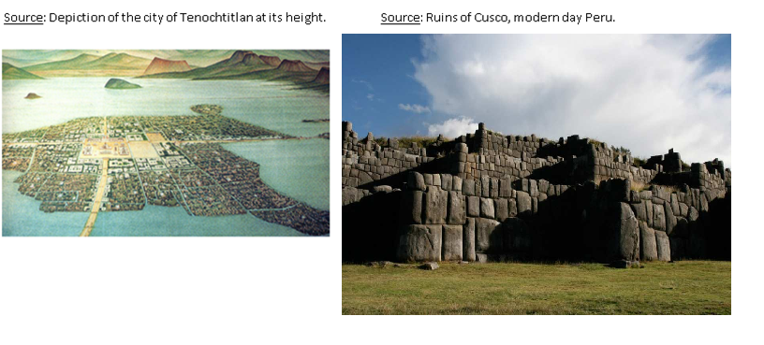
Document 1

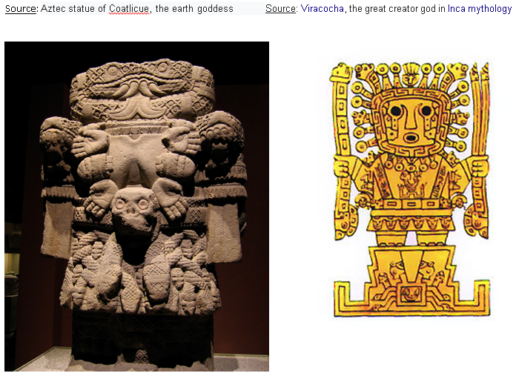
Document 2

Document 3
Source: Pedro de Cieza de Léon Chronicles of the Incas, 1540 CE.
At the beginning of the New Year the rulers of each village came to Cuzco, bringing their quipus, which told how many births there had been during the year, and how many deaths. In this way the Inca and the governors knew which of the Indians were poor, the women who had been widowed, whether they were able to pay their taxes, and how many men they could count on in the event of war, and many other things they considered highly important. The Incas took care to see that justice was meted out, so much so that nobody ventured to commit a felony or theft. This was to deal with thieves, rapists, or conspirators against the Inca.
As this kingdom was so vast, in each of the many provinces there were many storehouses filled with supplies and other needful things; thus, in times of war, wherever the armies went they drew upon the contents of these storehouses, without ever touching the supplies of their confederates or laying a finger on what they had in their settlements....

Document 4
Source: King Moctezuma I’s Laws, Ordinances, and Regulations c. 1450 CE.

The following laws were decreed:

- The king must never appear in public except when the occasion is extremely important and unavoidable.
- Only the king may wear a golden crown in the city, though in war all the great lords and brave captains may wear this (but on no other occasion).
- Noblemen are the only ones to be allowed to wear sandals in the city and no one else, also under pain of death, with the exception of men who have performed some great feat of war.
- Great privileges and exemptions are to be given those who dedicate themselves to religion, to the temples and gods. Priests will be awarded great distinction, reverence, and authority.

Exit Ticket
Directions: Please write a thesis statement responding to our Main Inquiry Question for today: How were the cultural and political structures of the Inca and Aztec similar and different? What caused those similarities and differences? Remember to use the sentence stem Both (sim). However, (diff).

_______________________________________________________________________________________________
_______________________________________________________________________________________________
_______________________________________________________________________________________________
_______________________________________________________________________________________________
_______________________________________________________________________________________________
_______________________________________________________________________________________________
_______________________________________________________________________________________________

Homework – Test Review
Directions: Complete the following test review to study for your exam Monday, answering the questions in complete sentences. In addition to this homework, you should also use your classwork, Key Terms, and Cornell Notes to study.

1. **What are the continuities between the Roman Empire and the Byzantine Empire?

2. ** What led to the split of the Christian Church?

3. What are the differences between the Eastern Orthodox and Roman Catholic churches?

4. What was the role of the church in the Crusades?

5. **What were the causes of the Crusades? What were the effects?

6. List and describe two technological achievements of the Tang and the Song.

7. **How did the Mongols create such a large empire in the Post-Classical Era?

8. **What are the effects of the Mongols?

9. **How are the Aztec and Inca similar?

10. **How are the Aztec and Inca different?

