Welcome to Class! Do Now Please!
Questions/Concerns:
Directions: Please read and annotate the questions below. Then, answer the questions that follow.

Source: Robert Strayer, Ways of the World

In the seventh century, a new faith took hold in the Middle East. This faith, called Islam, was monotheistic, like Judaism and Christianity. The followers of Islam, called Muslims, believe that Allah (God) transmitted his words to the faithful through Muhammad, whose followers recorded those teachings in the Quran, the holy book of Islam. Muslims believe that salvation is won through submission to the will of God, and through the Five Pillars: confession of faith, prayer (five times daily), charity to the needy (known as alms), fasting during Ramadan, and making the pilgrimage to Mecca.

Islam shares a common history with Judaism and Christianity. It accepts Abraham, Moses, and Jesus as Prophets (although it does not accept Jesus as a the son of God), and holds that Muhammad was the last great prophet. Like Christians, Muslims believe that all people are equal before god and should be converted to the faith. Early on, Islam split into two groups: Shia and Sunni. The split occurred over a disagreement about who should succeed Muhammad as leader of the faith.

**1. What AP Region did Islam develop in?

**2. How did Judaism and Christianity influence Islam?

**3. What are the Five Pillars of the Muslim Faith?

Directions: Using the chart, please answer the questions that follow.

Source: Pew Research Center, 2010.

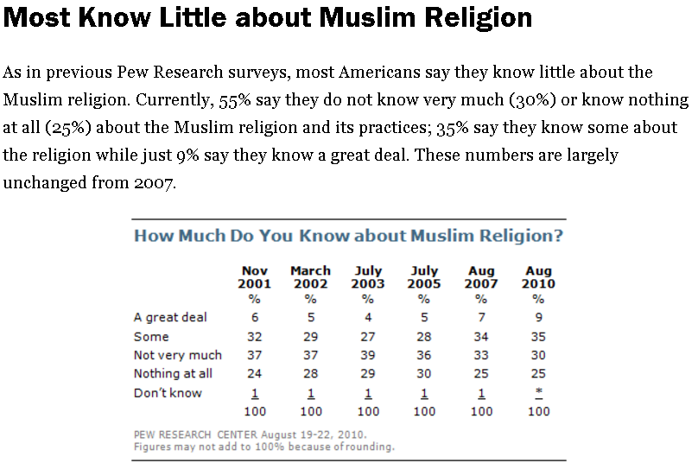

**1. In 2010, what is the total percent of people in America who know “Not Very Much” or “Nothing at all” about the Muslim faith?

**2. If you were to answer this question, would you say that you know a great day, some, not every much, or nothing at all about Islam? Why?

**3. What are possible consequences of this statistic?

**4. Why is it important for us as global citizens to learn about different faiths?

Document Analysis
Directions: Please read and analyze the documents below using the Four Corners Method. Recall that your significance statement should answer our main inquiry question: Evaluate the factors that led to the creation of Islam in the Post-Classical Era.

Scope:
Topic:
HTS:
Re-Written Question:

**Document 1
Source: Connections: A World History.

Muhammad’s definition of God and of people’s relations with him paralleled those of other religions with which Meccans were familiar. Jews were uncompromising monotheists who accepted a code of ethical conduct and followed well-defined religious practices. Christians believed in the Day of Judgement and described it in words and images similar to those transmitted to Muhammad. Zoroastrians believed in the eternal struggle between good and evil. But Judaism, Christianity, and Zoroastrianism had failed to win significant numbers of followers in Arabia, possible because in a land fragmented into tribes and clans, polytheism seemed more reflective of the realities of daily life. Now Muhammad believed that Gabriel had instructed him to do much more than simply believe in a single god. He was to prophesy in the tradition of Moses and Jesus, to speak t men and women on behalf of Allah, to turn them away from the errors of polytheism and lead them to the worship of the one true god. This belief system was highly attractive to the poor and working classes, as all people were seen as equal in the Muslim faith.

**Significance: Evaluate the factors that led to the creation of Islam in the Post-Classical Era.

**Document 2

Source: Robert Strayer, Ways of the World.

As the revelations granted to Muhammad became known in Mecca, they attracted a small following of some close relative, a few prominent Meccan leaders, and an assortment of lower-class dependents, freed slaves, and members of poorer clans. However, Muhammad was forced to flee Mecca in 622 CE, retreating to Medina in order to continue his teaching. The Islamic community, or umma, that took shape in Medina was a kind of “supertribe,” but very different from the traditional tribes of Arab society. Membership was a matter of belief rather than birth, allowing it to expand rapidly. Furthermore, all authority, both political and religious, was concentrated in the hands of Muhammad, who proceeded to introduce radical changes. Usury was out-lawed, tax-free market places were established, and a mandatory payment to support the poor was established.

**Significance: Evaluate the factors that led to the creation of Islam in the Post-Classical Era.

**Document 3

Source: Excerpts from the Quran, which detail the Five Pillars of the Muslim faith. These Five Pillars serve as an ethical code of conduct for all Muslims to live by.
(3:18) Allah witnesses that there is no deity except Him, and [so do] the angels and those of knowledge- [that He is] maintaining [creation] in just ice. There is no deity except Him, the Exalted in Might, the Wise.
(20:14) Indeed, I am Allah. There is no deity except Me, so worship Me and establish prayer for My remembrance.
(7:156) My mercy encompasses all things. So I decree it [especially] for those who fear Me and give zakah and those who believe in Our verses.
(2: 185) [In] he month of Ramadhan […] whoever sights [the new moon of the month], let him fast it. [Allah intends for you ease and does not intend for you hardship and [wants] for you to complete the period and to glory Allah for that which He has guided you; and perhaps you will be grateful.
(22:27-28) And proclaim to the people the Hajj [pilgrimage to Mecca]; they will come to you on foot and on every lean camel; they will come from every distant pass that they may witness benefits for themselves and mention the name of Allah on known days over what He has provided for them.

Exit Ticket

Directions: Using paraphrased evidence from the documents, please respond to the question below. Then, answer the stimulus based questions that follow.

**1. Which of the factors discussed today do you believe was the most influential in the creation of Islam? Explain.

___________________________________________________________________________________________

___________________________________________________________________________________________

___________________________________________________________________________________________

___________________________________________________________________________________________

___________________________________________________________________________________________

___________________________________________________________________________________________

___________________________________________________________________________________________

___________________________________________________________________________________________
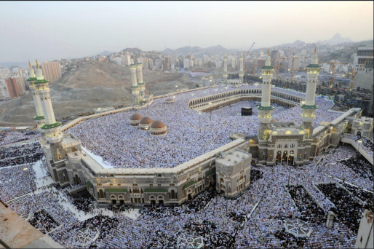
Source: Muslims pray in Mecca after making their pilgrimage, November 2012.

**2. The image above represents the practice of which part of the Muslim faith?
- Following the Ten Commandments
- Abiding by the Eightfold Path
- Reading and following the Sunna
- Following the Five Pillars

**3. In addition to the image above, what are the other aspects of this part of the Muslim faith?
- Faith in Allah
- Giving to charity
- Prayer five times daily
- Fasting during Ramadan
- I and II
- III and IV
- II only
- I, II, III, and IV

Homework
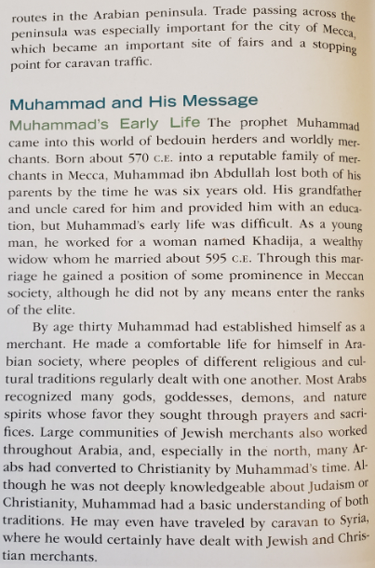
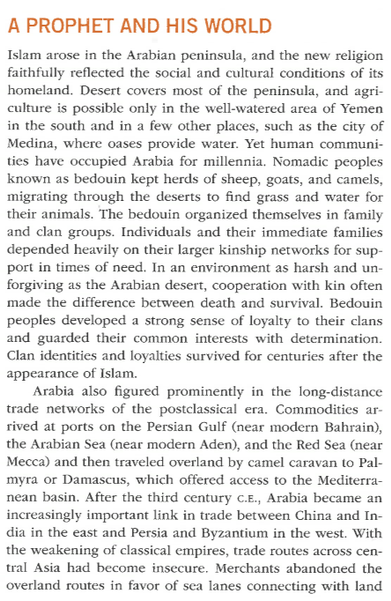
Directions: Please take CN on the reading below. Ensure that you bring your notebook to class tomorrow to be graded!

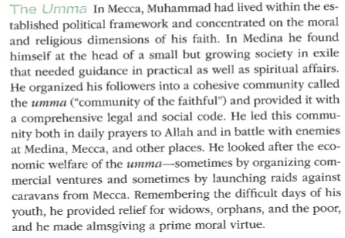
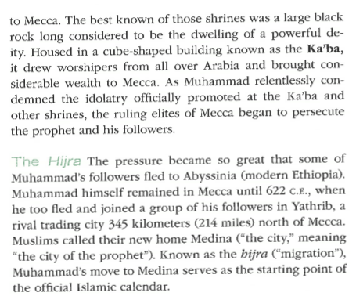
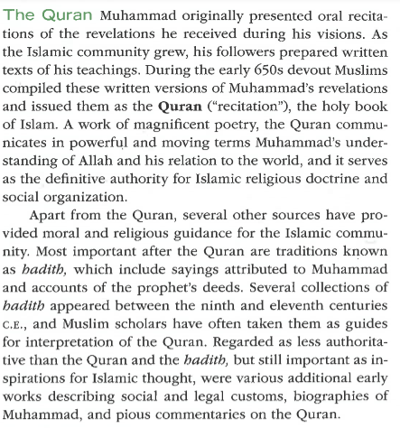
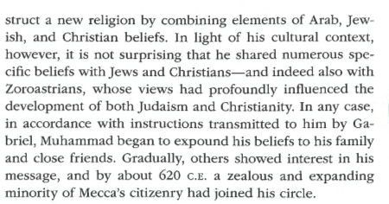
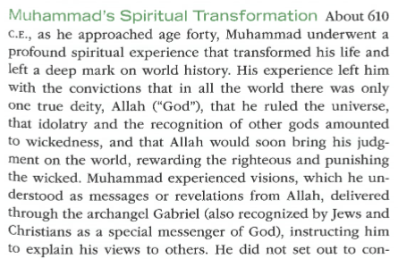
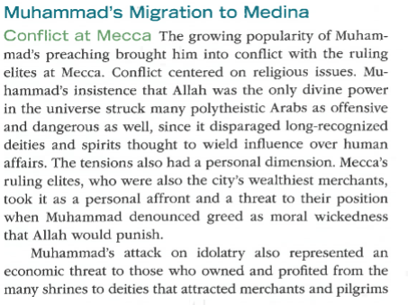

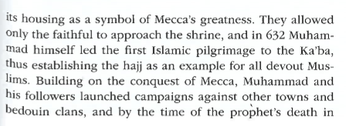
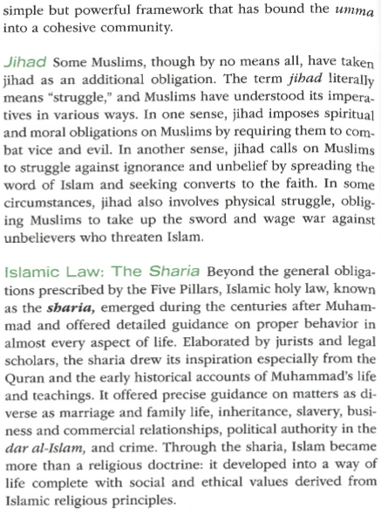
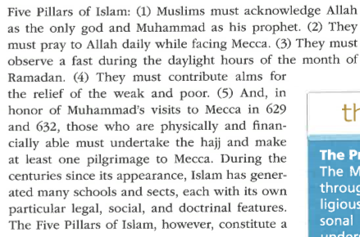
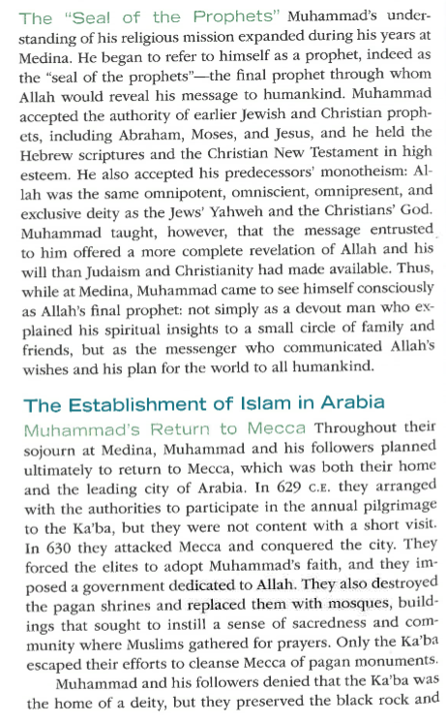
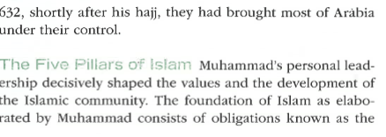

Key Terms List #10
Directions: Go to nsaworldhistory.weebly.com and click on “Link to Quizlet” for definitions. OR, go to Quizlet.com, search for NSAHS World History 1 and use Ms. Babbitt’s lists. You must write the full definition in the space below. As a reminder, these are due on Monday, 1/27 to the HW folders. You will have a quiz that day in class!

Key Term | Definition
Bedouins

**Allah

**Muhammad

**Islam

**Muslim

Hijrah

Medina

**Mecca

**Qur’an

Hajj

**Five Pillars

**Mosque

