Welcome to Class! Do Now Please!
Questions/Concerns:
Directions: Consider your prior knowledge and answer the questions below. Consider the following themes in your response: Humans and the Environment, Cultural Developments (including language and religion), Governance, Economic Systems, Social Organization (including class and gender), and Technology.

**1. What do you know about China?

2. What do you know about India?

**3. What do you know about Rome?

Exit Ticket
Directions: Using your lecture notes, respond to the questions below in complete sentences using paraphrased evidence.
**1. What is the difference between BCE and CE?

2. Why do some historians identify the period from 600 BCE to 600 CE as the ‘Second-Wave Era’?

**3. Why do some historians identify the period from 600 BCE to 600 CE as the ‘Classical Era’?

**4. Describe two developments from the period from 600 BCE to 600 CE which still have influence today.

Homework
Directions: Please read and annotate the text below, including quality marginal notes. Then, answer the questions that follow.

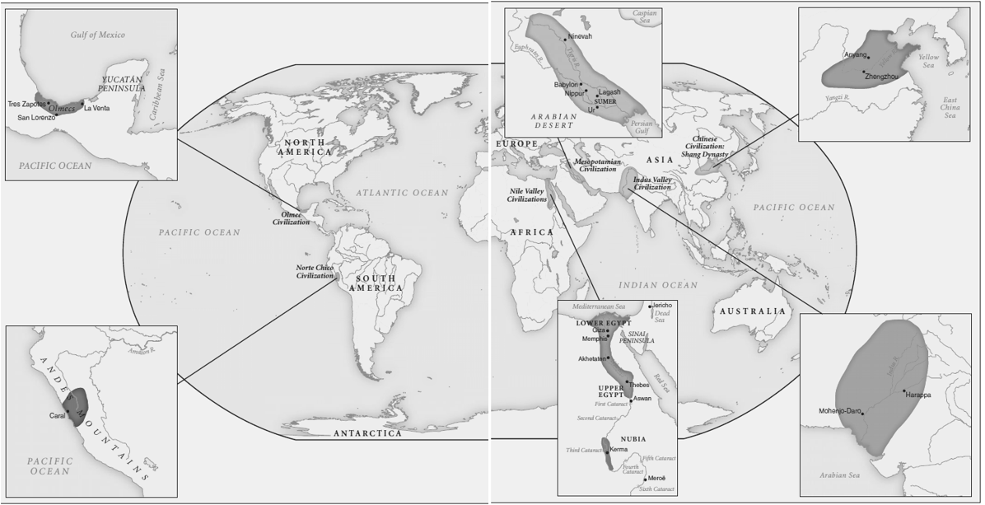
Introducing the First Civilizations
**The earliest civilizations emerged around 3500 B.C.E. to 3000 B.C.E. in three places. One was the Middle Eastern civilization, expressed in the many and competing city-states of Sumer in southern Mesopotamia (located in present day Iraq). Sumerian civilization gave rise to the world’s earliest written language, which was used initially by officials to record the goods received by various temples. Almost simultaneously, the Nile River valley in northeastern Africa witnessed the emergence of Egyptian civilization, famous for its pharaohs (kings) and pyramids, as well as a separate civilization known as Nubia, farther south along the Nile. Unlike the city-states of Sumer, Egyptian civilization took shape as a unified territorial state in which cities were rather less prominent. Less well known and only recently investigated by scholars was a third early civilization that was developing along the central coast of Peru from roughly 3000 B.C.E. to 1800 B.C.E., at about the same time as the civilizations of Egypt and Sumer. This desert region received very little rainfall, but it was interrupted by dozens of rivers that brought the snowmelt of the Andes Mountains to the Pacific Ocean. Along a thirty-mile stretch of that coast and in the nearby interior, a series of some twenty-five urban centers emerged in an area known as Norte Chico.

**Somewhat later, three additional First Civilizations made their appearance. In the Indus and Saraswati river valleys of what is now Pakistan, a remarkable civilization arose during the third millennium B.C.E. By 2000 B.C.E., it embraced a far larger area than Mesopotamia, Egypt, or coastal Peru and was expressed primarily in its elaborately planned cities. All across this huge area common patterns prevailed: standardized weights, measures, architectural styles, even the size of bricks. As elsewhere, irrigated agriculture provided the economic foundation for the civilization, and a written language, thus far undeciphered, provides evidence of a literate culture. The early civilization of China, dating to perhaps 2200 B.C.E., was very different from that of the Indus Valley. The ideal of a centralized state was evident from the days of the Xia dynasty (2200–1766 B.C.E.), whose legendary monarch Wu organized flood control projects on the Yellow River that “mastered the waters and made them to flow in great channels.”

Later dynasties—the Shang (1766–1122 B.C.E.) and the Zhou (1122–256 B.C.E.)—substantially enlarged the Chinese state, erected lavish tombs for their rulers, and buried thousands of human sacrificial victims to accompany them in the world to come. By the Zhou dynasty, a distinctive Chinese political ideology had emerged, featuring a ruler, known as the Son of Heaven. This monarch served as a link between heaven and earth and ruled by the Mandate of Heaven only so long as he governed with benevolence (kindness) and maintained social harmony among his people. An early form of written Chinese has been discovered on numerous oracle bones, which were intended to predict the future and to assist China’s rulers in the task of governing. Chinese civilization, more than any other, has experienced an impressive cultural continuity from its earliest expression into modern times. A final First Civilization, known as the Olmec, took shape around 1200 B.C.E. along the coast of the Gulf of Mexico near present-day Veracruz in southern Mexico. Based on an agricultural economy of maize (corn), beans, and squash, Olmec cities arose from a series of competing chiefdoms and became ceremonial centers filled with elaborately decorated temples, altars, pyramids, and tombs of rulers.

**1. What did the first civilizations develop around? Why?

**2. How was China similar to these other societies? How were they different?

Key Terms List #5
Directions: Go to nsaworldhistory.weebly.com and click on “Link to Quizlet” for definitions. OR, go to Quizlet.com, search for NSAHS World History 1 and use Ms. Babbitt’s lists. You must write the full definition in the space below. As a reminder, these are due on Monday, 11/4 to the HW folders. You will have a quiz that day in class!

**Confucianism
**Legalism
**Daoism
**Qin Dynasty
**Han Dynasty
**Filial Piety
Confucius’ Five Relationships
Shi Huangdi
**Civil Service
Province
**Mandate of Heaven

**Era of Warring States

**Bureaucracy

