Welcome to Class! Do Now Please!
Questions/Concerns:
**1. What are the key tenets of Hinduism?

**2. What are the key tenets of Islam?

**3. How did Islam spread in the Post-Classical Era?

- Who is the founder of Islam? | 8. What structures of East Africa changed due to Islam?
- Which AP region was Islam founded in? | 9. Which West African ruler encouraged the construction of Timbuktu as a trading city and center of Islamic cultre?
- What is one factor that led to the spread of Islam? | 10. What led to the Sunni/Shi’a Split?
- What are the Five Pillars? | 11. What is a sultanate?
- What is one similarity between Islam and Christianity? | 12. What role did Baghdad play in the Islamic Golden Age?
- What is one similarity between Islam and Judaism? | 13. What language do all Muslims speak?
- What role did West Africa play in trade? | 14. What is the holy book of Islam?

Source: Map of Islamic Populations by Region, Pew Center 2008.

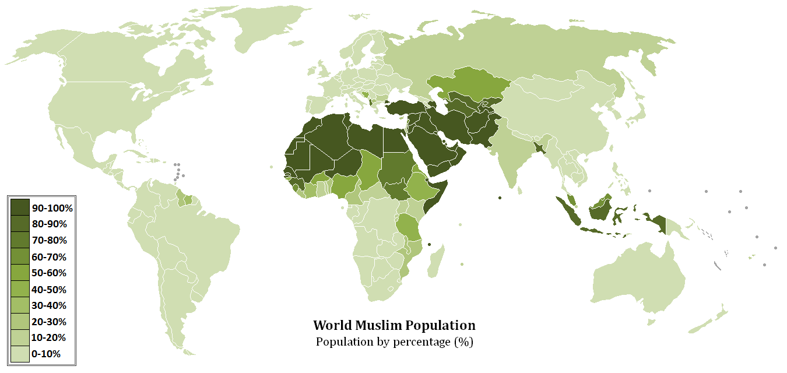

We know from our studies this week that Islam did reach South Asia, yet on this map very few of the people living there today identify as Muslims. Why do you think this is?

Document Analysis
Prompt: How and why did Islam affect Hindu beliefs in South Asia during the Post-Classical era?
Scope:
Topic:
HTS:
Re-Written Question:

Document 1
Source: The Bhagavad Gita (5th Century BCE), Hindu text. Lord Krishna is speaking.

As a man, casting off old clothes, puts on others and new ones, so the embodied self, casting off old bodies, goes to others and new ones. Weapons do not divide the self into pieces; fire does not burn it; waters do not moisten it; the wind does not dry it up. It is not divisible; it is not combustible; it is not to be moistened; it is not to be dried up. It is everlasting, all-pervading, stable, firm, and eternal. It is said to be unperceived, to be unthinkable, to be unchangeable. Therefore knowing it to be such, you ought not to grieve. But even if you think that the self is constantly born, and constantly dies, still, O you of mighty arms, you ought not to grieve thus. For to one that is born, death is certain; and to one that dies, birth is certain. Therefore about this unavoidable thing, you ought not to grieve. . . .

Brahmins who are learned in the Vedas, who utter om and who are great sages in the renounced order enter into brahman [the universal soul]. Desiring such perfection, one practices celibacy.

Document 2
Source: Bhagavata Purana, Book 11 (9th Century CE), Hindu text. Lord Krishna is speaking.

Only by practicing devotional service with full faith in Me can one obtain Me, the Supreme Personality of Godhead. I am naturally dear to My devotees, who take Me as the only goal of their loving service. By engaging in such pure devotional service, even the dog-eaters can purify themselves from the contamination of their low birth. Neither religious activities endowed with honesty and mercy nor knowledge obtained with great penance can completely purify one’s consciousness if they are lacking of loving service to Me. A devotee whose speech is sometimes choked up, whose heart melts, who cries continually and sometimes laughs, who feels ashamed and cries out loudly and then dances — a devotee thus fixed in loving service to Me purifies the entire universe.

Just as gold, when smelted in fire, gives up its impurities and returns to its pure brilliant state, similarly, the spirit soul, absorbed in the fire of bhakti-yoga [religious meditation], is purified of all contamination caused by previous activities and returns to its original position of serving Me in the spiritual world…Therefore, one should reject all material processes of elevation, which are like the mental creations of a dream, and should completely absorb one’s mind in Me. By constantly thinking of Me, one becomes purified.

Exit Ticket

Directions: Please write a thesis statement and topic sentences in response to today’s MIQ: How and why did Islam affect Hindu beliefs in South Asia during the Post-Classical era? As a reminder, your thesis should be structured with the following sentence stem: There were clear continuities between ____ and ____ such as _____. However, there were also clear changes such as ______ and ______.

**Thesis:____________________________________________________________________________________

___________________________________________________________________________________________

___________________________________________________________________________________________

___________________________________________________________________________________________

___________________________________________________________________________________________

___________________________________________________________________________________________

___________________________________________________________________________________________

**Topic Sentence 1 (Continuities): _______________________________________________________________

___________________________________________________________________________________________

___________________________________________________________________________________________

___________________________________________________________________________________________

**Topic Sentence 2 (Changes):___ _______________________________________________________________

___________________________________________________________________________________________

___________________________________________________________________________________________

___________________________________________________________________________________________

Homework
Directions: Please read and annotate the following excerpt, making quality marginal notes as you read. Then, answer the questions that follow.
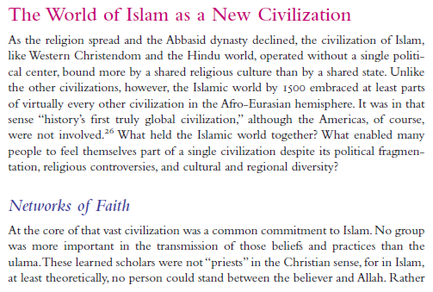
**
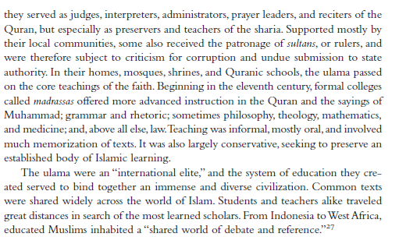
**

**1. Who were the ulama?
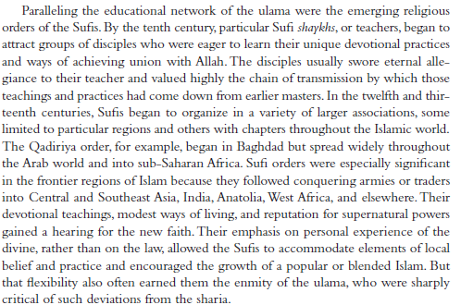
**

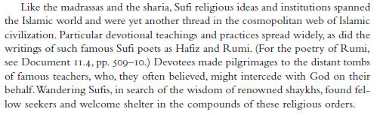
**
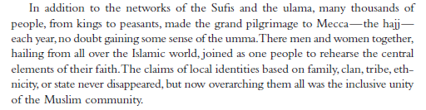
**2. Who were the Sufis?

3. Define umma.

