Welcome to Class! Do Now Please!
Questions/Concerns

Directions: Match each region with their response to Islam in the Post-Clas
**1. How did the Mongols rise to power?

**2. What are some of the effects of the Mongols?

3. (Review Habits of Academic Disourse on back) How will you show professionalism in today’s seminar?

**4. (Review Habits of Academic Disourse on back) What is one grow that you will focus on from our last seminar?

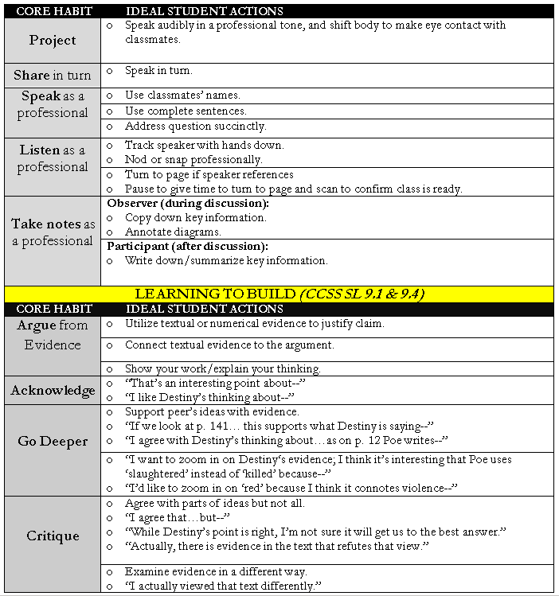

Guided Seminar Notes

Round 1 Review

- What are the causes and effects of the Rise of the Mongols?

- .Refer to your Habits of Academic Discourse handout. What is one habit that we did successfully in this round of discussion?

- What is one habit that we can improve in? How can we improve?

Round 2 Prep

Ultimately, was the rise of the Mongols more beneficial or detrimental to Post-Classical Society?

Exit Ticket

Directions: Using the evidence from our Guided Seminar, please write a paragraph responding to our Guided Seminar Question: What are the causes and effects of the rise of the Mongols? Was their empire more beneficial or detrimental to Post-Classical Society?
___________________________________________________________________________________________
___________________________________________________________________________________________
___________________________________________________________________________________________
___________________________________________________________________________________________
___________________________________________________________________________________________
___________________________________________________________________________________________
___________________________________________________________________________________________
___________________________________________________________________________________________
___________________________________________________________________________________________
___________________________________________________________________________________________
___________________________________________________________________________________________
___________________________________________________________________________________________
___________________________________________________________________________________________
___________________________________________________________________________________________
___________________________________________________________________________________________
___________________________________________________________________________________________
___________________________________________________________________________________________
___________________________________________________________________________________________
___________________________________________________________________________________________
___________________________________________________________________________________________
___________________________________________________________________________________________
___________________________________________________________________________________________
___________________________________________________________________________________________
___________________________________________________________________________________________
___________________________________________________________________________________________
___________________________________________________________________________________________
___________________________________________________________________________________________
___________________________________________________________________________________________
___________________________________________________________________________________________
___________________________________________________________________________________________
___________________________________________________________________________________________
___________________________________________________________________________________________
___________________________________________________________________________________________
___________________________________________________________________________________________
___________________________________________________________________________________________
___________________________________________________________________________________________
___________________________________________________________________________________________
___________________________________________________________________________________________
___________________________________________________________________________________________
___________________________________________________________________________________________
___________________________________________________________________________________________
___________________________________________________________________________________________
___________________________________________________________________________________________
___________________________________________________________________________________________
___________________________________________________________________________________________
___________________________________________________________________________________________
___________________________________________________________________________________________
___________________________________________________________________________________________
Homework
Directions: Read and annotate the text below, making quality marginal notes as you read. Then, answer the questions that follow. ENSURE THAT THIS HOMEWORK IS STAPLED BEFORE TURNING INTO THE FOLDERS!
**Towards the end of the Post-Classical Era, Mesoamerica- modern day Mexico and central America- underwent a period of building- in which new, larger, and more politically unified civilizations were created. The clearest example of this growth is in the Aztec empire. The Aztec were comprised of previously marginalized people who had forcibly taken over and absorbed the original mother cultures of the Americas- the Maya and Olmec primarily. The Aztec were able to rise to power through their military strength, the construction of their capital at Tenochtitlan, and their reliance on trade.

The Aztec were first created by the Mexica people, a semi-nomadic group from northern Mexico who were migrating south. From about 1325, the Mexica had worked to develop their military power.The first way in which the Mexica developed their military power was through being hired as mercenaries. When larger civilizations needed aid, the Mexica would be hired as soldiers to aid in war. This led to not only a large amount of Mexica soldiers being trained firsthand in combat, but also increased the clout and reputation of the Mexica army. This improved reputation led to a military contract known as the Triple Alliance, where the Mexica people and two neighboring city-states were able to come together as one.Over the next 100 years of highly aggressive military conquest, the Triple Alliance was able to unite most of Mesoamerica under one political framework.

**Similarly to the Mongols, the Mexica were able to build their large empire through conquest and strong alliances with their neighboring states.The Aztec Empire was thus born. Yet, with a core population of about 5-6 million people, the Aztec Empire was still very loosely structured. The consistent expansion of the empire and subjugation of captured peoples often led to civil unrest in conquered areas.To curb this rebellion, the Aztec government required conquered peoples and cities to provide free labor for Aztec projects and to regularly deliver to their Aztec rulers tribute- whether it was textiles and clothing, military supplies, jewelry, foodstuffs, animal products, and more.The Aztec government also centralized itself in order to oversee this large empire- with local leaders collecting tribute and being responsible for bringing it to the impressive Aztec capital. We can see that, although the Aztec were completely isolated in Mesoamerica, they still followed some of the same trends of Classical and Post-Classical Afro-Eurasian Empires, particularly in their methods of political control.

**Since the beginning of the Mexica’s conquests, marriage alliances had also been used to expand the power and territory of the empire. This work resulted in the creation of the Aztec capital city, Tenochtitlan. Tenochtitlan was the largest city in the Aztec empire- a metropolis of about 150,000-200,000 people. This city featured numerous canals, causeways, and bridges. A central walled area of palaces and temples lay in the middle of the city, including a pyramid almost 200 feet high. Surrounding the city were “floating gardens”- artificial islands created from swamp lands that supported highly productive agriculture. Vast marketplaces reflected the commercialization of the economy. There was an immaculate water and drainage system throughout the city, along with sewage and garbage disposal. In fact, each day a crew of a thousand women swept and washed the city streets. Ultimately, the size, power, and infrastructure of the capital city of Tenochtitlan aided in the success of the Aztec Empire. This city was not only renowned in the Americas, but was admired by Spanish conquistadores upon their arrival in the 16th century. Similarly to the city of Baghdad in the Middle East, Tenochtitlan was the center of culture, trade, and political control in Mesoamerica- it was the cornerstone of Aztec society.

**In addition, the Aztecs were able to rise to power based on their reliance on trade. Both local and long-distance trade was used in the Aztec Empire. The size of the empire, as well as rapid population growth stimulated the development of trade markets and the production of craft goods. Virtually every settlement, from the capital city to the smallest village, had a marketplace that hummed with activity during weekly market days. Merchants were one of the most powerful classes in Aztec society. Known as pochteca, these merchants were legally commoners, but their wealth often was larger than that of the noble class- as such they enjoyed a large amount of privileges and respect within the empire. This reliance on trade not only increased the amount of goods and cultures being traded within the empire, it also boosted the economy of the Aztec, making it one of the wealthiest empires in the world.

**While the Aztecs were constructing an empire in Mesoamerica, a relatively small community known as the Inca was building the Western Hemisphere’s largest imperial state along the spine of the Andes mountains.We saw in the case of the Aztecs that much of their culture drew on the traditions of the Toltec, the people who ruled the region before them. For the Inca, much of their traditions stemmed from the Chavin and other smaller groups.The Inca were able to rise to power due to their adaptations to the physical environment, their centralized government, and their well-organized economy.

Primarily, the Andes were able to build their empire through adapting to their physical environment. We know that natural barriers such as the Pacific and Atlantic Ocean, and mountain ranges such as the Andes prevented communication and interactions between North America and Latin America during the Ancient and Classical Eras. While the Aztecs and Inca developed independent of one another, the Inca were able to create the Western Hemisphere’s largest empire- all within the inhospitable environment of the Andes Mountains. This adaptation allowed for their entire empire to remain connected.

The Inca build an extensive network of roads and bridges that allowed them to carry a message from one end of the empire to another in about 12 days. The roads were paved with stone, and lined with retaining walls. Even on the narrowest mountain pass, twelve men could walk on the road side by side. Across the gorges formed by the swiftly flowing Andean rivers, the Inca threw suspension bridges made of thick fibers, securing each end with stones. For agriculture, they developed terraced fields to build on the mountainside.

Physically, the Inca had also evolved biologically to meet the demands of their harsh environment. To handle the stress caused by the lack of adequate oxygen at high elevations, their lung capacity was 40% greater than those living at sea level. In addition, their bodies also contained 25% more blood with very high viscosity- their hearts were enlarged by about 40% as a result. In general, the Inca were much shorter and compact, with low centers of gravity.

**Another factor that led to the rise of the Inca Empire was their incredibly well organized government. Unlike the more decentralized Aztecs, the Inca created a bureaucratic empire. At the top reined the emperor, who was viewed as a divine descendant of a god, and each of the approximately eighty provinces had an Inca governor. Subjects within the empire were grouped into hierarchical units of 10, 50, 100, 500, 1,000, 5,000, and 10,000 people, each headed by local officials, who were appointed and supervised by either the Inca governor or the emperor himself. A separate set of “inspectors” provided the imperial center with surveillance on governor’s power. There was even a postal system, which allowed messages to be sent from one province to the next. The record keeping system in the empire, called quipus, allowed for the meticulous collection of population, death, birth, and marriage data. This advanced record keeping and messenger system was used in many successful Classical and Post-Classical Afro-Eurasian Empires, including the Persians, the Tang, and the Song.

With this highly bureaucratic government, the Inca were able to better control the people they conquered. The Inca employed a resettlement program- conquered peoples who were considered a threat were forcibly moved to unfavorable portions of the empire, while the loyal were given the chance to move for promising economic or political opportunities.
**In addition, the leaders of conquered people were required to learn the native Inca language, called Quechua, and their sons were required to go to the capital for instruction on the Inca language and culture. These methods of political control allowed the Inca to grow exponentially and keep power over conquered peoples.

**In addition to geographical and political factors, the Inca were also able to rise to power due to their strong economy. The Inca people, unlike the Aztec, did not require tribute from their conquered peoples- instead, each household in the empire was required to give periodic labor services. Known as mita, this labor system allowed the Inca to build the incredible infrastructure that connected their expansive empire- from the roads, bridges, monuments, and farms.

**1. What factors led to the rise of the Aztec?

**2. What factors led to the rise of the Inca?

**3. What methods of political control did the Aztec and Inca both use?

