Welcome to Class! Do Now Please!
Questions/Concerns:
**1. Which Caliphate was in power before the Abbasid?

**2. What makes a caliphate unique as compared to other forms of political rule?

**3. What led to the spread of Islam in the Post-Classical Era?

**4. What are the Five Pillars?

Teacher Model: Stimulus Based Questions
Key Ideas and Questions:

Source: An Arab Ambassador in Constantinople, late 10th century. In the late tenth century the most powerful states in Western Eurasia were Byzantium and the Abbasid Empire. This item is an extract from the detailed account of an Arab envoy to Constantinople in the late 10th century.
So I proceeded to Constantinople and made my entry after I had been met and most courteously escorted by court officials. I was honourably lodged in the palace of the Kanikleios N'cephorus (the envoy come with me) who stood in favour with the Sovereign. Next I was summoned to the presence of the Chamberlain [i.e., the eunuch Basil], who said: "We are acquainted with the correspondence which bears on your message, but state your views." Thereupon I produced the actual agreement, which he inspected and then said: "Was not the question of relinquishing the land-tax on Abu Taghlib's territory [at Mosul], both past and future, settled with al-Bakilani in accordance with your wishes, and did he not assent to our terms as to restoring the fortresses we had taken, and as to the arrest of Bardas? Your master accepted this agreement and complied with our wishes, for you have his ratification of the truce under his own hand." I said that al-Bakilani had not come to any arrangement at all; he replied that he had not left until he had settled the terms of agreement, of which the ratification under the hand of his sovereign was to be forwarded, and that he had previously produced his letter approving the whole of the stipulations. Accordingly I was driven to find some device in order to meet this position.
1. Which of the following statements is most clearly supported by the text?
- The Abbasid Empire was not recognized as a legitimate empire outside of the Middle East =
- The Abbasid Empire was seen as an ally to the Byzantine Empire
- The Abbasid Empire only interacted with the Byzantines in an effort to promote trade
- The Abbasid Empire interacted with the Byzantine Empire in an effort to ensure that treatise were upheld
2. Which of the following is NOT a method of political control used by the Abbasid Caliphate? The first thing that I’m going to do is circle the word NOT- I know that this means I’m looking for an incorrect answer- one that won’t have any checks at all.
- The use of ambassadors to communicate with other empires
- The creation of treaties
- The use of government entrance exams to gain positions in their large bureaucracy
- The use of religious tolerance

You Do: Stimulus Based Questions

Directions: Using your notes from the teacher model, the document, and your prior knowledge, please answer the questions below. Don’t forget to use check marks!
Source: Among the early chronicles of the Arabs, by far the most celebrated is the many-volumed work of Masoudi, called the "Book of Golden Meadows." It is a collection of interesting and sometimes scandalous anecdotes about anything and everything in the past, but chiefly about the earlier caliphs. Masoudi himself was born at Baghdad, but was, like many of his countrymen, a wanderer. After visiting all lands, he finally selected Egypt as his dwelling-place, and there died, probably in 957.
The Caliph Haroun Al Rashid: Haroun Al Rashid became Caliph in the year A.D. 786, and he ranks among the Caliphs who have been most distinguished by eloquence, learning, and generosity. During the whole of his reign he performed the pilgrimage to Mecca or carried on war with the unbelievers nearly every year. His daily prayers exceeded the number fixed by the law, and he used to perform the pilgrimage on foot, an act which no previous Caliph had done. When he went on pilgrimage he took with him a hundred learned men and their sons, and when he did not perform it himself he sent three hundred substitutes, whom he appareled richly, and whose expenses he defrayed with generosity.

**1. Which of the following statements best defines the role of Haroun AlRashid?
- He was a sultan in the Abbasid Caliphate
- He was a religious and political leader of the Islamic state
- He was a local leader for the Umayyad Caliphate
- He was the successor to the Caliph

**2. The text “His daily prayers exceeded the number fixed by the law, and he used to perform the pilgrimage on foot, an act which no previous Caliph had done” shows that the Caliph followed:
- The Sharia of the Muslim faith
- The Vedas of the Muslim faith
- The Five Pillars of the Muslim faith
- The Ten Commandments of the Muslim faith

3. One limitation of this document is that
- The author was Hindu, and therefore did not know enough about the caliphate
- The author may have been paid to write this by the caliphate, resulting in him showing the Caliph in a more positive light
- None of the above

We Do: Stimulus Based Questions

Directions: Using your notes from the teacher model, the documents, and your prior knowledge, please answer the questions below. Don’t forget to use check marks!
Source: The following opinion was expressed about the Franks by the Muslim commander who conquered Spain (790 CE).
From an Arabian Chronicler
Musa being returned to Damascus, the Caliph Abd-el Melek asked of him about his conquests, saying "Now tell me about these Franks---what is their nature?"
"They," replied Musa, "are a folk right numerous, and full of might: brave and impetuous in the attack, but cowardly and craven in event of defeat."
"And how has passed the war betwixt them and thyself? Favorably or the reverse?"
"The reverse? No, by Allah and the prophet!" spoke Musa. "Never has a company from my army been beaten. And never have the Moslems hesitated to follow me when I have led them; though they were two score to fourscore."
**1. Which of the following methods of political control is best supported by the document?
- The reliance on cross regional allies
- The reliance on military expansion
- The use of mercenaries to expand
- The use of treaties to appease conquered peoples
**2. The use of generals in the Abbasid Caliphate clearly shows their use of:
- A large bureaucracy to continue to expand
- A standardized currency to facilitate trade
- Prisoners of war to gain state secrets
- None of the above

**3. Which of the following is a limitation of the source?
- It was written by a Frank and therefore would favor the opposing military forces
- It was written after the battle and therefore was not a full account
- It was written by an Arab chronicler who was most likely paid by the king
- It was written by a historian as a secondary source

4. The methods of political control seen in this document are most similar to:
- The use of dhow ships to traverse the Sea Roads
- The use of democracy in Athens
- The use of military power in Classical Rome
- The use of civil service exams in Classical India

Exit Ticket

Directions: Using your notes from the teacher model, the documents, and your prior knowledge, please answer the questions below. Don’t forget to use check marks!

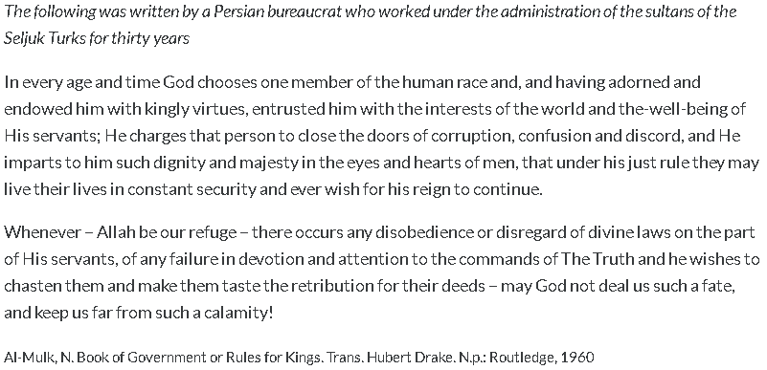

**1. Which of the following best captures the relationship between the religion of Islam and the state in this excerpt?
- Islam exists separately from the state
- Rulers are directly chosen by God due to their great qualities
- The qualities of divinity are utilized as a way to promote Sunni ideals
- The state serves to promote and enforce the teachings of Islam

**2. One limitation of this document may be that
- The author may have been forced to convert
- The author may have been paid to write this by the Caliph
- Western ideals and practices were in wide diffusion in the Middle East
- None of the above

**3 Which of the following political philosophies most closely resembles the one described in the excerpt?
- Christian Monasticism
- Mandate of Heaven
- Athenian Democracy
- Confucian beliefs

Source: Map of the Abbasid Caliphate, circa 900 CE.
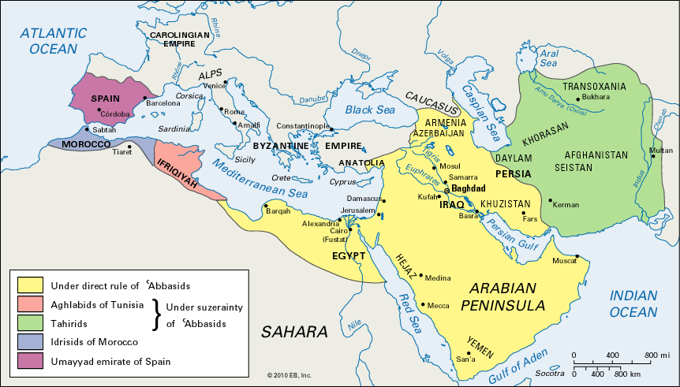

**4. Which of the following contributed to the expansion of the Abbasid Caliphate?
- The use of provincial leaders
- The use of a strong military
- The use of religious tolerance
- The use of terror tactics
- I and II
- II and III
- IV only
- I, II, and III

**5. The different colors in this map most clearly represent:
- Provinces of the Abbasid Caliphate
- City-states in the Abbasid Caliphate
- Allies of the Abbasid caliphate
- None of the above

**6. The map above is most similar to what trend of the Classical Era?
- Long-distance trade
- The use of Commanderies and satraps
- The use of a standardized currency
- The use of advanced technology such as dhow ships

Homework – Spiral Review
Directions: Please answer the questions below in complete sentences.

**1. Identify and explain two factors that led to the creation of Islam.

**2. What AP Region was Islam founded in? Who was the founder?

**3. What are the Five Pillars of Islam?

**4. Define a caliphate.

**5. Identify and describe two political structures of the Abbasid.

*6. Identify and describe two similarities between Islam and Christianity.

7. Why did these similarities exist between Islam and Christianity?

*8. Identify and describe two similarities between Judaism and Christianity.

