Welcome to Class! Do Now Please!
Questions/Concerns:
- **Which of the following best describes the Warring States Period within China?

  - A time period in which warlords and clans vied for political power in China.
  - A time period in which the Han Dynasty overthrew the Qin Dynasty.
  - A time period in which the Qin Dynasty overthrew the Han Dynasty.
  - A time period in which the Mandate of Heaven belonged to the Qin Dynasty.

- **The Qin Dynasty within Classical China was directly influenced by:

  - Daoism
  - Confucianism
  - Legalism
  - Buddhism

- What was not method used by Emperor Qin to strengthen his rule in China?

  - Focusing on limiting the amount of lands under his control.
  - Killing and eliminating scholars who opposed his methods of governing.
  - Creating a unified system of weights and measures throughout China.
  - Using lower class laborers to build the Great Wall of China for security reasons.

- ((Which of the following is the best definition of the Mandate of Heaven?

  - A ruler’s power was absolute as a result of having the support of the gods and could do anything to maintain power and control over the Chinese people.
  - A ruler’s power was directly tied to the will of the gods and the ruler must rule wisely in favor of the people to maintain power.
  - A ruler’s power was directly given to him or her by the Chinese people and must remain loyal to the people.
  - A ruler’s power was the result of having the most military power in China.

Document Analysis
Prompt: To what extent were the Qin and Han dynasties similar in Classical China?
Scope :
Topic:
HTS:
Re-Written Question:

Context

ERA: Classical

PLACE: Han and Qin China, East Asia
TRENDS: Era of Warring States leads to Confucianism, Daoism, Legalism, Qin end EWS with legalist government, centralization, standardization
OEV

Qin Dynasty = legalism, harsh punishment/quick rewards
Standardization, Great Wall

Han Dynasty= Confucianism, infrastructure, urbanization, social stratification

Source 6.5: Excerpts from Bret Hinsch’s Women in Early Imperial China, 2010.

[1] [The bureaucracy of the Qin and Han Empires] coupled with [political] unity allowed China’s resources to be organized on an unprecedented scale. Emperors constructed lengthy canals, impressive fortifications, grand irrigation works, and an admirable network of roads. However, the price for such efficiency was the alienation of most people from the workings of the government. Unlike Athens or the Roman Republic, for example, where the governed had some say in their government, ordinary people in early imperial China were far removed from decision making...

[2] Early imperial China was also noteworthy for its urbanization. The earliest Chinese cities were primarily centers of ritual and administration. But during the Qin and Han, many cities across north China had become sizable commercial centers. The standardization of currency during the Qin no doubt stimulated long-distance trade.

[3] Merchants traded in a wide variety of goods. Some merchants gained enormous wealth and invested it in land, decreasing the number of fields available to free peasants. In this way, the thriving commercial economy brought inequality and poverty to the countryside.

[4] [Many in the Han Empire] believed that individual interests should be sacrificed to strengthen the kin group. Grandparents, parents, sons, and daughters-in-law should all live and work together. The young should obey the old. And the property of kinfolk should be held in common and managed by family elders. Nowadays these ideas are often called “Confucian.” Although these values did indeed gain most prominence through Confucianism, they long predate Confucius.

Significance Statement (Complete sentences, answers MIQ):

PARAPHRASED evidence to support:

Source 6.6: Map of the Qin and Han dynasties, c. 200 BCE.
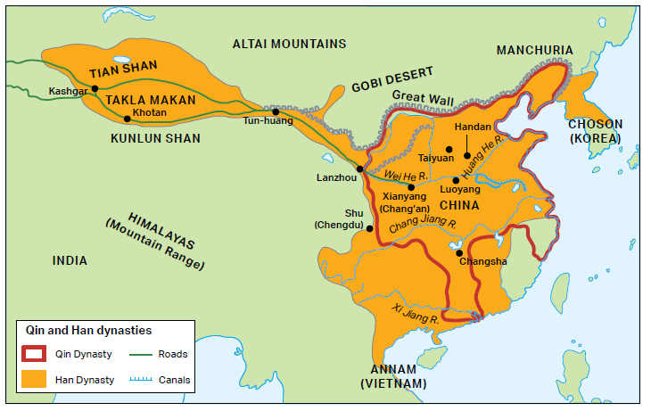

Significance Statement (Complete sentences, answers MIQ):

PARAPHRASED evidence to support:

Observe and Analyze

1. **What are some similarities and differences between the Han and Qin empires, or dynasties, mentioned or depicted in these sources?

2. **According to Hinsch, what were some of the benefits and drawbacks of the Han Dynasty’s political and economic structures?

3. To serve in the Han Dynasty, one had to pass examinations that supported Confucian principles. The Han Dynasty founded schools of Confucian thought. Based upon the description of Confucian ideas by Hinsch, how did this differ from Legalism?

4. **Use the following sentence stems to make separate contrasts between the Qin and
Han dynasties:

While the Qin Dynasty ________________________________________________________________________,

the Han Dynasty _____________________________________________________________________________.

While the Qin Dynasty ________________________________________________________________________,

the Han Dynasty _____________________________________________________________________________.

Exit Ticket
Directions: Answer the question below by writing one analytical thesis statement to the guiding prompt. In your response, be sure to fully answer the prompt with specific reasons. (Use the sentence stem Both (similarities). However, while __________, ________ (difference)).

Guiding Prompt: To what extent were the Qin and Han dynasties similar in Classical China?

___________________________________________________________________________________________
___________________________________________________________________________________________
___________________________________________________________________________________________
___________________________________________________________________________________________
___________________________________________________________________________________________
___________________________________________________________________________________________
___________________________________________________________________________________________

FEEDBACK
ARGUMENTATION:
- “To what extent” means take a stand- are they only similar? Only different? Both?
- Thesis statements are analytical when they briefly explain how and why.
- Ensure that you’ve answered all parts of the prompt.
- Historical thinking skill is weak or inaccurate (COMPARISON)
- Use the most relevant historical key terms.
- Some or all parts are not historically defensible (inaccurate).

GRAMMAR & SYNTAX
- Capitalize proper nouns
- Use the past tense when writing about history
- Use a transition phrase to connect two ideas.

Homework
Directions: Please answer the questions below in complete sentences.
**1. Define legalism.

**2. Define Confucianism.

3. Define Daoism.

**4. What was the Era of Warring States?

5. How did the Qin choose to rule China?

**6. What is the dynastic cycle?

**7. What is the Mandate of Heaven?

8. How did the Han choose to rule China?

Unprecedented: never before seen or occurred.
Canals: manmade rivers.
Fortifications: defensive structures, such as walls or towers.
Alienation: the process of turning someone against someone or something.
Urbanization: the process of expanding cities
Commercial: relating to the buying and selling of goods or services.
Standardization: to make something the same as others.
Currency: money
Thriving: do well, grow well
Kin: family group, blood relations
Prominence: well-known, importance

