Welcome to Class! Do Now Please!
Questions/Concerns:
**1. What was the ‘warring states’ period?

**2. What philosophy did the Qin follow?

3. How did the Qin unify China in only 10 years?

4. What does “Shihuangdi” mean?

**5. How did Qin Shihuangdi respond to those who opposed him?

6. What were the positive impacts of Qin rule in China?

Document Analysis
Prompt: To what extent did China change under the rule of Qin Shihuangdi?
Scope :
Topic:
HTS:
Re-Written Question:

Source 6.1: Map of the Warring States of China, c. 260 BCE

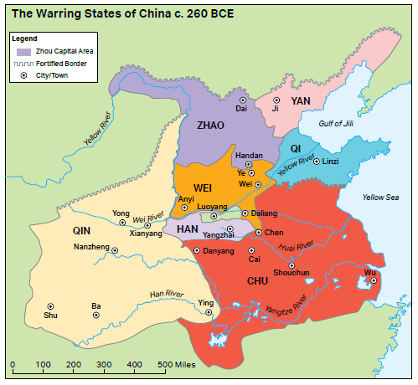
Significance Statement: (Complete sentences, answers MIQ)

Source 6.2: The words of Qin Shihuangdi (ruled 221–210 BCE) in an inscription on a stone tower that was built on Mount Langya (east of Linzi on the coast of China).

A new age is inaugurated by the Emperor; Rules and measures are corrected,
Many things set in order, Human affairs are made clear
And there is harmony between fathers and sons

No evil or impropriety is allowed… The common people know peace
Significance Statement: (Complete sentences, answers MIQ)
And have laid aside weapons and armor; Kinsmen care for each other,
There are no robbers or thieves; Men delight in his rule,
All understanding the law and discipline.

The emperor set forth to pacify the east, To inspect officers and men;
This great task accomplished He visited the coast.
Great are the Emperor’s achievements,

All the common people prosper; Tools and measures are made uniform,
The written script is standardized.
Observe and Analyze

**1. During the Warring States Period, many states mounted military campaigns in attempts to conquer other states. Looking at the map, which states had to defend all of their borders from potential invaders? Which states had to defend a small portion of their borders from potential invaders?

2. Compare the map to the changes described in the last two lines of the Mount Langya tower inscription. What would be the benefits of these changes? Why would these achievements be such a change from the past?

3. Given the location of the stone tower in which Qin Shi Huangdi made his inscription, who was the intended audience and what was the tower’s purpose? How does the use of the term pacify instead of conquer reflect the audience and purpose?

**4. Use the following sentence stems to compare the Warring States to the start of the Qin Dynasty:

Qin Shi Huangdi claimed to pacify the East because __________________________________________________
___________________________________________________________________________________________.
Qin Shi Huangdi claimed to pacify the East, but _____________________________________________________
___________________________________________________________________________________________.

Source 6.3: Excerpt from Han Fei Tzu’s Basic Writings, c. third century BCE, translated by Burton Watson, New York: Columbia University Press, 1964.

When a man of true worth becomes a minister, he faces north before the sovereign, presents tokens of his allegiance, and banishes from his mind the thought of all other loyalties. If he serves at court, he does not venture to excuse himself because of the lowliness of the post assigned him; if he serves in the army, he does not dare to avoid danger. He follows the lead of his superiors and obeys the laws of his sovereign; with empty mind he awaits orders and does not question whet her they are right or wrong. Thus, though he has a mouth, he never uses it to speak for private advantage; though he has eyes, he never employs them to spy private gain; in all things he is under the control of his superior. … For his part, the ruler must never make selfish use of his wise ministers or able men. So the people are never tempted to go beyond their communities to form friendships, nor need they worry about what happens a hundred miles away. Honorable and humble do not get in each other’s way, and stupid and wise find their proper place. This is the perfection of good government.

Significance Statement: (Complete sentences, answers MIQ)

Source 6.4: Excerpt from Edgar Kiser and Yong Cai’s “War and Bureaucratization in Qin China: Exploring an Anomalous Case,” 2003.

Legalists developed a philosophy of power stressing the role of absolute monarchy and arguing that rule should be based on clear laws and on strong, nondiscriminatory incentives and punishments. The focus on incentives without preferential treatment threatened and offended the aristocracy, and it is thus safe to assume that these ideas would not have been implemented if aristocrats were powerful enough to stop them.

Significance Statement: (Complete sentences, answers MIQ)

Observe and Analyze

**5. According to the ideas of Legalism, what should be the relationship between rulers and their ministers?

6. Emperor Qin Shi Huangdi was a fervent supporter of Legalism who, on occasion, ordered books of other philosophies to be burned. How does his inscription on Mount Langya relate to Han Fei Tzu’s Legalist teachings in this passage?

7. Revisit the claims Kiser and Cai make in the last sentence regarding the aristocracy’s reaction to Qin reforms. How does the excerpt from Han Fei Tzu’s Basic Writings relate to goals that wealthy aristocratic families likely sought to achieve?

**8. Use the sources to complete the following sentence stems:

Han Fei Tzu taught that Legalist principles would be beneficial because __________________________________

___________________________________________________________________________________________.

Han Fei Tzu taught that Legalist principles would be beneficial, but _____________________________________

___________________________________________________________________________________________.

Exit Ticket

**1. All of the following are changes instituted by Qin Shihuangdi EXCEPT:

- standardization of Chinese script.
- establishment of the first Chinese state.
- burning of books critical of the Qin.
- use of Legalism as the official government philosophy.

**2. Legalism proposes order in society is maintained through:

- proper relationships between superiors and inferiors.
- doing as little as possible to upset cosmic harmony.
- aristocrats controlling their local territory.
- clear laws and harsh punishments.

**3. Which of the following modern examples would a Legalist approve of?

- The Chinese government forces all minorities to learn to write using Chinese script.
- The Chinese government allows religious freedom and freedom of speech.
- Chinese officials use their posts to give building permits to contractors who pay bribes.
- Punishments for crimes should be light and focus on rehabilitation.

**4. Legalism was created:
- As a result of the Era of Warring States
- By Emperor Shi Huangdi
- Before the Era of Warring States
- By Emperor Wu

Homework
Directions: Please read and annotate the text below, including quality marginal notes. Then, answer the questions that follow.
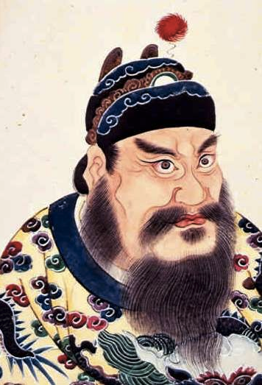
The Qin Dynasty
**Qin Shi Huangdi was a Legalist, and it showed. Shortly after he took power, he clamped down on freedom of expression. The Han Dynasty historian Sima Qian, who wrote roughly a century after the founding of the Qin Dynasty, quoted the emperor as saying:

**“[Historians] hold it a mark of fame to defy the ruler, regard it as lofty to take a dissenting stance, and they lead the lesser officials in fabricating slander. If behavior such as this is not prohibited, then in upper circles the authority of the ruler will be compromised, and in lower ones, cliques will form. Therefore it should be prohibited. I therefore request that all records of the historians other than those of the state of Qin be burned.”

And, indeed, there was a clampdown on the scholars of China. Many texts from non-Legalist philosophies were burned, and tradition holds—per Sima Qian—that Qin Shi Huangdi ordered 460 Confucian scholars buried alive. This mass burial may not have happened as described, however. Sima Qian, as a committed Confucian, may have embellished the truth of it to make Qin Shi Huangdi seem more immoral.

**The emperor's legalism touched everything. Qin Shi Huangdi abolished the divisions between the once-warring states and blunted the power of the aristocracy, establishing instead an imperial bureaucracy that could rule the peasantry directly, all in the name of national unity. This imperial control touched every life in China, as Patricia Buckley Ebrey writes in The Cambridge Illustrated History of China:

**”Ordinary people also suffered harsh treatment. Reporting crimes was rewarded, and the lawbreakers, once convicted, were punished severely by execution, hard labour, or mutilation (ranging from cutting off the whiskers to the nose or the left foot). Even perfectly law-abiding people were subject to onerous labour service, and both conscripted and penal labour were used for the building of palaces, roads, canals, imperial tombs, and fortifications [like walls and fortresses]. Several hundred thousand subjects were conscripted to build a huge new palace complex in 212 BC. Even more were drafted to construct the Great Wall. (p. 63)”

**The Qin Dynasty marks the period during which much of the original Great Wall of China was constructed—though little of that wall remains today. Defensive walls that formerly divided the warring states were knocked down to be rebuilt along China's northern border in order to keep out the Xiongnu, pastoralist horsemen from the northern steppes—a kind of dry grassland or open prairie—who raided agricultural settlements.
Qin Shi Huangdi’s court minted coins, standardized weights and measures, and even went so far as to standardize the length of cart axles so that all trade wagons could move along the same wheel ruts in the road.

**Perhaps most notably, the emperor commanded the use of a common written language across China. The newly unified country was composed of people who spoke very different languages, but Qin Shi Huangdi demanded that those different languages all be rendered in the same script. This enabled his edicts to be understood throughout the empire.

The First Emperor of the Qin survived multiple attempts on his life and grew obsessed with the idea of living forever. He was furious with those he perceived to have already achieved immortality. Sima Qian tells a story of how Qin Shi Huangdi cut down a holy grove just to spite a god. Qin Shi Huangdi sent out expeditions to find Peng Lai—the land of Chinese immortals—and he dispatched teams of scholars to hunt for the lingzhi mushroom, which he felt would bestow upon him eternal life.

Striving for immortality proved to be the Emperor's undoing. In 210 BCE, legend holds, he fell ill from mercury poisoning—thought to be an important component of the elixir of life—and died, throwing the empire into chaos. The imperial palace became tangled with intrigue. Heirs and their retainers—servants—were repeatedly murdered, and in the outlying provinces, popular uprisings began.

**1. Why might Qin Shi Huangdi have wanted to suppress historians?

**2. What was the benefit of standardizing weights, measurements, currency, and language?

3. What happened to Shi Huangdi? Why?

Inaugurated: begun
Pacify: to bring peace to
Minister: servant/advisor to the emperor/ruler
Sovereign: the ruler
Aristocracy: people of the highest class, usually in China landowners who had private soldiers and had power over local peasants. Aristocrats usually pass their title, land, and power to their sons.

