Welcome to Class! Do Now Please!
Question/Concerns:

Directions: Please read and annotate the text below. Then, answer the questions that follow.
Source: Cracking the AP World History Exam.
The Tang Dynasty ruled China beginning in 618 CE. Under emperor Xuanzong, the Tang expanded Chinese territory into parts of Manchuria, Mongolia, Tibet, and Korea (see map below). From the seventh to the thirteenth centuries, the Tang and then later the Song Dynasties in China were accomplished in virtually every category of human endeavor- art, architecture, science, philosophy, porcelain-making, silk-weaving, construction of transportation systems, and more.
At the height of both the Tang and Song Dynasties, China was relatively stable. One of the many reasons for the stability was the bureaucratic system that was based on merit through the use of the civil service examinations first developed by the Han. Because of the power of the dynasties were based on trade and expansion, each developed an urban base to pursue their economic and political strategies.
Under the Tang Dynasty, by 907, the empire had become so large that local warlords gained more and more power, and the Tang Dynasty collapsed. After a brief era of chaos, the Song took power, creating their new dynasty in 980 CE.
**1. What dynasty first created the civil service system?

**2. What were some of the accomplishments of the Tang and Song?

Lecture CFU
Directions: Using your Lecture Notes, please answer the questions below.
**1. How did the Tang and Song build on the success of past dynasties?

**2. Why were the Tang and Song dynasties seen as the “Golden Age” of Chinese culture?

Exit Ticket
Directions: Answer parts A and B.
- List and describe one way that the Tang and Song built on the success of previous dynasties.
- List and describe two innovations that are unique to the Tang and Song.
- Should the rule of the Tang and Song dynasties be considered the “Chinese Golden Age”? Explain.

___________________________________________________________________________________________
___________________________________________________________________________________________
___________________________________________________________________________________________
___________________________________________________________________________________________
___________________________________________________________________________________________
___________________________________________________________________________________________
___________________________________________________________________________________________
___________________________________________________________________________________________
___________________________________________________________________________________________
___________________________________________________________________________________________
___________________________________________________________________________________________
___________________________________________________________________________________________
___________________________________________________________________________________________
___________________________________________________________________________________________
___________________________________________________________________________________________
___________________________________________________________________________________________
___________________________________________________________________________________________
___________________________________________________________________________________________
___________________________________________________________________________________________
___________________________________________________________________________________________
___________________________________________________________________________________________
___________________________________________________________________________________________
___________________________________________________________________________________________
___________________________________________________________________________________________
___________________________________________________________________________________________
___________________________________________________________________________________________
___________________________________________________________________________________________
___________________________________________________________________________________________
___________________________________________________________________________________________
___________________________________________________________________________________________
___________________________________________________________________________________________
___________________________________________________________________________________________
___________________________________________________________________________________________
___________________________________________________________________________________________
___________________________________________________________________________________________
___________________________________________________________________________________________
___________________________________________________________________________________________
___________________________________________________________________________________________
___________________________________________________________________________________________
___________________________________________________________________________________________
___________________________________________________________________________________________
___________________________________________________________________________________________
___________________________________________________________________________________________
___________________________________________________________________________________________
___________________________________________________________________________________________
___________________________________________________________________________________________
Homework
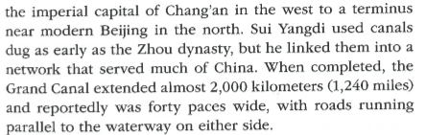
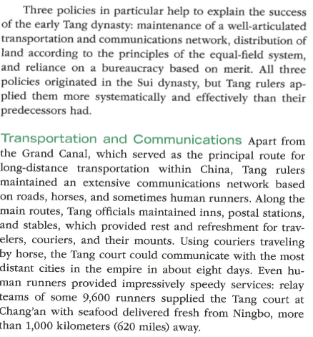
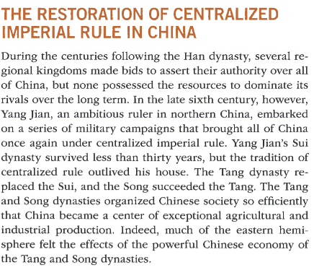
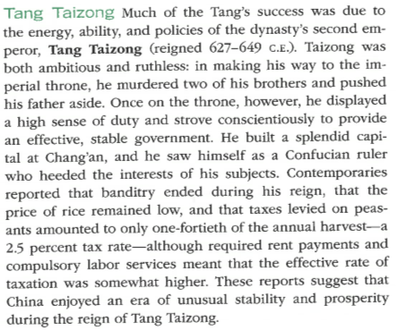
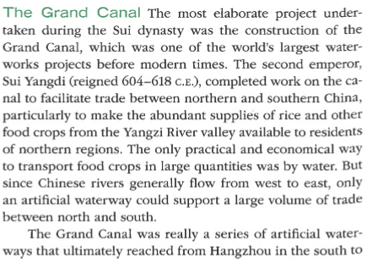
Directions: Complete CN on the text below. Ensure that you bring your notebook to class to be graded!
