|  |
| --- |
| **Welcome to Class! Do Now Please!** |

|  |
| --- |
| Questions/Concerns: |

**1. What trade routes did West Africa have access to in the Post-Classical Era?

**2. What technology made these trade routes possible?

**3. What items did Mali and Ghana trade?

**4. What are two effects of long-distance trade?

**Document Analysis**

Prompt**:** *What role did West Africa play in Afro-Eurasian trade during the Post-Classical Era?*

Scope:

Topic:

HTS:

Re-Written Question:

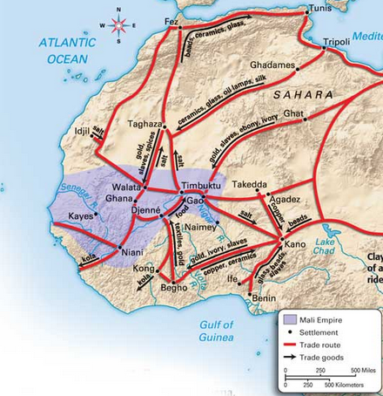**Document 1**

Source: Goods traded through the Mali Empire, Post-Classical Era.

**Significance***: What role did West Africa play in Afro-Eurasian trade during the Post-Classical Era?*

**Document 2**

Source: Antonio Malfante, a European Merchant, wrote this letter in the central Sahara in 1447 CE, to a colleague in Europe, who is also interested in trading in West Africa. He seems to have traveled widely in the region and was eager to report what he thought he learned about places he did not visit directly.

This locality is a part of the country of the African Muslims to which merchants come to sell their goods: gold is carried hither, and bought by those who come up from the coast. There are many rich men here. It is true that the Arabs with whom I came from the coast brought with them corn and barley which they sell to the Africans throughout the year.

The wares for which there is demand here are many: but the principal articles are copper, and salt. The copper of the Byzantines, which is obtained through Alexandria, is always in great demand throughout the land of the Blacks. The Egyptian merchants come to trade here with half a million head of cattle and camels- a figure that is not fantastic in this region.

The place where I am is good for trade, as the Egyptians and other merchants come hither from the land of the Blacks bring in gold, which they exchange for copper and other goods. Thus everything sells well, there is nothing left or sale.

**Document 3**

Source: Candace Goucher and Linda Walton “Trade, Transport, Temples, and Tribute: The Economics of Power” (1998).

Of the numerous empires that emergend o nthe African continent, Mali was one of the first south fo the Sahara to capture the attention of both the Islamic and European worlds. The capital of Mali, Niani, was an area rich in iron and ogld. It was well situated on the forest edge to become the intersection of extensive trade routes that linked the different econoloical zones of the empire. The caravans of gold made the Mali Empire a celbrated name far beyond West Africa. The caravan routes met at Niani and other staging posts, and their protection was a major function of the empire. Gold, salt, copper, and kola nuts were central to Mali’s economy. And soon, Mali became the world’s largest producer of gold.

Along with the movement of material goods went the dissemination of the Mali language, Mande, along with technology and culture. Even later, the empire would serve as a major promoter of Islamic ideaology and culture across the West African savanna.

Management of the Trans-Saharan Trade Network was a central feautre of the Ghana, Mali, and Songhai Empires, notably due to their geographic location. These empires were situated on an area that straddled the desert and the savanna. The exchange between these regions supplied not only a diverse amount of products, but also a lucrative source of income.

**Significance***: What role did West Africa play in Afro-Eurasian trade during the Post-Classical Era?*

**Document 4**

Source: Ibn Battuta, *Travels in Asia and Africa* (1325-1354 CE). In this excerpt, Battuta describes the challenges of mining salt in West Africa.

From Morroco I traveled with the suite of our Sultan to Fez, where I then set out for the Negrolands. I then set out with a caravan, including, amongst others, a numer of merchants. After twenty five days we reached Taghaza, an untractive village with the curious feature that its houses and mosques are bult o f blocks of salt, roofed with camel skins. In te sand is a salt mine; they dig fo rthe salt and find it in thick slabs. A camel will carry two of these slabs. No one lives at Taghaza except slaves, who dig for the salt.

The negroes come up from their country and take salt away from there… the negroes use salt as a medium of exchange, just as gold and silver is used elsewhere; they cut it up into pieces and buy and sell with it.

**Exit Ticket**



Source: This detail from the *Catalan Atlas,* a series of maps issued in Spain in 1375, illustrates Mali’s reputation in Europe for its great wealth in gold. This reputation later propelled Portugese voyages down the west coast of Africa in search of direct access to that wealth.

Ancient West African Proverb: “Salt comes from the north, gold from the south, and silver from the country of white men, but the word of God and the treasures of wisdom are to be found only in Timbuktu.”

**1. The trade and cultural links with the Islamic world, on which Timbuktu’s growth depended, could not have been forged without:

1. Horses
2. Camels
3. The lateen sail
4. Wagons capable of traversing the desert

**2. The sponsorship of which of the following rulers brought both trade and scholarship to Timbuktu?

1. Sundiata
2. Ibn Battuta
3. Sunni Ali
4. Mansa Musa

3. Which of the following Islamic traditions encouraged the development of Timbuktu?

1. The *hajj*, or annual pilgimage to Mecca
2. *Zakat*, the tradition of giving alms to the poor
3. The *shahadah*, or profession of faith
4. *Salat*, praying five times a day facing Mecca

**Homework**

**Directions**: Read and annotate the text below, ***making quality marginal notes as you read.*** Then, answer the questions that follow.

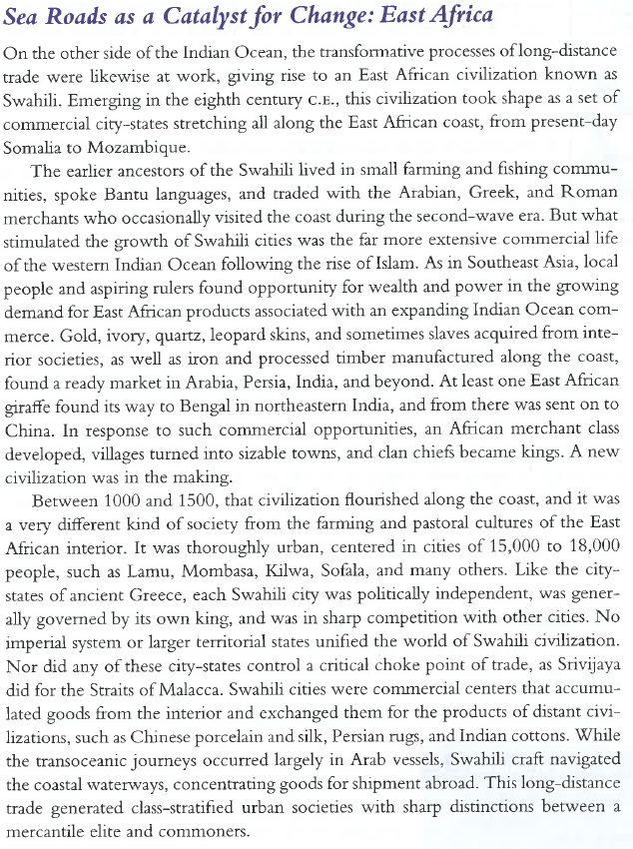

**\*\***

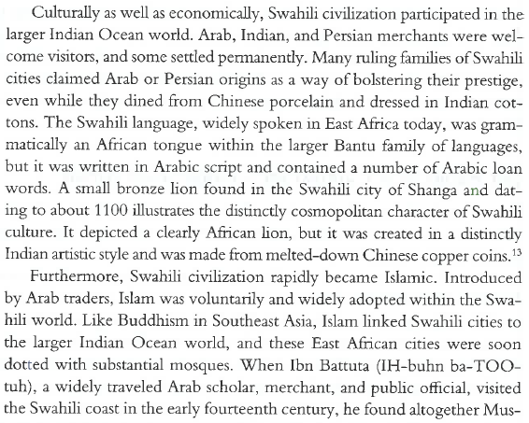

**\*\***

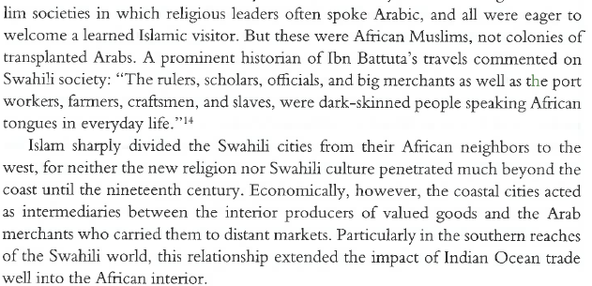

**\*\***

**1. What were the impacts of long-distance trade on East Africa? (Name at least two effects)

**2. How did East and West Africa differ in this time period?