Welcome to Class! Do Now Please!
Questions/Concerns:

**1. What led to the spread of Christianity in the Classical Era?

**2. What led to the spread of Buddhism in the Classical Era?

Directions: Using the Do Now, your Cornell Notes, and your prior knowledge, please answer the question below.

**1. Infer: What factors caused the spread of Islam in the Post-Classical Era?

Document Analysis
Directions: Please read and analyze the documents below using the Four Corners Method. Recall that your significance statement should answer our main inquiry question: What led to the spread of Islam in the Post-Classical Era?

Scope:
Topic:
HTS:
Re-Written Question:

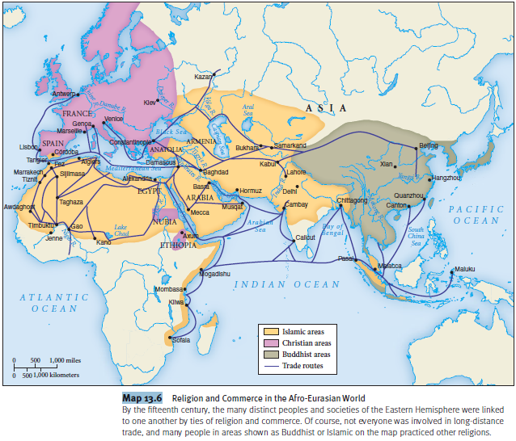
Document 1
Source: Religion and Commerce in the Afro-Eurasian World (2011). Used in Robert Strayer’s Ways of the World.

Significance: What led to the spread of Islam in the Post-Classical Era?

Document 2
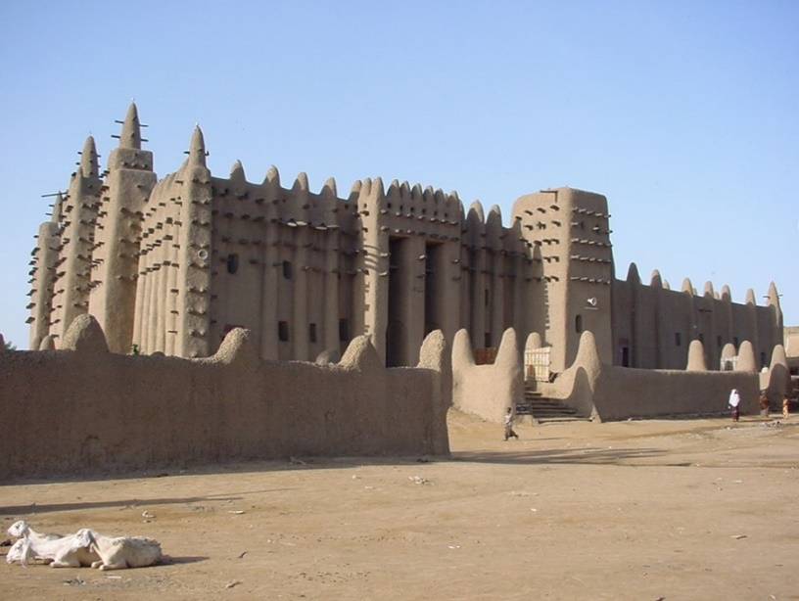
Source: Metropolitan Museum of Art Online Resource.

Local Mixes of Islamic and African Traditions

Islam has often existed side by side with other traditional African traditions such as masquerading. Such practices have often been viewed as supplemental rather than oppositional to Islam, particularly when they are seen as effective or operating outside the central concerns of the faith. Although Islam has influenced a wide range of artistic practices in Africa since its introduction, monumental architecture is the best-preserved legacy of its early history on the continent. Mosques are the most important architectural examples of the tremendous aesthetic diversity generate by the interaction between African peoples and the Islamic faith. An example of this can be seen in the mosque below. Called the Great Mosque of Djenne, this mosque was first built in the 13th century CE, and was restored and expanded in 1907.

Significance: What led to the spread of Islam in the Post-Classical Era?

Document 3

Source. The Quran 2:177.

Righteousness is not that you turn your faces toward the east or the west, but true righteousness is in one who believes in All, the Last Day, the angels, the Book, and the prophets and gives wealth, in spite of love for it, to relatives, orphans, the needy, the traveler, those who ask for help, and for freeing slaves; and who establishes prayer and gives zakah; to those who fulfill their promise when they promise; and those who are patient in poverty and hardship and during battle. Those are the ones who have been true, and it is those who are the righteous.

Document 4

Source: Ibn Muslama’s Pact with the Christians of Tiflis (653 CE). One question that faced the conquering Islamic armies was how to deal with their non-Muslim subjects, particularly Jews and Christians. The Quran morbidly forbids forced conversions, and the Prophets own actions underscored that prohibition. In 628 Muhammad entered into a contract with an Arabic Jewish tribe at the oasis of Khayabar, whereby he guaranteed to defend them and respect their religious practices in return for their submission, assistance, and payment of tribute. This contract of protection became the norm for Islam’s generals and statesmen as Arab armies expanded out of the peninsula. The excerpt below is a pact of peace offered to the Christian inhabitants of the city of Tiflis, known as dhimmis or people of the book.

“In the name of Allah, the compassionate, the merciful. This is a statement from Habib ibn-Muslama to the inhabitants of Tiflus… securing them safety for their lives, churches, covenants, religious services, and faith, provided they acknowledge their humiliation and pay tax to the amount of one dinar on every household. You own us counsel and support against the enemies Allah and his Prophet to the utmost of your ability […] If you return to the obedience of Allah and observe prayer, you are out brethren in faith, otherwise poll-tax is incumbent upon you.

Exit Ticket
Answer parts A and B.

“Trade was the single most important factor in the spread of Islam in the Post-Classical Era.”

A. Explain one piece of specific evidence that supports this claim.
B. Explain two pieces of specific evidence that refute this claim.

___________________________________________________________________________________________

___________________________________________________________________________________________

___________________________________________________________________________________________

___________________________________________________________________________________________

___________________________________________________________________________________________

___________________________________________________________________________________________

___________________________________________________________________________________________

___________________________________________________________________________________________

___________________________________________________________________________________________

___________________________________________________________________________________________

___________________________________________________________________________________________

___________________________________________________________________________________________

___________________________________________________________________________________________

___________________________________________________________________________________________

___________________________________________________________________________________________

___________________________________________________________________________________________

___________________________________________________________________________________________

___________________________________________________________________________________________

___________________________________________________________________________________________

___________________________________________________________________________________________

___________________________________________________________________________________________

___________________________________________________________________________________________

___________________________________________________________________________________________

___________________________________________________________________________________________

___________________________________________________________________________________________

___________________________________________________________________________________________

___________________________________________________________________________________________

___________________________________________________________________________________________

___________________________________________________________________________________________

___________________________________________________________________________________________

___________________________________________________________________________________________

___________________________________________________________________________________________

___________________________________________________________________________________________

___________________________________________________________________________________________

___________________________________________________________________________________________

___________________________________________________________________________________________

___________________________________________________________________________________________

___________________________________________________________________________________________

___________________________________________________________________________________________

___________________________________________________________________________________________

___________________________________________________________________________________________

___________________________________________________________________________________________

___________________________________________________________________________________________

___________________________________________________________________________________________

___________________________________________________________________________________________

Homework
Directions: Please answer the questions below using your Grade Report.
**1. What was your HW Average for History in Q2? (This can be found on the bottom of the back of your grade report) _____________
**2. What was your Classwork Average for History in Q2? (This can be found on the bottom of the back of your grade report) _____________
**3. What was your Test Average for History in Q2? (This can be found on the bottom of the back of your grade report) _____________
**4. What was your Quiz Average for History in Q2? (This can be found on the bottom of the back of your grade report) _____________
**5. How many of your HW assignments were marked as a 70% or below? Why was this the case?

**6. How many classwork or homework grades are zeros? Why was this the case?

**7. How many times per week did you check your history grade? How many times did you use the classroom website to obtain missing work and complete that work?

**8. What are you most proud of in regards to your history grade this quarter?

**9. What do you need to improve upon in history class this quarter? Write a SMART goal below.

