Welcome to Class! Do Now Please!
Questions/Concerns

Directions: Match each region with their response to Islam in the Post-Classical Era.
- **Middle East ______ | - Delhi Sultanate is created in the north, Chola Kingdom is created in the south- Delhi sultanate is more affected by Islam
- **East Africa ______ | - Diffused Muslim culture with Jewish and Christian culture, home to the largest mosque in the world at La Mezquita in Cordoba
- South East Asia ______ | - Diffused Muslim culture with local beliefs, created sultanates and included Muslim symbols on flags
- **South Asia ______ | - Islam spreads to this region as a result of the Indian Ocean Trade Basin and the Silk Roads and included large-scale conversions of the population
- **Spain ______ | - Region in which Islam was founded, largest population of Muslims today
- West Africa ______ | - Islam spreads in this region as a result of the Sand Roads- most well-known for Gold exports and the city of Timbuktu

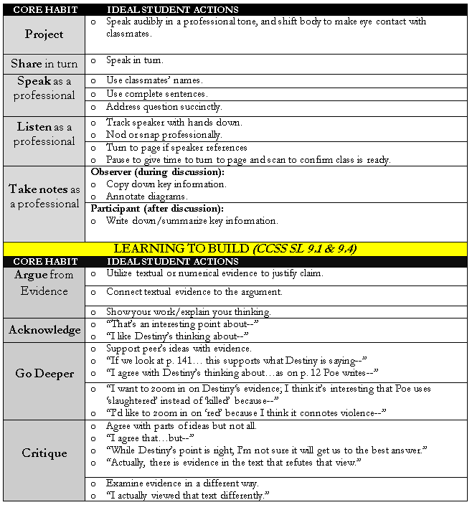

Guided Discussion Notes
Round 1 Question: How did regions respond differently to the arrival of Islam?

Round 2 Question: Why did these regions respond in different ways?

Round 1 Review

- How did different religions respond to the arrival of Islam?

- Refer to your Habits of Academic Discourse handout. What is one habit that we did successfully in this round of discussion?

- What is one habit that we can improve in? How can we improve?

Round 2 Prep

- Why did these regions respond in different ways?

Exit Ticket

Directions: Using the evidence from our Guided Seminar, please write a paragraph responding to our Guided Seminar Question: How did regions respond differently to the arrival of Islam? Why did these regions respond in different ways?
___________________________________________________________________________________________
___________________________________________________________________________________________
___________________________________________________________________________________________
___________________________________________________________________________________________
___________________________________________________________________________________________
___________________________________________________________________________________________
___________________________________________________________________________________________
___________________________________________________________________________________________
___________________________________________________________________________________________
___________________________________________________________________________________________
___________________________________________________________________________________________
___________________________________________________________________________________________
___________________________________________________________________________________________
___________________________________________________________________________________________
___________________________________________________________________________________________
___________________________________________________________________________________________
___________________________________________________________________________________________
___________________________________________________________________________________________
___________________________________________________________________________________________
___________________________________________________________________________________________
___________________________________________________________________________________________
___________________________________________________________________________________________
___________________________________________________________________________________________
___________________________________________________________________________________________
___________________________________________________________________________________________
___________________________________________________________________________________________
___________________________________________________________________________________________
___________________________________________________________________________________________
___________________________________________________________________________________________
___________________________________________________________________________________________
___________________________________________________________________________________________
___________________________________________________________________________________________
___________________________________________________________________________________________
___________________________________________________________________________________________
___________________________________________________________________________________________
___________________________________________________________________________________________
___________________________________________________________________________________________
___________________________________________________________________________________________
___________________________________________________________________________________________
___________________________________________________________________________________________
___________________________________________________________________________________________
___________________________________________________________________________________________
___________________________________________________________________________________________
___________________________________________________________________________________________
___________________________________________________________________________________________
___________________________________________________________________________________________
___________________________________________________________________________________________
___________________________________________________________________________________________
Homework
Directions: Please complete the questions below in preparation for our Extended Oral Drill on Monday.
QUESTION | ANSWER
- **What are the Five Pillars of Islam?
- **Who founded Islam?
- **What is one factor that led to the spread of Islam?
- What innovations were created in the Islamic Golden Age in Baghdad?
- How did East Africa respond to Islam?
- How did West Africa respond to Islam?
- How did Islam spread to South East Asia?
- How did Islam affect the political structures of South Asia?
- Name two long-term effects of the Al-Andalus Caliphate.
- **What led to the Sunni/Shi’a Split?
- **Who are dhimmis?

- **What religions influenced the creation of Islam?
- **Define cultural diffusion.

