Welcome to Class! Do Now Please!
Questions/Concerns:
- What were two ways that Islam was spread throughout the globe? Explain.

- What are the Five Pillars of Islam?

- What is a sultan? Who would use the term?

Directions: Please read the questions below. Then, after watching the video, answer them silently.

- What did you notice about the spread of Islam as compared to other religions?

- Why do you think this was the case?

Document Analysis

Prompt: Evaluate the influence of Islam on South East Asia’s cultural and political structures.
Scope:
Topic:
HTS:
Re-Written Question:

Document 1
Source: The Spread of Islam to South East Asia, JSTOR Historical Journal, September 2016.

Rapid commercialization increased global trade that involved Southeast Asians in extensive travel outside their home areas. Animism, or the belief in spirits, was an intensely 'local' religious form. It was difficult to perform rituals outside of one's own home area, since spirits (ancestral or otherwise) were not 'portable'. The increased global trade influenced indigenous Southeast Asian traders in two ways: 1) they were attracted to new religious forms that were not tied to specific places; and 2) they were impressed by the wealth and apparent materialistic power and talents of foreign traders.

Wealth and power, by indigenous animistic beliefs, signaled enhanced spiritual power. In other words, traders began to contemplate Islam and Christianity as alternative, in some cases superior, forms of religious belief. The success of European traders and Arabic traders during this period provided the basis of attraction to new ritual practices. In many cases, new religious practices were absorbed into the existing Southeast Asian ritual practices. Southeast Asian peoples came into direct contact with Muslim traders who had been not just to India but also to Arabia. Arabic scholars and missionaries (Sufis) also came to Malaysia and Indonesia facilitating information about the new religion.

Significance:

Document 2

Source: Map of Islamic Populations by Region, Pew Center, 2008.

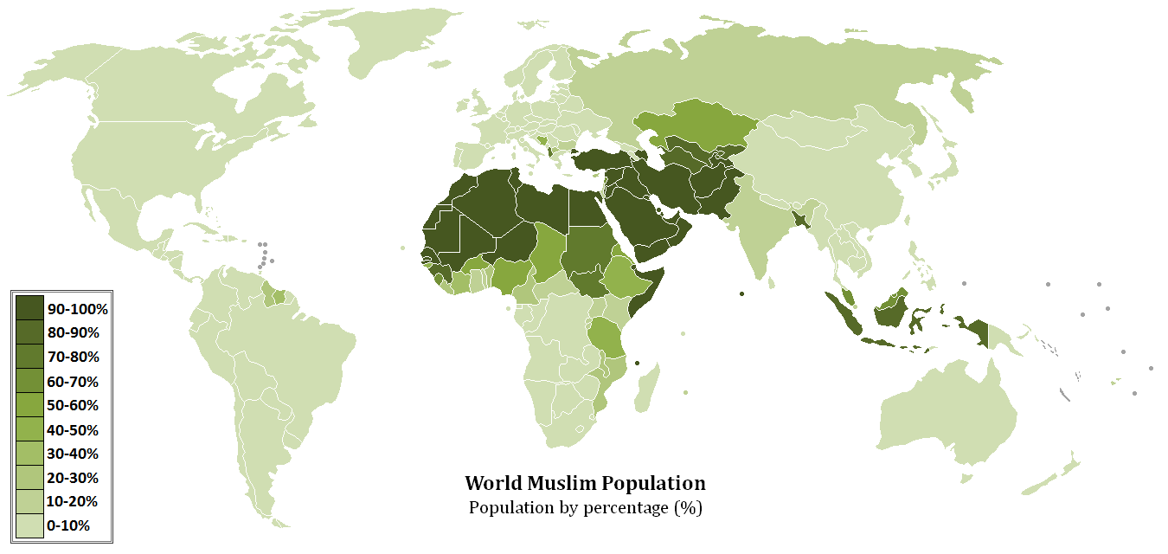
Significance:

Document 3
Source: The Coat of Arms of the flag of Kedah, Malaysia- one of the first sultanates in the World. The Green Crescent symbolizes Islam as the official religion of Kedah.

Significance:

Exit Ticket

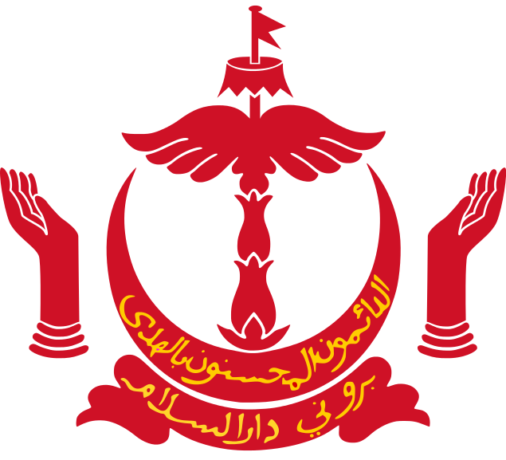
Questions 1-3 refer to the image below.

Source: Crest of the flag of Burnei- a sovereign state in Southeast Asia near Malaysia. The Burnei Sultanate reached its height in the 15th century CE-this crest is still a part of their national flag today.

- Which of the following statements can be supported by this image?
- The Burnei Sultanate was created after a leader converted to Islam
- As the sultanate, Burnei leaders had more power than the caliph
- The Burnei Sultanate was positively affected by the Sand Road Trade Network
- The use of Arabic was only used in official government documents within the sultanate

- **Which of the following factors contributed to the spread of Islam to Asia?
- Trade through the Silk Roads
- Trade through the Sand Roads
- Sufis traveling to the area
- The attractiveness of the religion to new converts

- I, II, and III
- I, III, and IV
- I and II only
- IV only

- **The image above suggests which of the following long-term effects of the spread of Islam to Southeast Asia?
- The fusion of Southeast Asian and Islamic cultures
- The creation of powerful political entities founded on Islam
- The dominance of Islam in the region, even in modern times
- All of the above

Homework
Directions: Please complete the graphic organizer below using detailed bullet points. As a reminder, you will not be allowed to participate in seminar and will receive a zero for your classwork for that day if your homework is missing, incomplete, or poor.

Region | How did Islam arrive to this region?  (1-2 Detailed Bullet Points) | **Effects of Islam in this region  (3-4 Detailed Bullet Points)
**West Africa
**East Africa
**Spain
**South Asia
**South East Asia

