**1. What three trade routes were used in the Classical Era?

**2. What are two effects of long-distance trade?

**Define cultural diffusion.

4. What are the key characteristics of Classical Era Empirest?

Lecture CFU
Directions: Using your Lecture Notes, please answer the questions below.
**1. List and describe two factors led to the spread of Islam to West Africa.

**2. What role did Timbuktu play in the spread of Islam to West Africa?

Exit Ticket
**1. Answer parts A and B.
Another of their good qualities is their zeal for learning the Koran by heart. They put their children in chains if they show any backwardness in memorizing it, and they are not set free until they have it by heart. I visited the Qadi in his house on the day of the festival. His children were chained up, so I said to him, "Will you not let them loose?" He replied, "I shall not do so until they learn the Koran by heart.“
- Ibn Battuta’s observations of the city of Timbuktu (14th century)
- Identify and explain two factors that led to the spread of Islam to Timbuktu.
- Identify one potential limitation of the document as a source of information about Timbuktu.

___________________________________________________________________________________________
___________________________________________________________________________________________
___________________________________________________________________________________________
___________________________________________________________________________________________
___________________________________________________________________________________________
___________________________________________________________________________________________
___________________________________________________________________________________________
___________________________________________________________________________________________
___________________________________________________________________________________________
___________________________________________________________________________________________
___________________________________________________________________________________________
___________________________________________________________________________________________
___________________________________________________________________________________________
___________________________________________________________________________________________
___________________________________________________________________________________________
___________________________________________________________________________________________
___________________________________________________________________________________________

___________________________________________________________________________________________
___________________________________________________________________________________________
___________________________________________________________________________________________
___________________________________________________________________________________________
___________________________________________________________________________________________
___________________________________________________________________________________________
___________________________________________________________________________________________
___________________________________________________________________________________________
___________________________________________________________________________________________
___________________________________________________________________________________________
___________________________________________________________________________________________
___________________________________________________________________________________________
___________________________________________________________________________________________
___________________________________________________________________________________________
___________________________________________________________________________________________
___________________________________________________________________________________________
___________________________________________________________________________________________
___________________________________________________________________________________________
___________________________________________________________________________________________
___________________________________________________________________________________________
___________________________________________________________________________________________
___________________________________________________________________________________________
___________________________________________________________________________________________
___________________________________________________________________________________________
___________________________________________________________________________________________
___________________________________________________________________________________________
___________________________________________________________________________________________
Homework
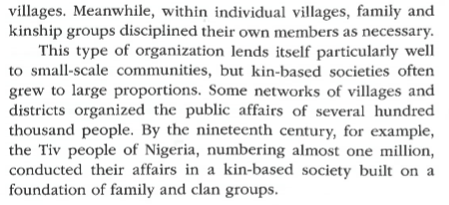
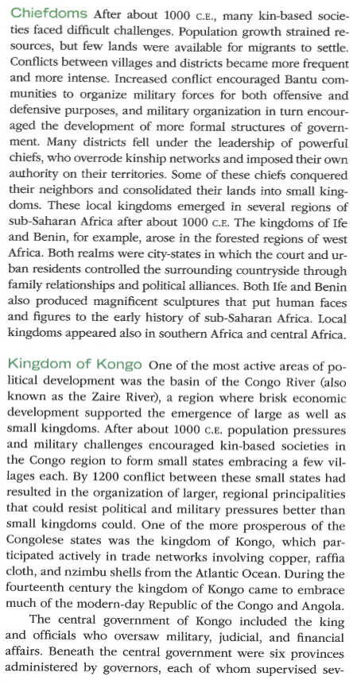
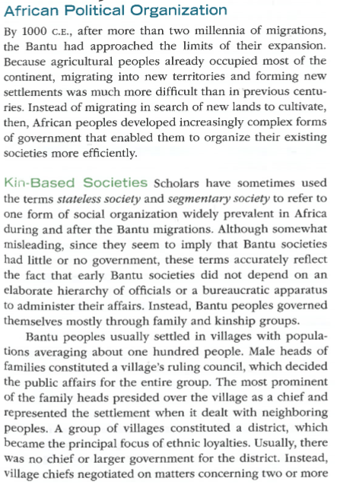
Directions: Please read and take CN on the text below. Ensure that you bring your notebook to class tomorrow to be graded!
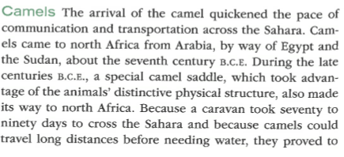
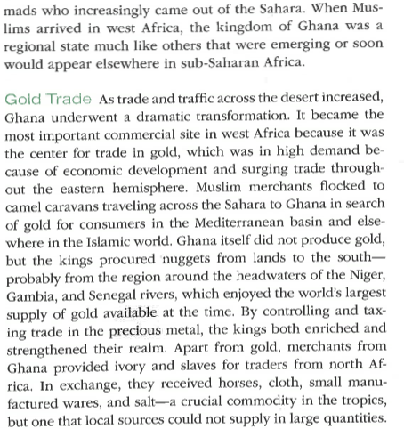
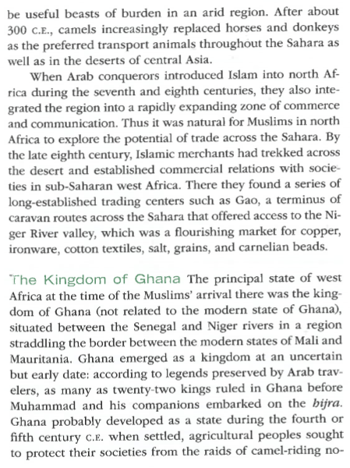
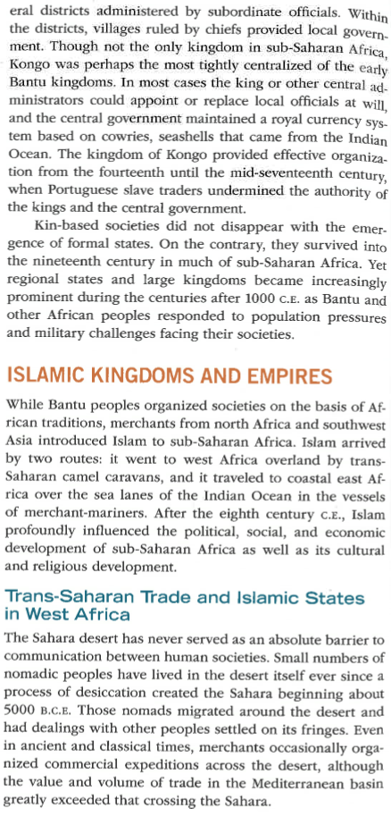
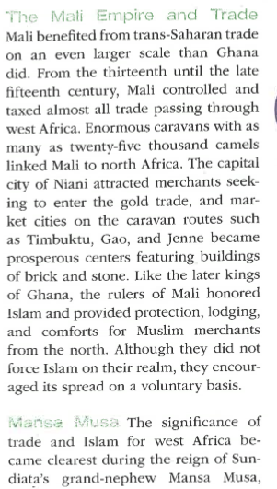
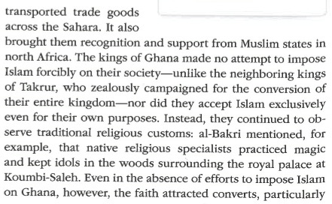
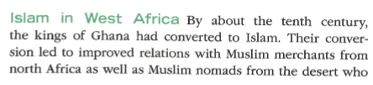

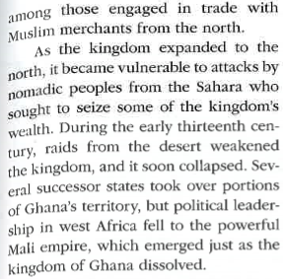

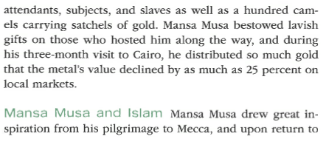
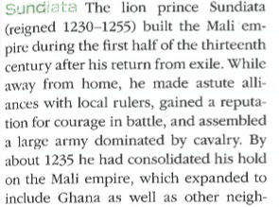
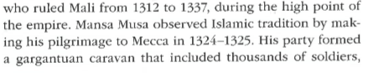

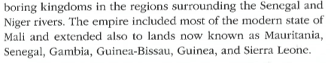
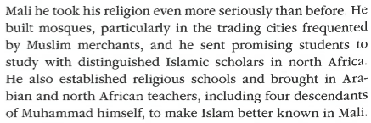

Key Terms List #12
Directions: Go to nsaworldhistory.weebly.com and click on “Link to Quizlet” for definitions. OR, go to Quizlet.com, search for NSAHS World History 1 and use Ms. Babbitt’s lists. You must write the full definition in the space below. As a reminder, these are due on Monday, 2/10 to the HW folders. You will have a quiz that day in class!
Key Term | Definition
**Ghana

**Mali

**Timbuktu

Sundiata

**Mansa Musa

**Ibn Batuta

Songhai

**Sultanate

**Oasis

Great Zimbabwe

**Swahili

