**1. What are the two major sects of Islam?

**2. What caused the split between the Sunni and Shi’a?

**3. Who do Sunnis believe is the rightful successor to Muhammad?

**4. Who do Shi’a believe is the rightful successor to Muhammad?

Directions: Please read the questions below. Then, after watching the video, answer them silently.

- According to the video, what is one of the largest causes of conflict in nations such as Syria, Saudi Arabia, Lebanon and Iraq?

- What is happening in countries where the majority of the country is one sect of Islam, and the ruling class is another?

- How does this affect the United States?

Document Analysis
Prompt: Evaluate the factors that led to the Sunni/Shi’a split and the long-term effects of that split.
Scope:
Topic:
HTS:
Re-Written Question:

Document 1
Source:How the Current Sunni-Shiite Conflict Frames the Current Crisis in Iraq” by Zoe Mintz, International Business Times (June 17th, 2014)
As ISIS keeps advancing on the ground in Iraq, the hardline jihadi militants have revived with a vengeance one of the oldest conflicts there is: the rift between the Sunnis and Shiites in Islam. Iraq is a perfect ground for the divide to turn violent: it has a Shia-majority population, a Shia-led government under Prime Minister Nouri al-Maliki, and an embattled Sunni minority, which dominated the country for centuries, from the Ottoman Empire until the U.S. invasion deposed Saddam Hussein in 2003."The Iraq conflict plays out on several levels between Sunnis and Shiites. First and foremost, it's about how to share power in a 21st century state. The prime minister, a Shiite, has failed abysmally in creating a formula to share power with the Sunnis, the traditional political masters in Iraq," Robin Wright, a joint fellow at the U.S. Institute of Peace and the Woodrow Wilson Center, non-partisan institutions, told NBC News.
The Iranian Revolution in 1979 was a turning point in the Sunni-Shiite conflict, creating a radical Shiite theocracy in a large, oil-rich and well-armed nation. While the Ayatollah Khomeini, the revolution's inspiration and Iran's supreme leader, tried to build bridges between the two sects, other religious and secular leaders advanced the divide. Today, Iranian Sunnis do not have a mosque of their own, they do not hold top government posts, and Sunni businessmen have difficulties obtaining import and export licenses. In Saudi Arabia, it’s the opposite. Sunnis are in power, with Shiites being the target of discrimination. Most Shia holy places in the kingdom have been destroyed by the Saudi royal family. A particularly rabid brand of local Sunni fundamentalism entwined with the state, known as Wahhabism, places severe restrictions on Shia practices, with some leaders being jailed.

Significance:

Document 2
Source: Sunni and Shi’a: Islam’s Ancient Schism- BBC News. January 4th, 2016.
In countries which have been governed by Sunnis, Shia tend to make up the poorest sections of society. They often see themselves as victims of discrimination and oppression. Sunni extremists frequently denounce Shia as heretics who should be killed. The Iranian revolution of 1979 launched a radical Shia Islamist agenda that was perceived as a challenge to conservative Sunni regimes, particularly in the Gulf. Tehran's policy of supporting Shia militias and parties beyond its borders was matched by Sunni-ruled Gulf states, which strengthened their links to Sunni governments and movements elsewhere. Today, many conflicts in the region have strong sectarian overtones. In Syria, Iranian troops, Hezbollah fighters and Iranian-backed Shia militiamen have been helping the Shia-led government battle the Sunni-dominated opposition. Sunni jihadist groups, including Islamic State (IS), have meanwhile been targeting Shia and their places of worship in Syria and neighboring Iraq. In January 2016, the execution by Saudi Arabia of a prominent Shia cleric who supported mass anti-government protests triggered a diplomatic crisis with Iran and angry demonstrations across the Middle East.

Significance:

Document 3
Source: Pew Center: Countries with ≥5% of Muslim Population, Labeled by Sunni, Shi’a, and Other
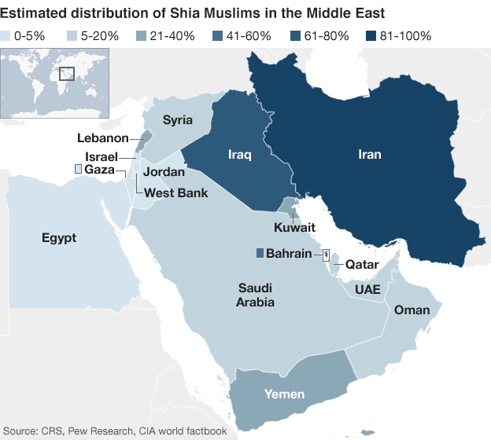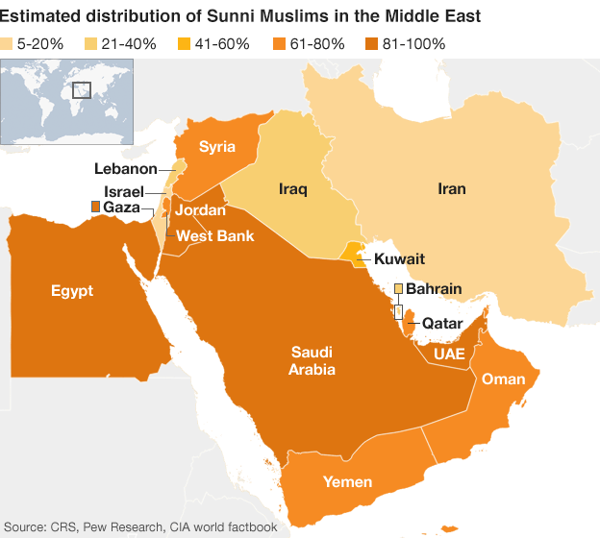
Significance:

Exit Ticket
1. *Which of the following best describes a reason for why the Islamic community split into two different groups, the Sunni and Shi’a?
- Because of a disagreement over whether the caliph needed to be a relative of Muhammad.
- In the interest of peace, the majority of Muslims accepted the Umayyad’s rule.
- Because the Sufis tried to achieve a life of poverty
- Because of the rise of the Abbasids
- Because the Fatimad Dynasty divided the weakly-controlled Islamic territory.

2. **Name and describe at least one long term effect of the Sunni/Shi’a split.
___________________________________________________________________________________________
___________________________________________________________________________________________
___________________________________________________________________________________________
___________________________________________________________________________________________
___________________________________________________________________________________________
___________________________________________________________________________________________
___________________________________________________________________________________________

Homework
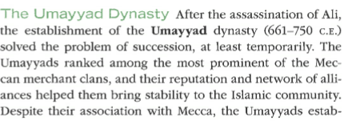
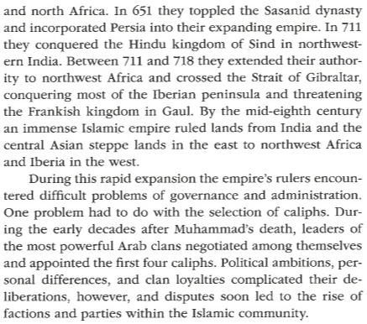
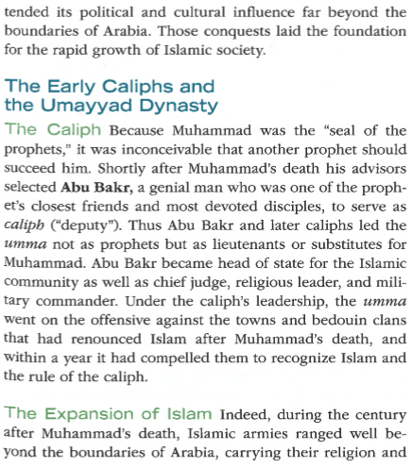
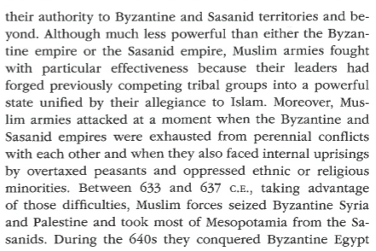
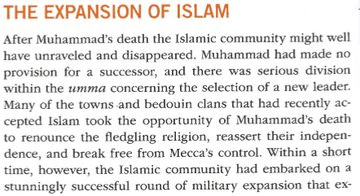
Directions: Please read and take CN on the text below. Ensure that you bring your notebook to class tomorrow to be graded!

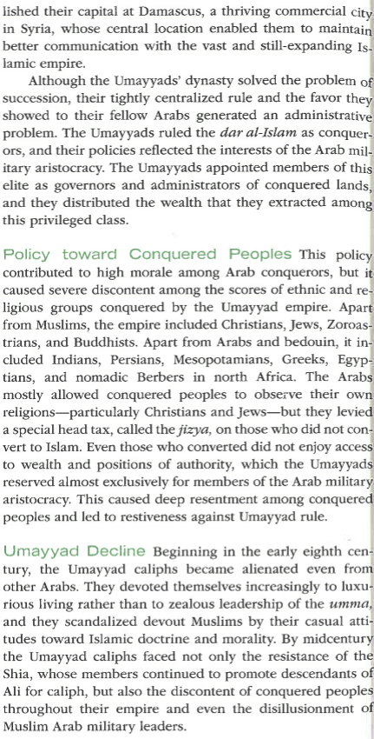
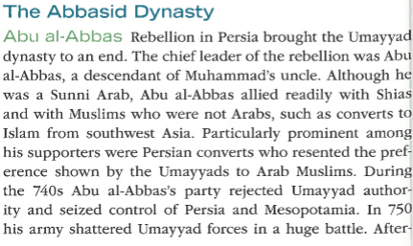
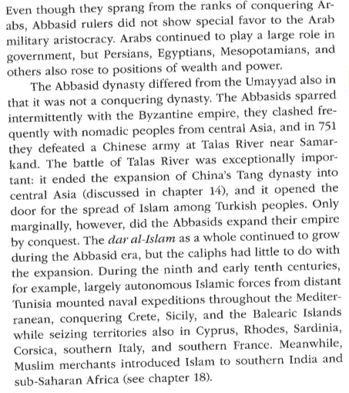
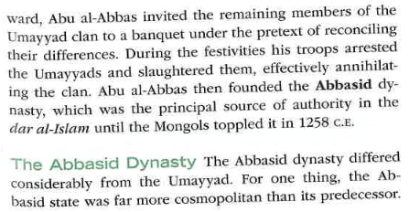

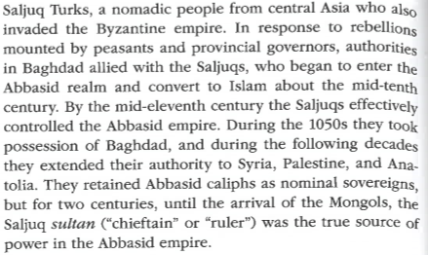
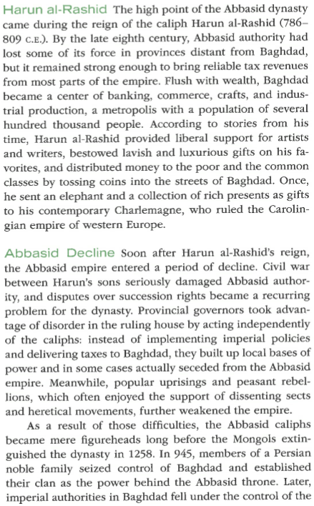
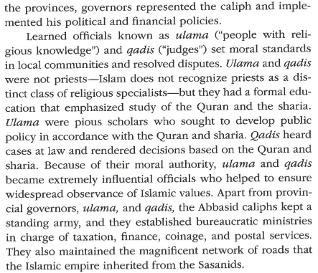
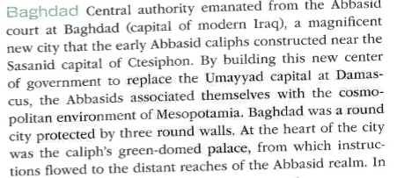
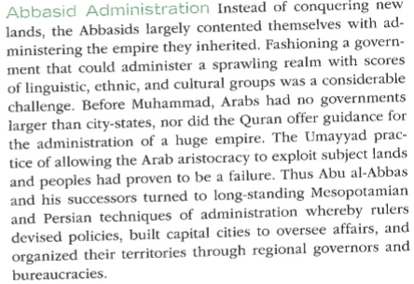

Key Terms List #11
Directions: Go to nsaworldhistory.weebly.com and click on “Link to Quizlet” for definitions. OR, go to Quizlet.com, search for NSAHS World History 1 and use Ms. Babbitt’s lists. You must write the full definition in the space below. As a reminder, these are due on Monday, 2/3 to the HW folders. You will have a quiz that day in class!
Key Term | Definition
**Sunna

*Shari’a

**Caliph

**Umayyad Empire

**Shi’a

**Sunni

**Sufis

**Abbasid Empire

**Al-Andalus Empire

Fatimid Empire

