Welcome to Class! Do Now Please!
Questions/Concerns:
**1.) Place the following dynasties in their proper order: Han, Qin, Song, Tang,

**2.) What were at least three technological advancements were made in the Tang and Song Dynasties and what impact did each of them have?

3.) How did the social structure of China change during the Tang and Song Dynasties?

Document Analysis
Prompt: Analyze the impact of new technologies developed by the Tang and Song.

Scope:
Topic:
HTS:
Re-Written Question:

Document 1
Source: Huang-Lu Rice in Chinese History, Research Institute of History in Natural Science, Scientifica Sinica, Beijing (1998).

Huang-lu, a yellow rapid-ripening rice was not very popular until Song Dynasty (960-1279). Huang-lu’s fast ripening and water resistance permitted proper ripening, surpassing actual need. It could also use the limited time before and after flooding to complete growth from sowing to harvesting. These traits met economic needs and natural conditions; e.g., land reclamation from water. Hence, huang-lu promotion and popularity played an important role in grain supply and population growth after Song Dynasty.

Significance:

Document 2
Source: The Song also began to study astronomy, naming what we now know to be supernovas as “Guest Stars”. The text below was written in the 10th century and details the observation of one of these “guest stars”.

Emperor Renzong of Song, 1st year of the Jiayou reign period, 3rd month, day xinwei. The Director of the Astronomical Bureau said that the guest star had disappeared; it was an omen of a guest departing. Early in the morning of the 5th month of the Zhihe reign period, the guest star appeared in the east and Guarded Tianguan. During the daytime it appeared like Venus with horned rays in all directions. It had a reddish-white color and lasted for a total of 23 days.
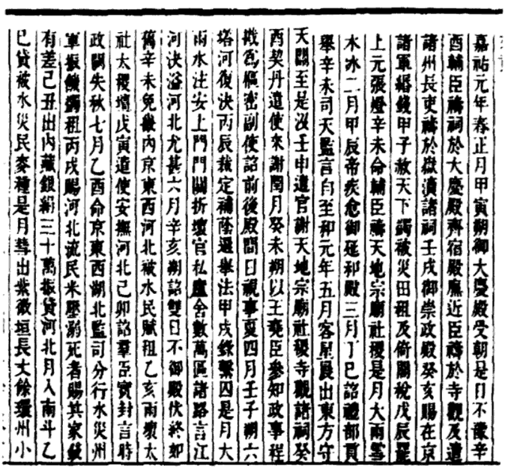

Document 3
Source: A woodblock printer, used in Tang China (750 CE). With this publication technique, characters are carved into flat blocks of wood, which are then rubbed within k and then pressed on paper. Later, in the Song Dynasty, It became the major means of producing traditional printed matter in China.

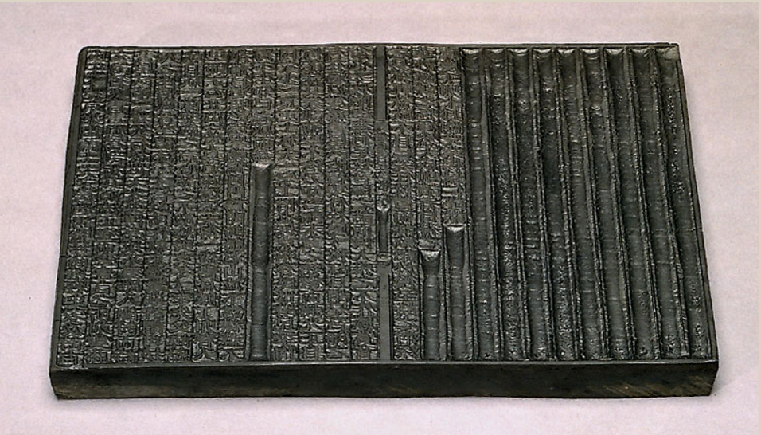

Document 4
Source: The Song Dynasty saw major advancements in shipbuilding with improvements in speed, security against pirates, adaptability to marine conditions, and steadiness. Song battleships, such as the one drawn below (11th century CE), were equipped with fire-bomb catapults and incendiary arrows that used gunpowder. Sometimes protected stations on upper decks were created for crossbowmen who also played the role of watchmen.

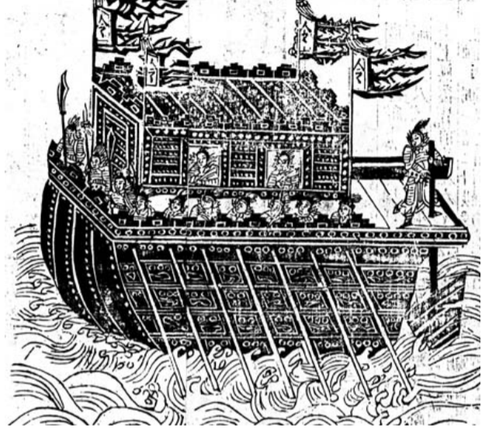

Exit Ticket
Prompt: Analyze the impact of new technologies developed by the Tang and Song.

Thesis: ________________________________________________________________________________________
_______________________________________________________________________________________________
_______________________________________________________________________________________________
_______________________________________________________________________________________________
_______________________________________________________________________________________________

Homework
Directions: Please answer the questions below in complete sentences.
**1. What continuities (things that stayed the same) existed from the Han to the Tang and Song Dynasties?

**2. What changes existed from the Han to the Tang and Song Dynasties?

**3. What are two technological innovations of the Tang and Song? What were the impact of those innovations?

**4. Define Feudalism.

**5. What led to the Great Schism in 1054?

**6. What continuities (things that stayed the same) existed between Rome and the Byzantine Empire?

**7. What changes existed between Rome and the Byzantine Empire?

8. What are the Five Pillars?

9. What led to the creation of Islam?

10. What led to the spread of Islam?

